Healthy food
- The traditional food we eat at home is:
- Cuttlefish risotto (black risotto)
- Smoked ham (prosciuto)
- Pag cheese
- Octopus under the bell
- Žrnovski makaruni

- Cuttlefish risotto (black risotto)
It has an intense taste and it is a real delicacy that will delight fish lovers. Although, the traditions have been slightly changing, the black cuttlefish risotto in Dalmatia, the southern part of Croatia, is often prepared as it was on Christmas Eve when, according to Christian tradition, simple dishes with fish and seafood are cooked.
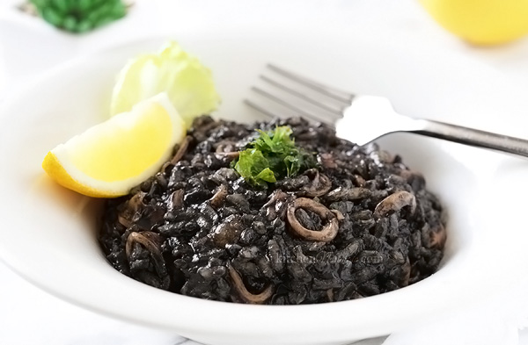
- Smoked ham (prosciuto)
Dalmatian prosciutto is a gastronomic specialty created by drying pork legs (cleaned) on smoke. Due to its specific taste and unusual way of production, it is considered one of the most original products of Croatian cuisine, and thus has become an indispensable part of the tourist, catering and private offer not only of Dalmatia but of the rest of Croatia. It is similar in taste and manner to Istrian prosciutto and some ham in the northwestern part of Croatia.
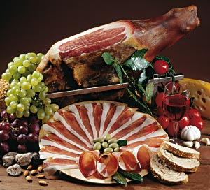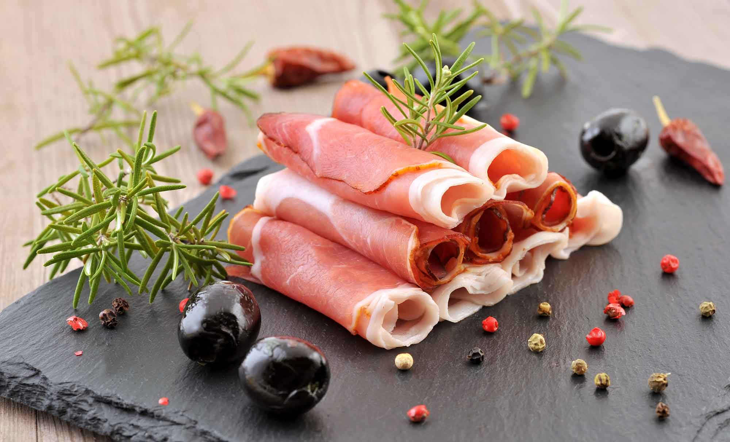
- Pag cheese
Pag cheese is a well-known and respected cheese produced on the island of Pag in the Adriatic Sea. Cheese is made from sheep's milk. Pag cheese was named the best sheep cheese in the world at the Global Cheese Awards in English Somerset on September 12, 2017.
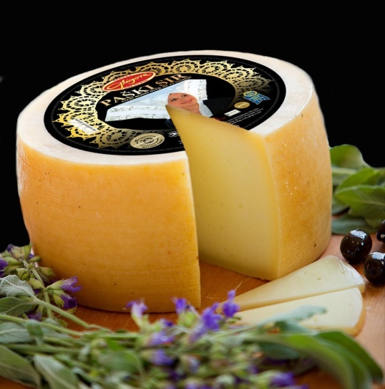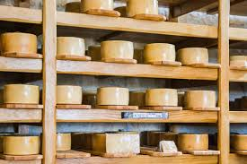

- Octopus under the bell
That is an octopus with potatoes and vegetable, drizzled with olive oil, baked in a large, deep pan covered with iron bell, on a fireplace, surrounded and covered with coals and ashes.
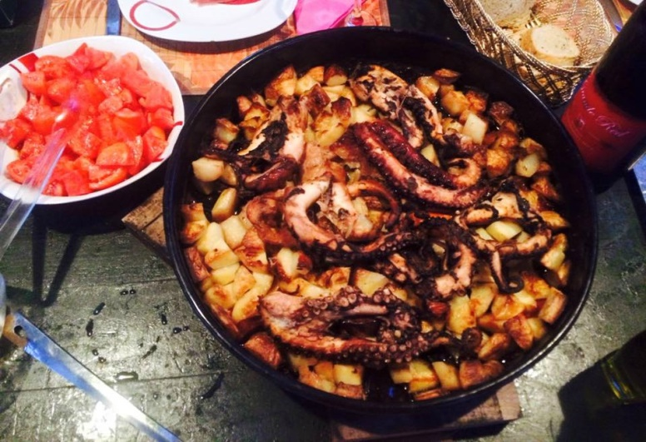
Žrnovski makaruni
Žrnovski macaroni is a traditional dish with homemade fresh pasta from the village of Žrnovo on the island of Korčula.
You need to mix the dough to the right consistency (hard!), cut the small pieces of dough and then roll each piece on the wooden stick (wooden needle just like a skewer) between your palms making each ‘macaroon’. Originally we make Žrnovski macaroni with meat sauce (beef) but it's delicious with other sauces such as tomato or prawn.
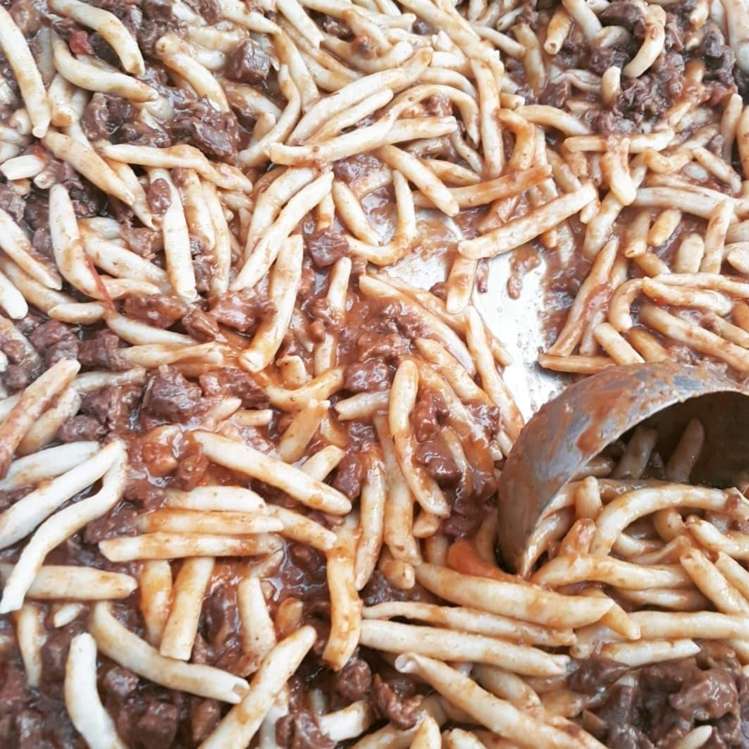

Enjoy our meals!

