LOJENICE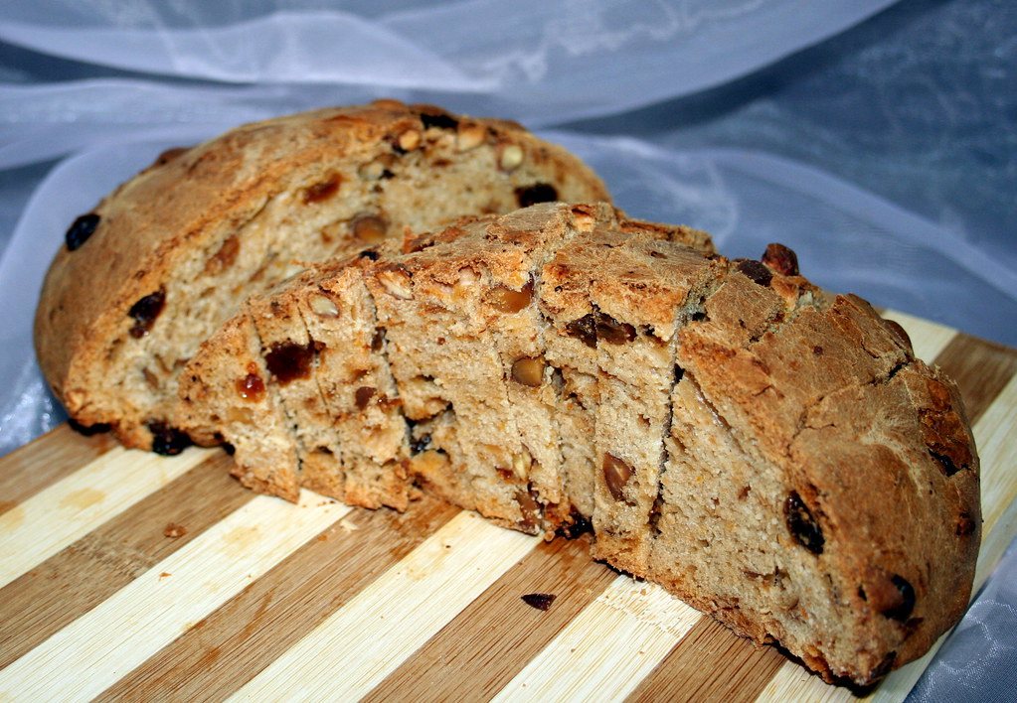
They are made for St. Martin's Day (11th November).
120 g of yeast | 100 g raisins
300 ml water | 250 g (chopped almonds,walnuts, pine nuts and dried figs)
250 g fat ( tallow,lard,butter ) | 1 tablespoon cinnamon
50 ml brandy of roses | 1 teaspoon nutmeg
250 g sugar | zest of one lemon
1 vanilla sugar | zest of two oranges
1.5 tsp salt

1 kg flour

IN CROATIAN LANGUAGE:
120 g kvasca | 100 g grožđica
300 ml vode | 250 g sjeckanih badema, oraha, pinjola i suhih smokava
250 g masti | 1 žlica cimeta
50 ml rakije od ruža | 1 žlica muškatnog oraščića
250 g šećera | korica jednog limuna
1 vanilin šećer | korica 2 naranče
1.5 žlica soli
1kg brašna

In Korčula's cakes the most used ingredients are: -sugar ( šećer, cukar ) – eggs ( jaja ) -lemon ( limun ) - milk ( mlijeko ).

