Romanian Christmas traditions at the table

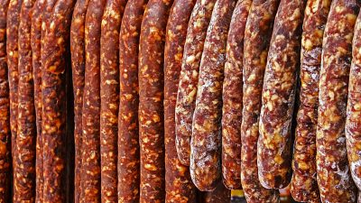

The feast of the Birth of Jesus Christ or Christmas represents for the Romanian people (especially the Orthodox Christian) an opportunity of great joy. According to the post of Christmas, a period of both physical and spiritual restraint, the relegation to sweet food brings with it many customs and a potpourri of pork preparations and holiday sweets. Pork cutting is done on Ignat day. From pork, for Christmas, prepare bacon, chop, beef salad, sausage, lebar, crab, drill, sarmale, piftie, ham, pastram, parsley, but also pork ribs and pomegranate that are the first preparations consumed after you pig. The sweets that end the feast table, or with which the guests who walk the threshold of the house and carvings are humankind, are: cozonac, pie and leeks. All these preparations have diversifications according to the ethnographic area and are accompanied by drinks specific to each area: snuff, palinka, various wines.

