

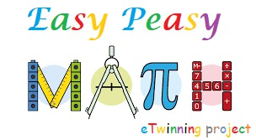

Easy peasy math etwınnıng project lesson plans

**AUTHORS:**

**Damla Güder**

**Anamaria Corina Golumbeanu**

**Seda Sünker**

Şehit Selim Topal Secondary School

Damla Güder-İzmir/Turkey



EASY PEASY MATH ETWINNING PROJECT Lesson plan

Title

Math Lesson with Sol LeWitt

Author(s)

Damla Güder

Subject

*-Math (6-7-8-9 Digit Numbers)*

*-Art*

*-Gamification*

Aim of the lesson

*Reviewing the pictures made by the Sol LeWitt,*

*To discuss the mathematics in these pictures,*

*Students will choose a number they want,*

*Students draw these numbers with pictures similar to Sol’s works,*

*Playing Game with these colourfull numbers,*

*To create a variety of six seven eight and nine digit numbers with the commands given by the teacher according to the number created by everyone.*

Age of students

11-12

Time

Preparation time: 40 min

Teaching time: 40 min

Teaching material

Online:

*List here all the links of online tools and support documents that you will use during the lesson.*

<https://tr.wikipedia.org/wiki/Sol_LeWitt>

[*https://youtu.be/Pq4tE6kW2vY*](https://youtu.be/Pq4tE6kW2vY)

[*https://youtu.be/Fb9cGR29jp8*](https://youtu.be/Fb9cGR29jp8)

Offline:

*Paper, colourful pencils*

21st century skills

* *Innovation Skills*
* *Critical Thinking*
* *Communication*
* *Collaboration*
* *Creativity*
* *Information, Media and Technology Skills*

Lesson Plan

| Name of activity | Procedure | Time |
| --- | --- | --- |
| Introduction | Students search the SoL LeWitt from the internet and examine the work of this painter. | 10 |
| Task 1 | Students work individually. They choose a number from zero to nine, and prepare this number as an A4 size paper and build patterns similar to the patterns in the SoL LeWitt paintings. | 10 |
| Task 2 | The teacher gives some instructions and the students try to create the number in the teacher's instructions based on the numbers they have | 10 |
| Task 3 | The students will create asked to write the numbers of the teacher collaboratively, if the number is a six digit number, the six students will form the appropriate number, if the number is seven digits seven students will collaborate. How many digits the teacher wants to create, the more students will collaborate. | 10 |
| Task 4 | After the numbers have been created, the discussion will be started. Is it true? Which numbers are changed if they are replaced, or if there is a mistake, they will be asked to write the numbers correctly by asking questions such as what we can do to write the number correctly. They may be asked to read the numbers they wrote. Every team will answer these:  1. What have learned?  2. How have learned it?  3. Has it been useful?  4. It will be used in the future? | 10 |

Assessment

Questions asked by the teacher during the game:

Can be written with the numbers in your hands:

- what is the biggest seven-digit number?

- What is the smallest number with different six digits?

- What is the biggest even number with different eight digits?

- What is the smallest odd number with different nine-digit numbers??

- What is the biggest nine-digit odd number?

- What is the smallest odd number with eight digits??

- What is the biggest odd number with different six digits?

- What is the biggest nine-digit number?

- What is the biggest eight-digit number?

- What is the biggest seven-digit number?

- What is the biggest six-digit number?

- What is the smallest nine-digit number?

- What is the smallest eight-digit number?

- What is the smallest seven-digit number?

- What is the smallest six-digit number?

Teacher will observe:

* The painter's work is examined together and how it works is discussed (SoL LeWitt).
* How the students put the works of the painter in the numbers they chose is examined.
* Attention is paid to students working with different numbers.
* After the numbers are painted, gamification is made for reading the six seven eight and nine digit numbers.
* Students are asked to build the numbers given by the teacher by gamification.
* If students make mistakes, students are provided to make correct rankings with instant questions and answers.

Student feedback

At the end of the lesson, students will apply the commands given by the teacher while playing games and instant feedback will be given in this context.

Students will be able to ask their questions at the moment and get the necessary answers.

**Ion Țuculescu Secondary School Craiova**

Anamaria Corina Golumbeanu-Romania

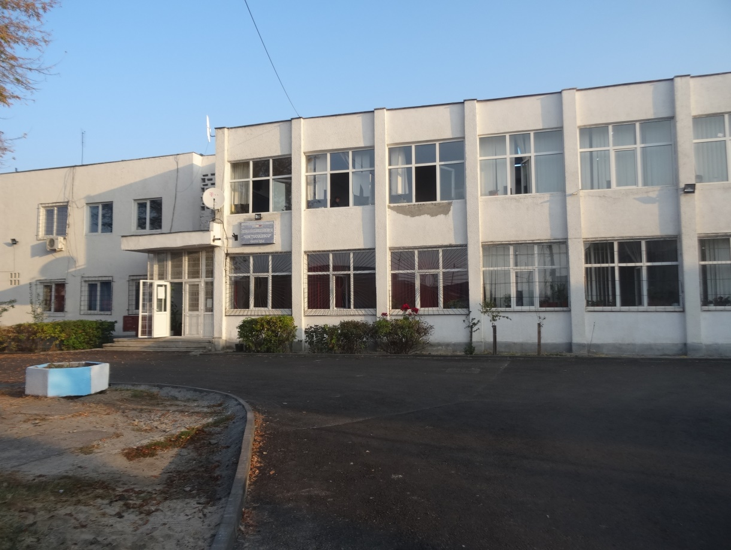

**learning scenario**

**Title**

Azorel's house

**Author**

Anamaria Corina Golumbeanu

**Summary**

*Students divided into teams of 5 students will build the model of Azorel's house, will make various calculations and study the condition of the dog in society by data analysis.*

**Key elements**

|  |  |
| --- | --- |
|  | |
| Subject | *Mathematics, social education* |
| Topic | Mathematics for animal welfare |
| Age of students | *12* |
| Preparation time | *4-5 days to prepare :*  *- a poster about* Azorel's house,  - documentation of Azorel's house : dimensions, scale of the model, perimeter of the base, base area, lateral area, total area  - data collection, data analysis and presentation about the dog's condition in society (owned dogs vs. stray dogs, dogs as pets, dogs with jobs, dogs in Laboratories) |
| Teaching time | *2 hours:*  *One hour for presenation of models for* Azorel's house and  *calculations of perimeter and area*  *One hour for presentations about dog condition in society and data analysis* |
| Online teaching material | *Padlet to sharing photos of* Azorel's house  Google form to collect data  Moodle for formulas question type to solve at the end of the activities  Wikipedia |
| Offline teaching material | *Paper, pencils, cardboard, glue, scissors*  *PC for PowerPoint presentation* |
| Resources used | <https://www.carodog.eu/school-projects-2/>  *<https://www.cesarsway.com/dog-care/>*  *<https://www.clinypet.ro/sfaturi-utile/sfaturi-utile-pentru-ingrijirea-cainilor.html>*  *<https://cmvro.ro/utile/legislatie/legislatie-caini/>*  *<https://www.peta.org/issues/animals-used-for-experimentation/dogs-laboratories/>* |

**Aim of the lesson**

Students will develop the skills of calculating the perimeters, areas, scale drawing, data analysis.

Students will develop their critical thinking and science literacy skills by collecting data about dog condition in our society

**Trends**

*Project-Based Learning*

**21st century skills**

Digital competence will be developed by using smartphones, PC and internet to collect data, to make PowerPoint presentations.

Mathematical competences and basic competences in sciences and technologies will be developed by calculating the scale of a drawing, perimeters and areas, data analysis.

Foreign language communication competence will be developed by using data in various language and sharing the results in an eTwinning project.

Communication skills in mother tongue will be developed by presenting the model of Azorel's house and the PPT presentations in front of the class

Learn to learn will be developed by the work on the project themselves

Social and civic competence will be developed by learning about animal protection. Working in teams students will develop their skills of cooperation and mutual respect

Spirit of initiative and entrepreneurship will be developed by finding economical solutions to realize the project by using reusable materials.

Cultural awareness and expression will be developed by finding the image of dog in our culture and across over the world

**Lesson Plan**

|  |  |  |
| --- | --- | --- |
| Name of activity | Procedure | Time |
| 1 | Teacher will form teams of 5 students and will present the components of the project Arorel's house:  *a poster about* Azorel's house,  documentation of Azorel's house : dimensions, scale of the model, perimeter of the base, base area, lateral area, total area  data collection, data analysis and presentation about the dog's condition in society (owned dogs vs. stray dogs, dogs as pets, dogs with jobs, dogs in Laboratories) | 15 min |
| 2 | *Teams of students will do:*  *a poster about* Azorel's house,  a documentation of Azorel's house : dimensions, scale of the model, perimeter of the base, base area, lateral area, total area  will collect data from their classmates about pets in a google form.  will collect data about dog in our society (owned dogs vs. stray dogs, dogs as pets, dogs with jobs, dogs in Laboratories) on the Internet and will analyze the data. Next They will do a PPT presentation with their work. | 4-5 days |
| 3 | Teams of students will present their models of Azorel's house and their calculations regarding model scale, base perimeter, base area, side area and total area | 50 min |
| 4 | Teams of students will present their PPT presentation.  Teacher will mediate a discussion about laws, ethics and animal protection. | 50 min |
| 5 | Students will done a quize on the moodle platform about scale of the model, perimeter and area, statistics | 10 min |
| 6 | Students will share their products (posters and dog house models) in an exhibition on the school hall in a campaign on animal protection | 40 min |

**Assessment**

*************************** **AFTER IMPLEMENTATION** ***************************************

Students will done a quize on the moodle platform about scale of the model, perimeter and area, statistics and will comment this activity.

**Student feedback**

*I will analyze the score obtained by the students on the quize and their comments at the end of the activity.*

**Teacher’s remarks**

*In my opinion all these activities will arouse students' interest for ethics in science, protection of animal welfare*

**Kutalmışbey Secondary School**

Seda SÜNKER-Ankara/Turkey

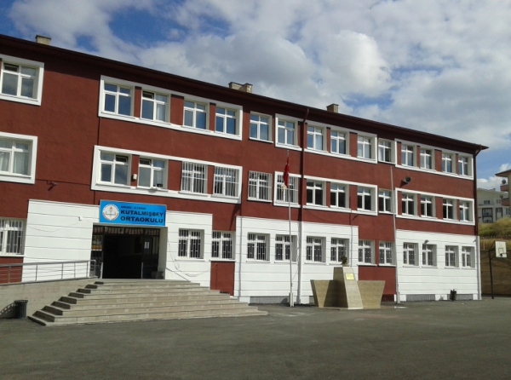

EASY PEASY MATH ETWINNING PROJECT Lesson plan

KUTALMIŞBEY SECONDARY SCHOOL-ANKARA /TURKEY

Title

MATHEMATICS IN OUR TRADITIONAL ARTS

Author(s)

SEDA SÜNKER

Subject

-PATTERNS

-GEOMETRİC SHAPES

-ART

Aim of the lesson

* Student will realize the relationship between our mathematics and artistic works
* Creating awareness for our traditional art works
* *To discuss the mathematics in our traditional carpet, wooden materials, architecture*
* Student will create patterns

Age of students

10-11

Time

40 min+40 min

Teaching material

*Photo with traditional patterns, paper, colourful pencils*

21st century skills

* *Innovation Skills*
* *Critical Thinking*
* *Communication*
* *Collaboration*
* *Creativity*
* *Information, Media and Technology Skills*

Lesson Plan

| Name of activity | Procedure | Time |
| --- | --- | --- |
| Introduction | Students are divided into groups of 4.  Group 1: a photo with our traditional carpets is given Group 2: a photo with our traditional wooden products (door etc.) is given  Group 3: a photograph is given as a traditional architectural building Group 4: a photo with traditional clothing is given | 5 |
| Task 1 | Students are asked to determine the patterns in the photos | 15 |
| Task 2 | Photos of students are changed in four groups. So every student works with every photo | 20 |
| Task 3 | Hangs each group of photos on the board. The student presents his presentation to his classmates | 20 |
| Task 4 | Teacher give isometric paper to students.  The teacher want the students to create patterns | 20 |

Assessment

- Students work together on patterns in photos.

- Students examine repetition of patterns, angles, geometric shapes

-Students present their work

-students create their own patterns

- If the students make mistakes, it is the right order for the students with instant questions and answers.

