PIZZA SHOPPING LIST
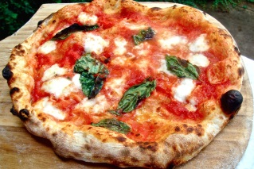
Match the ingredients with the pictures and guess the missing ones.
FLOUR | 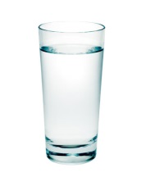
………………….. | 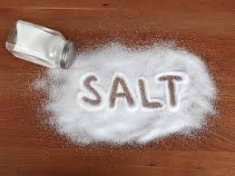
-------------------------
YEAST
-------------------------------- | 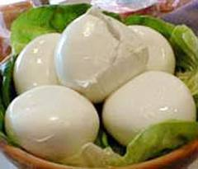
MOZZARELLA CHEESE
………………..
WATER | 