Herons
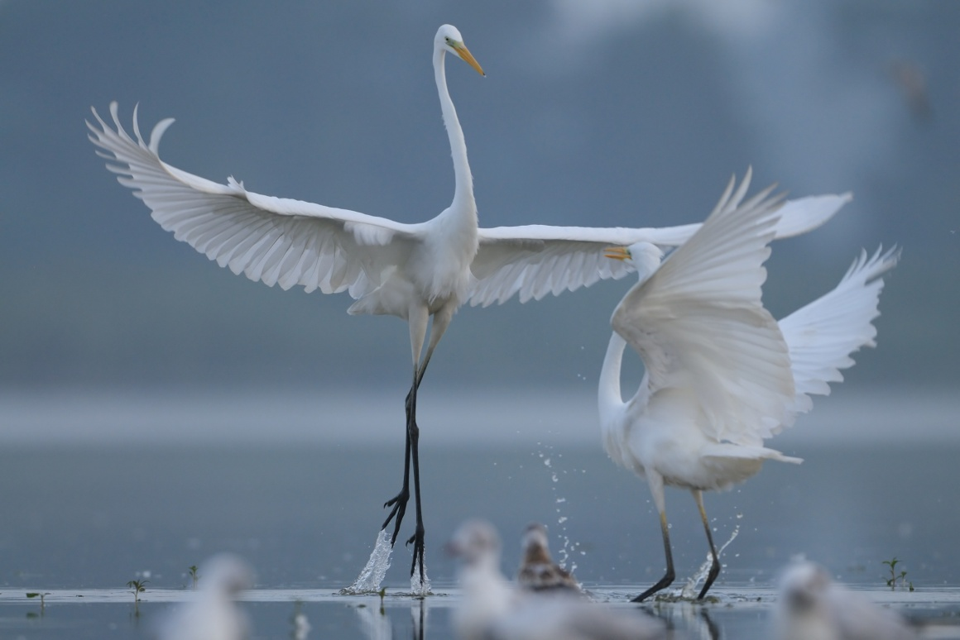

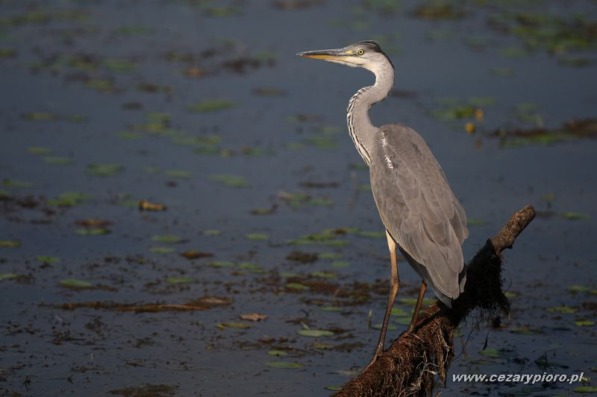
The habitat of this species is shallow waters at lakes, rivers and estuaries, reeds, mangroves and rice fields . It usually nestles near the freshwater, and its coastline only appears in winter . The color of the gray heron resembles a crane, but it is smaller and has a different silhouette. The habitat of this species is shallow waters at lakes, rivers and estuaries, reed beds, mangroves and rice fields. The food is very varied, mainly fish, small mammals and small birds, frogs, snails, crustaceans and snakes. He can also catch insects on the fly. Daytime bird, but the most active is at dawn and at dusk. He is a careful bird.
Body length: 90-105 cm A stork-sized bird with a slim silhouette with a long curved neck. Plum gray on the outside and whitish on the underside. At the back of the head hangs a black tip and the front of the neck has a row of black spots. Young heron does not have a clear figure on the head and neck. In flight, it differs from a stork or crane with an arched neck and curved wings.
place

Various types of water reservoirs, river valleys, swamps. The colonies are often located on islands or in old stands near the waters
number

A small breeding bird: 9000-10,000 pairs
nest

It is nested mostly in the trees, rarely in the reeds. Nest of the branch
brood

3-5 blue eggs. Getting off 25-26 days. Young leave the nest after about 50 days
food

She feeds on fish, amphibians, small mammals and aquatic invertebrates, who she waits patiently
hiking

Wandering, but some birds wintering in the country. Arrival: III- IV, Departure: IX-XI
protection

Partially protected species except breeding grounds, listed in the Birds Directive

