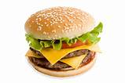
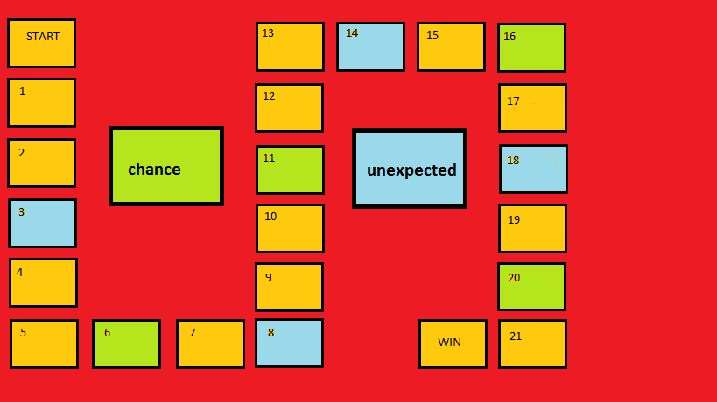
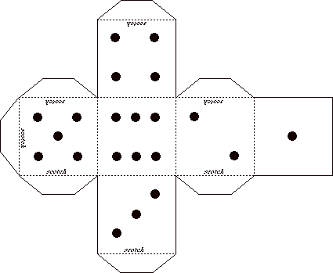
DICE

Rules
-Each player puts their counter on the space that says ‘start’
-Take it turn to roll the dice. Move your counter forward the number of spaces shown on the dice, the target is get to win space.
-When you stop on a green space pick up a “chance” card, when you stop on a blue space pick up an “unexpected” card.
= +1 space = stop one turn
=+3 spaces = -1 space
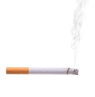
=rool the dice again = go back to the square one
CHANCE UNESPECTED
You are drunk…  You can’t drive  Stop two turns! |  | You forgot the cigarettes at home…  Go back two spaces to pick them up!
You go for a run to stay fit  Move your counter forward four spaces! |  | You feel bad after eating junk food…  Roll the dice again and move backward the number of spaces as rolled on the dice
What substance in cigarettes can cause addiction?  If you give the right answer you roll the dice again |  | You are drunk and go the wrong way home..  Move backward to the previous unespected space
The fruit you’ve eaten gives you new energy  Move directly to the next chance space |  | You have a bad cough from smoking…  Roll the dice and if you get three, go back to the start space
Which organ can be damaged by alcohol?  If your answer is right, move your counter forward two spaces |  | You drink water and get fit  Move forward two spaces
You shut down your cell phone and go out with a friend  Roll the dice again |  | How many hours should you sleep each night?  If your answer is wrong, stop one turn
You perform a workout at home: 10 push-ups, ten squats and sky diver for 60 seconds.  move your counter forward three spaces |  | You forgot to worm-up before your last workout and got a muscle strain.  Stop one turn and rest!

COUNTERS
