How dangerous for society fake news can be.
Fake news or false news is a phenomenon that has existed for many years. However, with the emergence of social networks has become a very common phenomenon. It was assumed that the Internet was going to democratize information. And he has done it. However, it has also brought with it a phenomena such as mass deception.

Almost always the fake news are accompanied by an image. This is what apparently gives them credibility. However, the image also turns out to be false or simply taken out of context. In this way, the illusion is created that something is true without being so.

In other occasions, what is done is to spread a false or inaccurate information. A community with certain interests is responsible for circulating this information massively. When repeated in social networks, it is taken for granted without being so. There are extreme cases like the one of a supposed earthquake in Peru announced in advance. The information came to generate real panic.

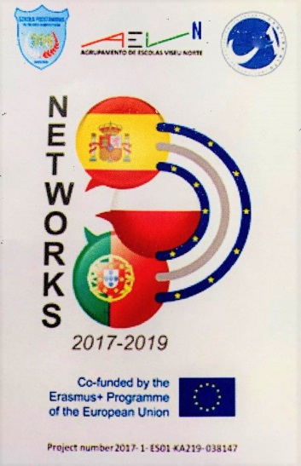
Román Martín Santos

