SALVADOR DALÍ
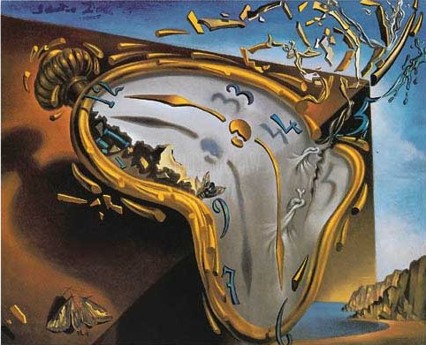
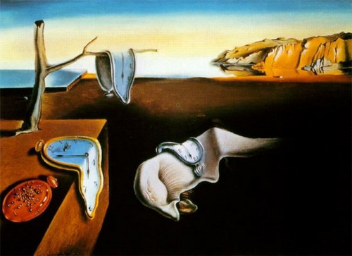
Salvador Dalí was born in Figueres in 1904 and he died in 1989. He was a surrealist artist his most famous painting is "els rellotges tous" (the soft clocks).
He was an eccentric person, he has got a big moustache and he said meaningless things. But he was a great person.
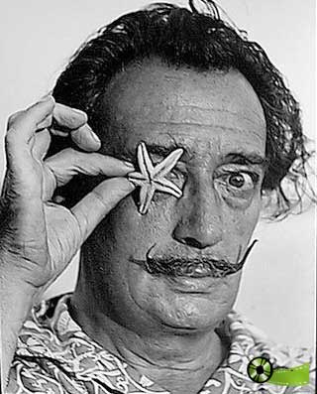
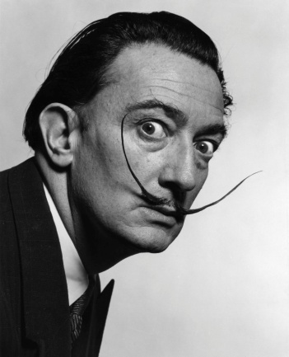

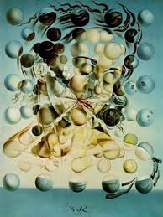
His wife was a reference to paint lots of his paintings. Her name was Gal.la.
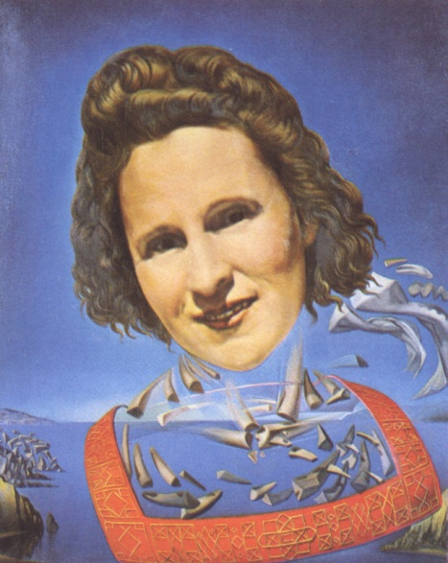

IMPORTANT THINGS THAT HE MADE

Theatre-Museum
The Dalí Theatre Museum, opened in 1974, is considered the most surrealistic building in the world. In 2011, the museum received 916.560 visitors.

The museum continues to grow and the artist made changes and additions till the year of his death in 1989.

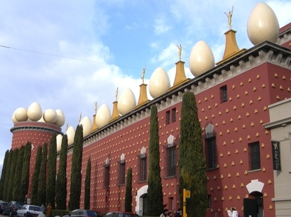

Persistence of the memory

The background is the landscape of Portlligat. On the background there are four clocks and in the middle there is a “soft monster”.

The painting was created by Dalí one day he was ill at home. He was thinking about the properties of the Camembert cheese he had eaten for dinner. this gave him the inspiration to create the painting.

