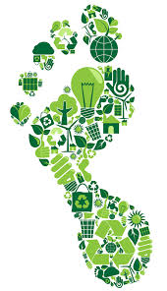
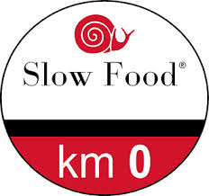
What is carbon footprint?

https://www.youtube.com/watch?v=DKDq1RMHscQ
https://www.youtube.com/watch?v=AGRlo87oAUg

A.- How do you say it in your Language?
B.-Let’s calculate your carbon footprint .
https://islandwood.org/footprint-calculator/
- How long do you spend in the shower?
- When brushing your teeth do you turn off the tap?
- How often do you flush the toilet?
- What kind of clothing do you wear?
- How do you get from place to place?
- After eating what do you discard?
- Where do you recylce or compost?
- How often do you trun off the lights when you leave home?
- How would you describe your eating hàbits?
- How much leftover food do you have after each meal?
C .-What’s your footprint score?
D.- What areas do you have to improve?
E.- What is ? What are slow food products?

D.- Give examples of Km0 or slow food products

E.-Let’s talk about one of these products.
