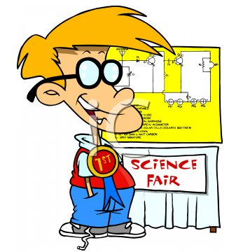
4th Science Fair Self-evaluation
Names_______________________
Answer the questions on the right. 1 is little and 10 a lot
Class
Experiment Name
Use of English while working | 1 2 3 4 5 6 7 8 9 10
Working athmosphere | 1 2 3 4 5 6 7 8 9 10
Would you work with the same people? | Why/ why not
Did you keep the schedule? | 1 2 3 4 5 6 7 8 9 10
Did you bring all the material? | 1 2 3 4 5 6 7 8 9 10
Experiment Success in class | 1 2 3 4 5 6 7 8 9 10
Experiment Success-Final | 1 2 3 4 5 6 7 8 9 10
Oral presentation in class | 1 2 3 4 5 6 7 8 9 10
Final oral presentation | 1 2 3 4 5 6 7 8 9 10
Did you do a good group work? | Why/ why not
Mark suggested for each membre
Which experiment, in your opinion is the best? | Why?
Any suggestion for next time?

Who did what?

