“Sharing my games”
eTwinning project evaluation

Theodora Chandrinou
Art Teacher and Artist
Θεοδώρα Χανδρινού
Εικαστικός, Ζωγράφος-Χαράκτρια

Η συμμετοχή μου στο έργο eTwinning “Sharing my games” ολοκληρώθηκε με επιτυχία, χάρη στη συνεργασία των μαθητών μου, από δύο Ελληνικά Σχολεία - 1^{ο} δημοτικό Σχολείο Πεύκης, Αθηνών και 4^{ο} δημοτικό Σχολείο Ζωγράφου, Αθήνας – με Σχολεία από άλλες χώρες. Η δραστηριότητά μας κάλυψε δύο Σχολικά έτη. Μέσα από το πρόγραμμα eTwinning επικοινωνήσαμε, ανταλλάξαμε εκπαιδευτικό υλικό, μοιραστήκαμε συναισθήματα, παρουσιάσαμε εποχιακές δημιουργίες. Αξιοποιήσαμε την τεχνολογία για την επικοινωνία μας, για την ανταλλαγή υλικού και την παρουσίαση των αποτελεσμάτων του έργου. Βοήθησα τους μαθητές να γνωρίσουν και να κάνουν χρήση της εκπαιδευτικής πλατφόρμας Twin space. Χρησιμοποιήσαμε διαφορετικά ψηφιακά εργαλεία web 2.0 και δημιούργησα εκδηλώσεις eTwinning για τη σύμπραξη μεταξύ των Σχολείων και τη διάχυση εκπαιδευτικών πρακτικών. Διδάσκω Εικαστικά και η συμβολή μου στο έργο βοήθησε τους μαθητές να προσεγγίσουν διαθεματικά τους στόχους του έργου. Πρότεινα δραστηριότητες για να εμπλουτίσω το έργο σχετικά με την αξία της Υγιεινής διατροφής στη ζωή. Είχαμε βιωματική και θεωρητική προσέγγιση. Η πρωτοτυπία των δραστηριοτήτων και η αποτελεσματικότητά τους κάλυψε πολλά επίπεδα: γνωστικό, μετα-γνωστικό, στην καλλιέργεια δεξιοτήτων των μαθητών σε ενδο-προσωπικό και διαπροσωπικό επίπεδο. Συνέβαλε στην απόκτηση νέων εμπειριών μέσω της Τέχνης και της επικοινωνίας, στην Αγωγή Υγείας σε θέματα διατροφής και πρόληψης βλαπτικών συνηθειών.

Εκ των αποτελεσμάτων είναι φανερό πως όλοι μαζί οι συμμετέχοντες στο πρόγραμμα eTwinning “Sharing my games” επιτύχαμε τους παιδαγωγικούς στόχους που θέσαμε. Οι ιδρυτές του έργου αποδέχθηκαν τις ιδέες που παρουσίασα με τους μαθητές μου και είχαμε γόνιμη συνεργασία, από την αρχή ως το τέλος του Σχολικού έτους.

Με τους μαθητές μου καταφέραμε την επικοινωνία και την ενεργή συμμετοχή με τους συνεργάτες. Συνέδεσα το έργο eTwinning με τα Εθνικά προγράμματα που υλοποίησα, και που παρουσιάσαμε σε ανοιχτές για το κοινό εκδηλώσεις και εκθέσεις Εικαστικών, καθ’ όλη τη διάρκεια του Σχολικού έτους. Υπήρξε ευρύτατη διάχυση των αποτελεσμάτων, στο ευρύ κοινό. Τα σχόλια που λάβαμε ήταν πάντα εξαιρετικά και οι μαθητές διασκέδασαν τη συμμετοχή τους. Καταφέραμε να λειτουργήσουμε, όλοι μαζί στο έργο, δημιουργικά, υπήρξε αλληλεπίδραση στις δραστηριότητες που υλοποιήθηκαν και διάδοση μηνυμάτων. Πρότεινα τη δημιουργία αφίσας και τη συμμετοχή σε μαθητικό διαγωνισμό. Είχα την επιμέλεια και παρουσίαση εκθέσεων Εικαστικής δημιουργίας στα Σχολεία, καθώς υπήρξε θετικότατη η συνδρομή των Διευθυντών των Σχολείων: 1^{ου} δημοτικού Σχολείου Πεύκης κ. Αθανάσιο Καραστάθη και 4^{ου} δημοτικού Ζωγράφου, κ. Κωνσταντίνο Πιτταρά στη διοργάνωση των εκδηλώσεων για την ανάδειξη των πεπραγμένων στην ευρύτερη κοινωνία.
Είχαμε την συμπαράσταση κι άψογη συνεργασία των Πρεσβευτών eTwinning και όλη της Ελληνικής ομάδας υποστήριξης. Συνεργάστηκα επίσης σε ομάδες eTwinning και μέσα από εκδηλώσεις έγινε διάχυση των αποτελεσμάτων του έργου. Βραβεύτηκα για τη δράση μου ως μέλος της εκπαιδευτικής κοινότητας eTwinning το 2018.

Ακολουθούν: περιγραφή και ο σκελετός του έργου, ενδεικτικές αποδεικτικές αναφορές με παραπομπές και αξιολόγηση. Είναι στα Αγγλικά αφού θα τα προωθήσω στους συνεργάτες του έργου και για διευκόλυνσή τους στη μετάφραση.

ABOUT THE PROJECT

The main idea of the project is that children be aware of the importance of their culture and other cultures and take contact with children of other nationalities, using as much as they can the english language.
For this reason, and related with our subject, Physical Education, we think that traditional games are a very interesting tool for interacting with other cultures. Our children could record a video explaining a game that we use to play in our city or country and make a demo playing it.

PROJECT LINKS/ ΑΝΑΦΟΡΕΣ ΣΤΟ ΔΙΑΔΙΚΤΥΟ ΓΙΑ ΤΟ ΠΡΟΓΡΑΜΜΑ

I have proposed activities and created twin space pages, for those.
Σχεδίασα δραστηριότητες και δημιούργησα twin space σελίδες, γι’ αυτές.

Results presentation – dissemination/ Αποτελέσματα παρουσίαση - διάχυση

# https://blogs.sch.gr/arteducate/2017/10/29/sharing-my-games-etwinning-project-2016-2017/

# https://www.youtube.com/watch?v=jTZzBef88zI

# https://padlet.com/arteducate/tlrcoys1ipvx

# https://twinspace.etwinning.net/33000/pages/page/279596

https://wordart.com/idgfyjl65dbu/sharing-my-games-etwinning-project-2016-17

https://www.slideshare.net/TheodoraChandrinou/helthy-mediterranean-diet-etwinning-2016-17

Easter creations – wishes exchanging/ Πάσχα – ανταλλαγή ευχών
#https://padlet.com/arteducate/vtw6jwr2w14n

# https://padlet.com/arteducate/5ha0xmakxdim

# https://www.youtube.com/watch?v=J5hkSAPUzLU

#https://www.youtube.com/watch?v=bx4JWSuWgN0
*

#https://wordart.com/idgfyjl65dbu/sharing-my-games-etwinning-project-2016-17

Our Twin space pages:

The project: Sharing my games

With Mrs. Anna Iosifidou we cooperated and created the twin space page to share ideas:

Physical Education - ideas sharing
And you can see the ideas I had for the interdisciplinary and cross curricular activities. For that reason I created the following twin space pages and invited pupils and Teachers to participate:

The name of our team!

Cross curricular approach among Schools

Interaction - Sharing emotions

Healthy Mediterranean diet through Art

Wishes for the new year!

Easter wishes!

Summer wishes!

Our project experience

Project evaluation

Results presentation - dissemination

PEDAGOGICAL INNOVATION AND CREATIVITY

Through the project, I tried to cultivate my pupils’ life skills, emotional intelligence and especially empathy. Through the Aesthetic values to achieve personal and social competences, the inter-connection with present life and healthy behaviors. To motivate pupils to become active and creative citizens, to create posters, exhibitions, presentations open to public, to achieve communication between the School and the public. During this School year I created other Greek National projects about Health prevention and I made a connection with this eTwinning project, through Art activities, sports, Healthy diet and Emotional Education.
I used experiential, group cooperative method in my teaching practice. I organized small and big working teams of pupils. Also children worked as individuals. Web research and ICT tools combined with Art lessons as an innovative and creative pedagogical practice. I applied transformative learning through Art and emotional education, project method and role playing, idea storming and storytelling, we were reading books and tails about healthy diet and emotional education.
With partners we used the safe Twin space platform and cooperated through this. Interaction and cooperation with other pupils under a common theme was the procedure used. Results shared via different ICT tools, on line and on site exhibitions and events took place. .
The eTwinning experience helped children in all aspects as the results testify.

CURRICULAR INTEGRATION

Aims:1. To Know the importance of our culture.2. To Be aware of the importance of different cultures.3. To use English language in a real context.4. To Share an international experience.5. To use cross – curricular approach.
Process: I created small and big working groups. In cooperation with the Teacher of Physics, I helped pupils to choose a game and prepare the class for explaining the basics rules of the game, trying that the maximum number of children participate in the explanation speaking English, then the teacher records them playing the game and giving their opinions about it and share it with the other school. The second part of the project was to watch the videos created by the children of the other schools, playing it and listening to their feelings about the game. After they proposed a new game and cross- curricular activities.. Results: Our main expectation was to participate in an international experience and try to enjoy it as much as possible. My pupils became more active and creative; we used Art as our vehicle, free artistic expression and emotional education. They learned, cooperated, participated and enjoyed their communication with other foreign Schools. The pupils made new friends, met interesting persons and exchanged ideas. They learned new Art techniques, to use different materials and to combine them (painting, computer design, posters creation).

COMMUNICATION AND EXCHANGE BETWEEN PARTNER SCHOOLS

I teach Fine Arts and with my pupils we used different art material and worked on cross - curricular activities. I taught them to use the safe twin space platform and created pages open to public. Presentations shared through twin space (events, mails, chat, forum, project diary, mail) eTwinning events, photo gallery, uploads in my eTwinning profile.
I encouraged my pupils to use internet exploring, by searching information, to create video and upload it to you tube, to present and exchange material. We participated in the activities that the other Schools created and we uploaded creations in folders and collaborated. I used finally, my blog in the Greek School net for results presentation – dissemination #http://blogs.sch.gr/arteducate/
Also me and my pupils we used many different ICT web 2.0 tools (google Earth, airpano, wordArt, padlet, slide share, pizap for our posters and painting program, word & PDF archives).
The School Head masters were positive and in the end of each School year Art exhibitions took place in the Schools and I was the coordinator. eTwinning Ambassadors and the Greek group supported us a lot during the project process.

COLLABORATION BETWEEN PARTNER SCHOOLS
We had a perfect contact, me and my pupils with the project partners. We collaborated with the pupils with success in many aspects, through the eTwinning platform. We were active from the beginning until the completion of the project. The Teacher’s bulletin and the project diary helped us very much. I combined Art, sports, health prevention sand emotional education. I was working with pupils during my Art lessons. I was in contact from the beginning with the founders and they invited me as project administrator. We used for our collaboration and interaction the twin space platform. I created folders to upload creations, to help partners share material and interact. Also, I used mail, eTwinning events to organize and present activities. I proposed activities and my ideas had been accepted by the project members, so, I organized project presentations on line and on site with seasonal themes and others, using ICT web 0.2 tools. We exchanged ideas and educational material, creations, photos, videos, archives, messages and emotions.The contact with different cultures and countries was a great experience for my pupils, as they evaluated the project positively and they loved all the activities .

USE OF TECHNOLOGY

I encouraged my pupils to use the twin space platform and taught them how to use it. I helped them to create account, and how to use and make twin space pages, to contact and upload materials.
I helped children to use internet exploring, searching information, to use You Tube, and to share videos, present and exchange activities. We participated in the activities that the other Schools created and we uploaded creations in the project folders.
For our communication with project partners we used the twin space platform: my profile page, pages, folders (to exchange material), mail, eTwinning events, project diary, Teacher’s bulletin, chat contacts, my Google account, You tube, gmail and the School facebook account.
Me and my pupils, invited in interaction the project partners through the eTwinning events and twin space pages.. We participated in all the project activities and we created pages open to public. Presentations shared through twin space (events, mails, chat, forum, project diary, mail), uploads.
We promoted the Greek Cultural heritage and patrimony through web links and activities. We used different ICT tools to communicate, produce and share creations among other Schools and abroad. Also, me and my pupils used: google Earth, wordArt, slide share, painting program and pizap for our posters, photo gallery word & PDF archives,
I participated in eTwinning events #https://live.etwinning.net/profile?v=events
And suggested the use of different ICT tools and padlet for the group cooperation among Schools and eTwinning events. We created posters for Safe Internet Day and to promote Health education. We participated in the School celebrations and in open to public events and final School sports activities took place. We awarded our pupils.
The School Head masters od the 1st pr. School of Pefki, Mr. Athanasios Karastathis and of the 4th primary School of Zografou, Athens, Greece Mr. Konstantinos Pittaras supported us. Mr Pittaras uploaded in the School facebook page our project video about health education. Invitations, activities and announcements were also visible for results presentation and dissemination and I used my blog, in the Greek School net #http://blogs.sch.gr/arteducate/

RESULTS, IMPACT AND DOCUMENTATION

#https://blogs.sch.gr/arteducate/2017/10/29/sharing-my-games-etwinning-project-2016-2017/# From the results is visible the success of the project and aims fullfield. Results were presented in open to public Art exhibitions June 2017 and 2 & 3 of June 2018, eTwinning events and announcements were sent in digital form, posters and invitations printed. We received enthusiastic comments, through social media and in personal contacts with the pupils’ parents, Teachers, the local community and the public.
My pupils cultivated athletic skills, communication and cooperation increased. They gained benefits in personal and social skills and especially those with low self-esteem became better, in other subjects. They improved English language and cultivated Aesthetic values. They became active and creative through cross curricula activities. ICT tools, web 2.0 embedded in the Art lessons and this was very important. The pupils learned more about other countries and their customs, searched for more information about Cultural heritage.
Open to public exhibitions and videos were shared. I have given links to activities documentation, relating to the planning, progress and outcomes. I created open to public web pages – in my blog and twin space. Dissemination and impact to the society was achieved through the Art exhibitions and projects presentation events, open to public, presented on site in the1st primary School of Pefki, Athens, Greece and the 4th primary School of Zografou, Athens, Greece. The School facebook page of the School was used for announcements.

OTHER AWARDS

* My pupils of the 1st primary School of Pefki, Athens, Greece received awards for their participation in the “40th children’s festival with the title” The world through the eyes of the children, organized by the Municipality of Pefki –Lykovrisi, Greece.
* In the 4th primary School of Zografou, Athens, Greece, the pupils received awards for their successful participation in the School Handball championship. They received their medallions, in a public ceremony Teacher of Physical Education: Dimitrios Tsitos.
*In the 4th primary School of Zografou, Athens, Greece I was working, from the beginning until the end, in order to achieve the “eTwinning School label” award, with success.
* I received the “Awarded eTwinner” recognition.

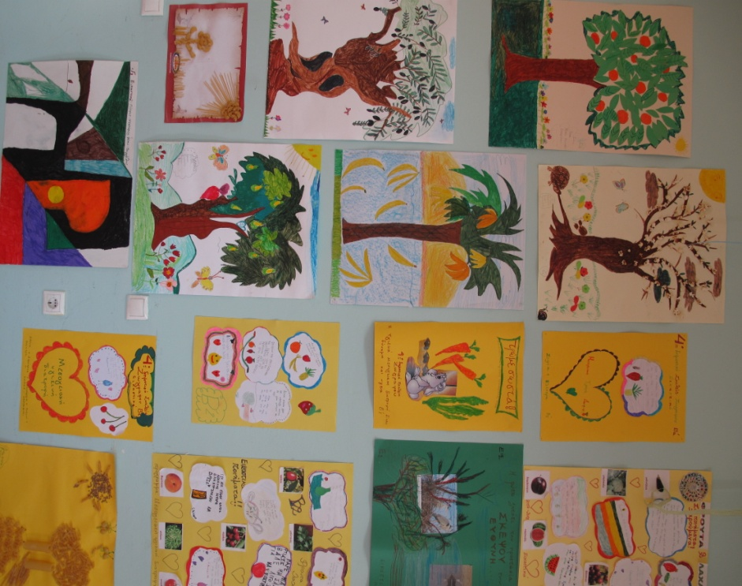
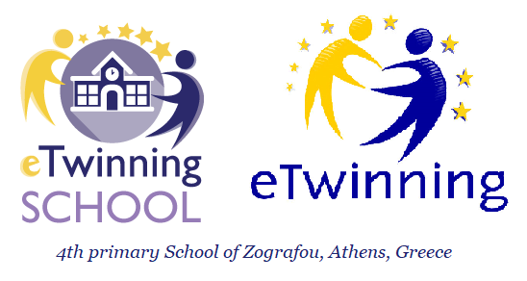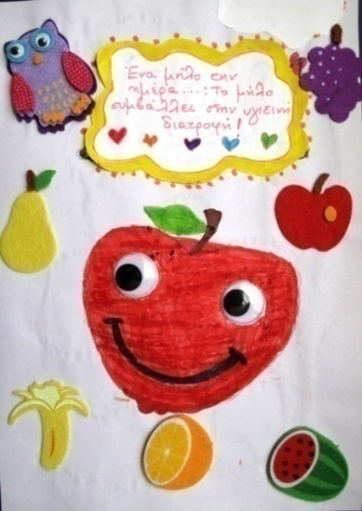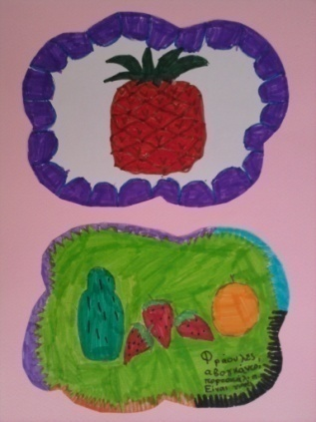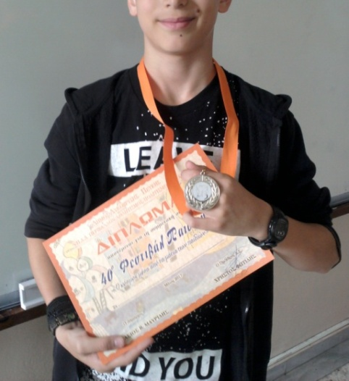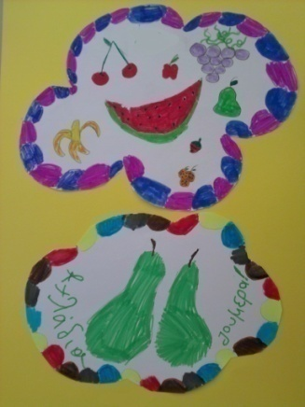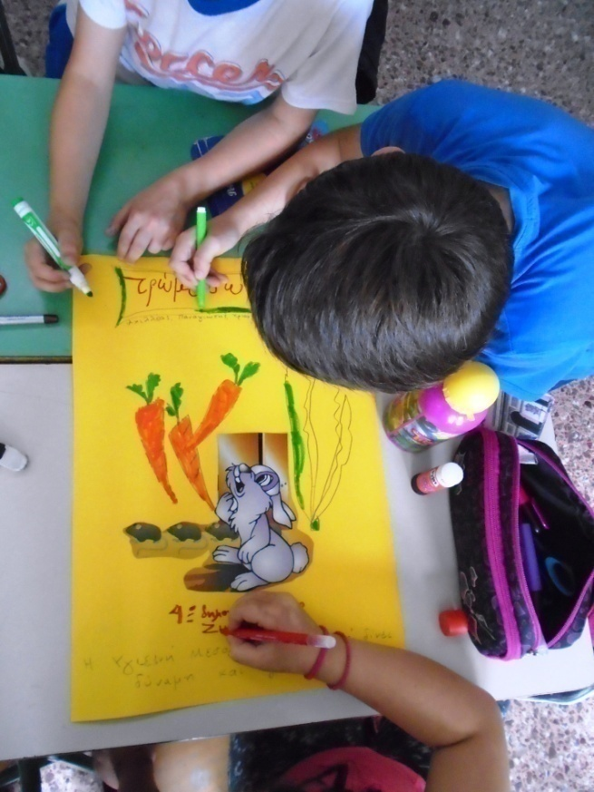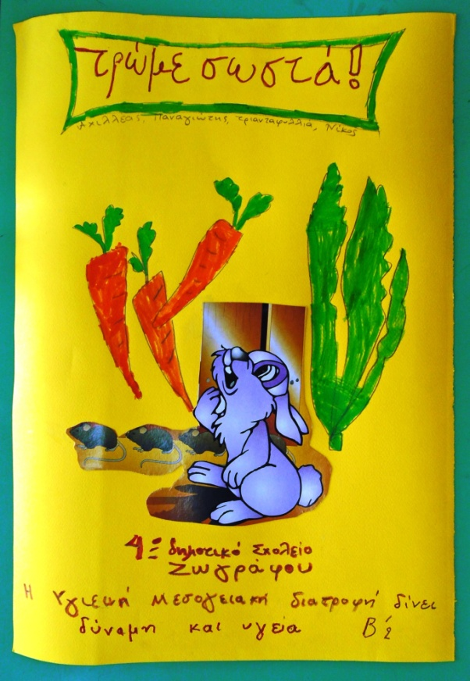
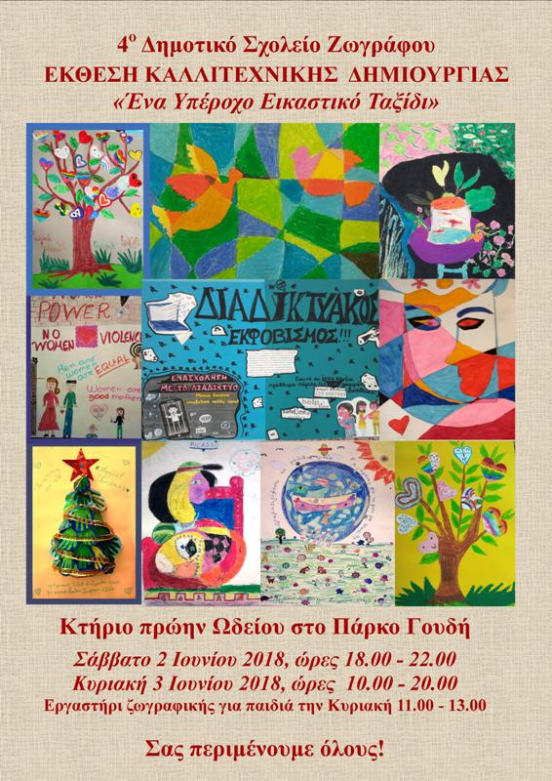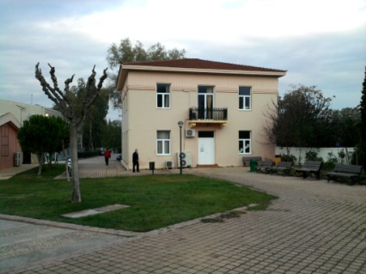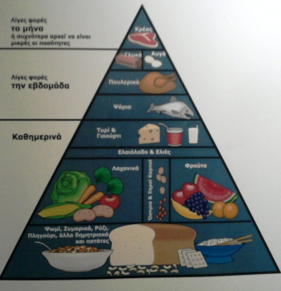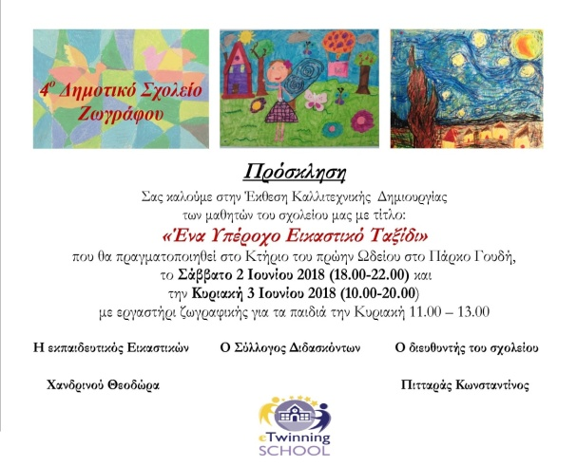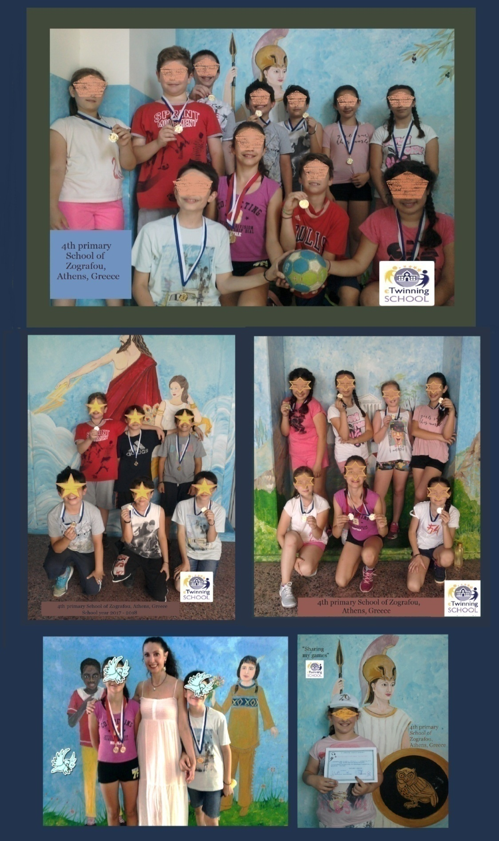

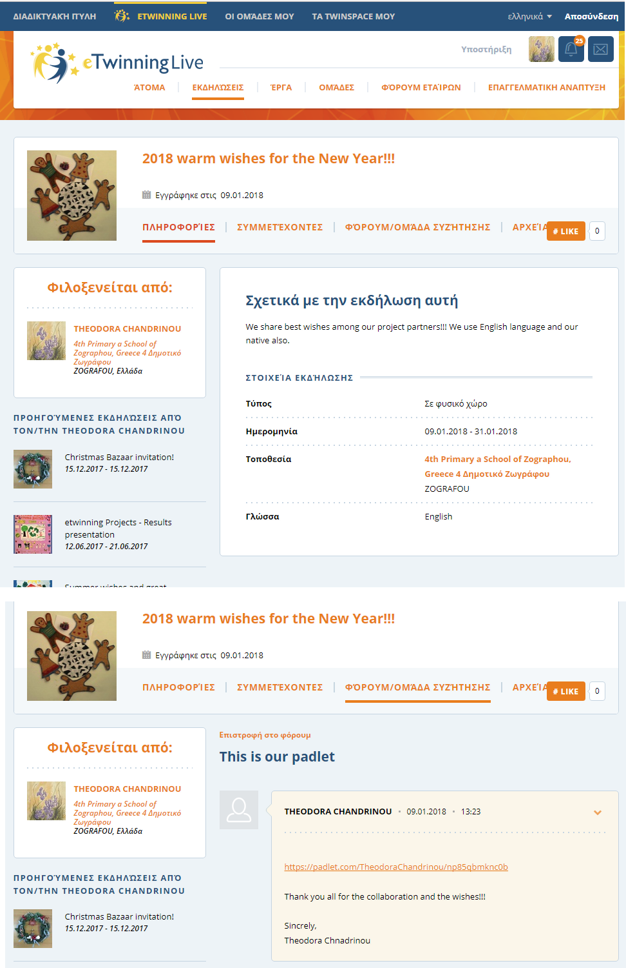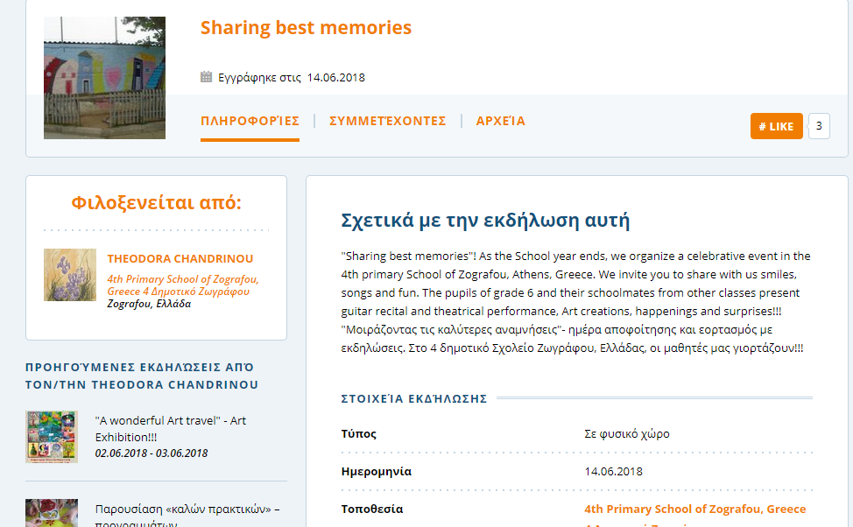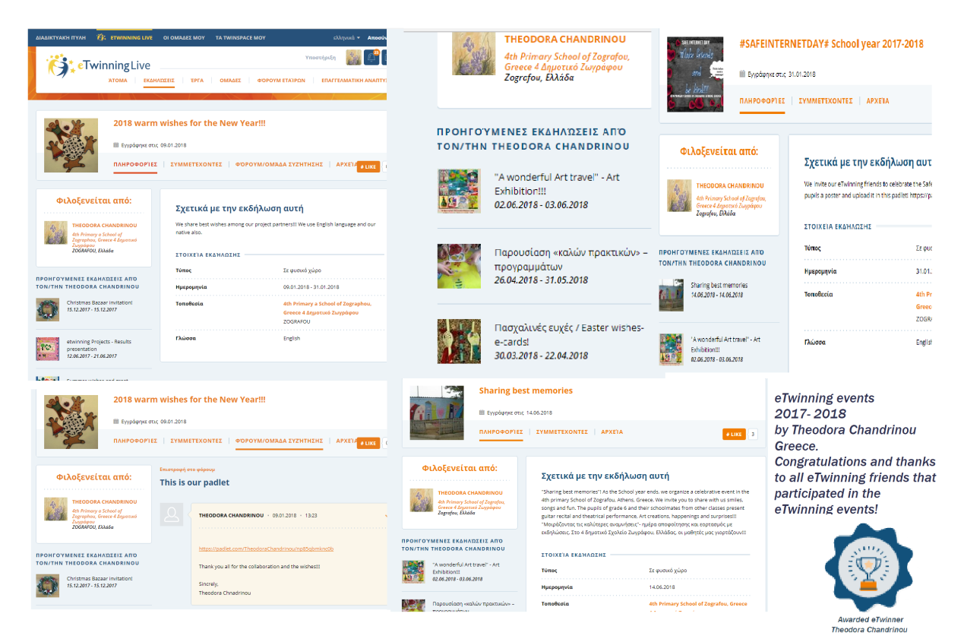
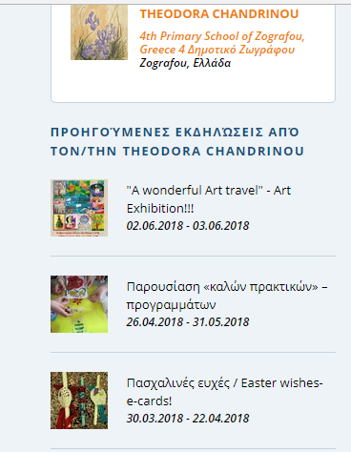
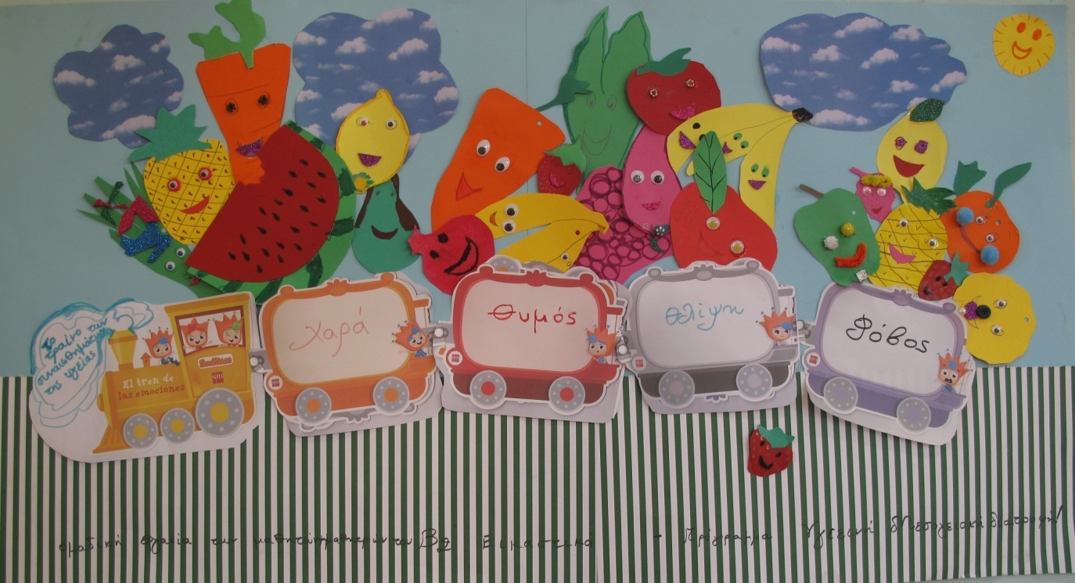

Congratulations!!!

