How Do I Tell If a Mushroom Is Safe to Eat? Parasols. The first thing for even an amateur mushroom hunter to remember is to avoid parasol-shaped mushrooms, or mushrooms that look like wide-open umbrellas with white rings around the stem and white, milky gills. These mushrooms, especially brightly colored and spotted parasols, may be Amanitas, mushrooms full of one of nature's deadliest poisons. False Morels. Another type of mushroom to avoid are so-called "false morels." If you see a mushroom with wrinkled, irregular caps that look like brain coral or saddles, with a bottom edge that hangs free around the base, avoid it.
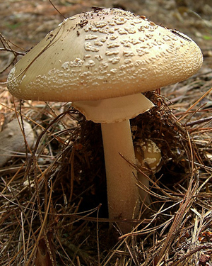
How Do I Tell If a Mushroom Is Safe to Eat? Others. This list is hardly exhaustive, but over at the Missouri Department of Conservation's guide to poisonous mushrooms, they list a few more, like the sweet-smelling Jack O' Lantern and the catch-all "Little Brown Mushroom" that's hard to distinguish. They point out that experienced mushroom hunters will be able to tell the non-poisonous false morels from the dangerous ones, and some of them are only poisonous if you have an allergy to them, but many are best to avoid entirely if you're out camping and want to try your hand at foraging. Photo by Dan Bennett.
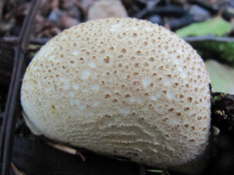
How Do I Tell If a Mushroom Is Safe to Eat? Puffballs. Round, fluffy, and often large, the puffball is the quintessential safe-to-eat forest mushroom. They can be anywhere from an inch to 12 inches in diameter, and grow in late summer and fall in soil or on decaying wood. They're particularly good fried or deep fried, but you should slice them open to inspect them first, just to make sure they're not young parasols. Photo by Leonora Enking.
Oysters and Chantrelles. Often found in fancy dishes, Oyster mushrooms and Chenterelles are fairly easy to identify in the wilderness, or to grow yourself. Oysters are always white or ivory colored, soft to the touch, and are usually found in clusters growing on wood, usually during warmer months. Chanterelles on the other hand are trumpet-shaped mushrooms with wavy caps and irregular edges. Take care to inspect the gills on the bottom: some are smooth, others have wrinkles that go all the way down the stem, but none have sharp, jagged gills. If your chanterelle is tall with jagged gills, it may be a Jack O' Lantern, which is poisonous. If you're not sure, leave it alone.
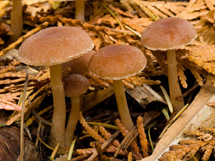

How Do I Tell If a Mushroom Is Safe to Eat? Hen of the Woods. Also known as Maitake, these mushrooms are easy to identify because they're vaguely round and look like an angry chicken with ruffled feathers. They have brown, fan-shaped caps that overlap one another. These mushrooms can grow remarkably large, up to 100 lbs. Break off the soft and tender parts for a treat that can feed you for days. Best of all, like Puffballs, the Hen of the Woods has no look-alikes that are poisonous, so if you see one, it's a relatively safe bet.
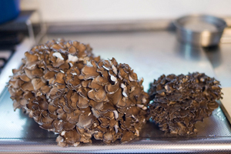
Others. This list isn't exhaustive either, especially depending on where you live. There are plenty of others that grow all over North America and Europe that are easy to identify and are equally delicious. For example, the Shaggy Mane or the Bearded Tooth are all excellent candidates as well with few or no poisonous look-alikes. A book or a guide. If you're interested in foraging for mushrooms, there are a number of great books to take with you, including Mushrooming Without Fear, A Field Guide to Mushrooms, Simon and Schuster's Guide to Mushrooms, and the Audubon Society's field guides. If you're headed out on your own, make sure to do plenty of research and go armed with an illustrated book to help you identify before you start plucking and eating.
