A sample card : geography (my country)
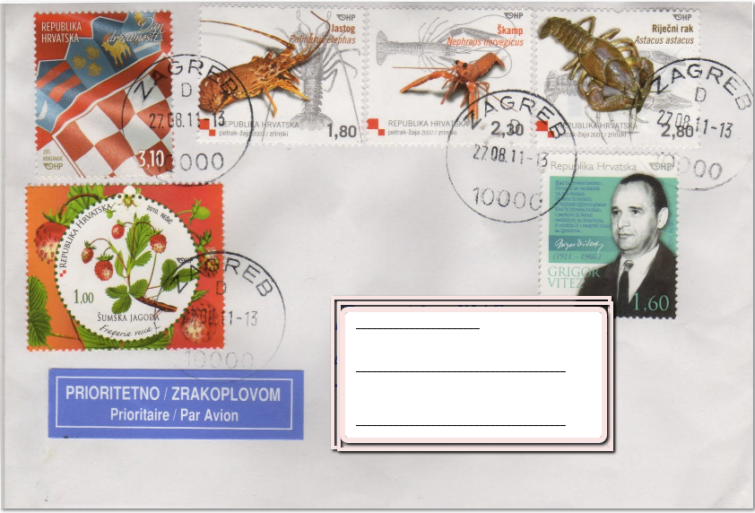
__________________________________________________________________________________
One sentence regarding the each postage stamp information on geography ( choose five /5 postage stamps )
Hi!

1----------------------------------------------------------------------------

2..............................................................................................................

3.----------------------------------------------------------------------------

4.-----------------------------------------------------------------------------

5.-----------------------------------------------------------------------------

Bye to you! Thank you for your lovely cards. Now I know more!
(name)

