Work-Life Balance.

Answer the following questions for yourself in writing:
- How many hours a week would you like to work?
- What is your place of work / office going to look like?
- What other options are there to office work?
- What could work-life balance mean?

Read this article
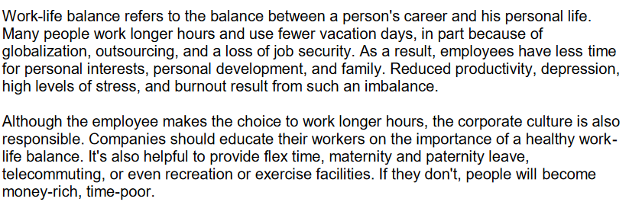
http://www.headsupenglish.com/lower-intermediate/minilessons/worklifebalance.pdf [8.10.16]
Were you surprised by the information in the article? Why (not)?

Discuss the following working styles in groups of two and write down, what they could mean:
- telecommuting
- freelance work
- home business
Read the text on the next page.

Finish:
Would you prefer any of the possibilities away-from-work, or would you like to work 40 hours/week in an office?
Can you think of situations when you might prefer any of the new working models?

