Group competition
The same time table
The school starts at 9 and finish at 1 or 2.The breaks will be 5 minutes between lessons and after the third lesson there are 20 or more for lunch.
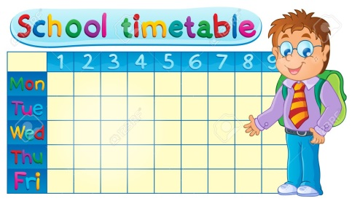
More sport
the school must have a competition between other schools or classes or towns but only if you choose more sport lessons. You can also choose the type of sport you want to play. If you are good at sports you will get some kind of stipend. Sport teacher should train their team.
More practical class
the practical classes will be useful because if you are in school where you have a profession you must go to a real place where you can practice what you have learned at school because in school is different than work in real place.
How to spend money
We should have a lessons about finances twice a week because it will be more useful than the thing we learn and forget after we graduate.
How to raise the children, having up children
We should have lesson about having a family twice a week only in the last year of the high school, because once we raise kids or have a family we must be prepared.
Choose teacher, subjects
The student will have classes with different teachers every time and in their second year they will choose the teacher that will teach them. The student will also be able to choose their subjects after their first year , because in their first year they got to know the subjects that they can learn in the future.
More presentations
the students will pay more attention to the teacher. It’s more understandable and also students have to do the presentations. The students will also make presentations and they will teach their classmates.

Invite more successful people
These people can talk about their experience, about their life and they can give the students advices and also motivate them.
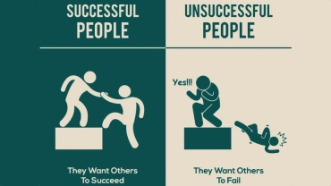
Always have a second chance
If a student have a bad mark he always can try again to correct his mark. It’s not only about the final but for all the tests.
Teacher should have bigger salary
They should have a bigger salary because they will have a better motivation and they won’t be in a bad mood every day.
Coaching
If the students are not good at school the teachers should give them a private lessons to improve their marks.

