Christmas in Bulgaria
Christmas is very important custom for Bulgarians, because we celebrate the birth of Jesus Christ. We celebrate Christmas on December 25. Bulgarian Christmas is full of customs and traditions that make this time of year special for those who maintain them. Here are some of them:
The Christmas Eve
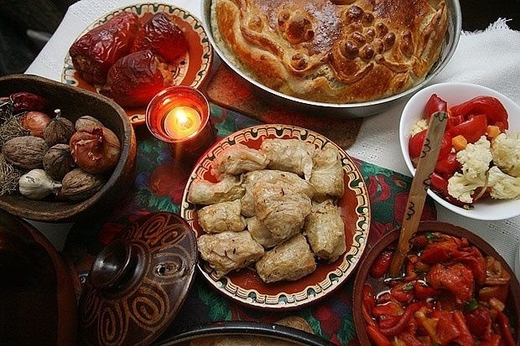
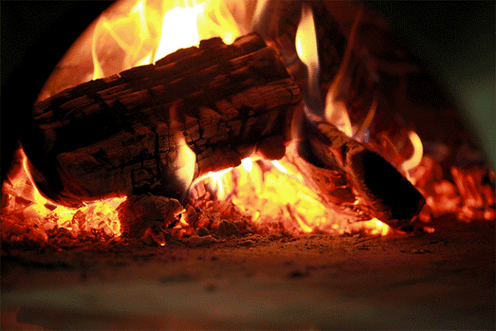
Christmas Eve or badni vecher is just as important (in some minds even more important). It's the last day of fasting for Advent and, like so many Slavic cultures, an odd number of meatless dishes are served at a grand meal. A budnik or ceremonial log is brought into the house and set alight in the fireplace.

The Ritual - Survakane
Today, Christmas is still a very special family holiday in modern Bulgaria. In the cities, the Koledari tradition is not followed as strictly as in the villages. However, city dwellers should not be surprised if kids (Survakarcheta) knock on the door after midnight on Christmas to sing a song, wishing happiness, love, health and wealth during the coming year.
