Changes in school system

Timetable
The school should start later, because it is easier to get up when the sun is shining, the students sleep more so they are more mentally prepared for the school lessons.
It is said that the teenagers should have at least 10 hours of sleep to be productive during the day.
That could help the students who live far away, because they don’t have to get up that early.
The school finishes later (for example: 4 or 5 pm).
The point of this idea is for the students to get more sleep, so that they could be more concentrated in school.

Curriculum
The school should have gap days. (For example: there is a gap day every third day.)That would be good for the students, because they will not be tired and it would be less stressful and they will not be pressured.
The difficult subjects (Maths, foreign language, Physics, Biology, Chemistry) should be separated (one difficult subject per a day).
There should be easier exams that should be in a form of games, so they would not put so much pressure on the students in primary school, but it is a great way to test the student for their knowledge .
The students should have the opportunity to choose what they are going to learn. There should be different schools (Professional schools, Art schools and Sport schools), in which you will learn only what you will need.
The first years of high school the student should learn a little from everything and then they should focus on the things they will need.

Classroom
Every classroom should have its own sitting plan(the students should sit around the teacher, because they will have better outlook for eachother).
Every classroom should be equipped with tablets and smartboards.

Activities in school
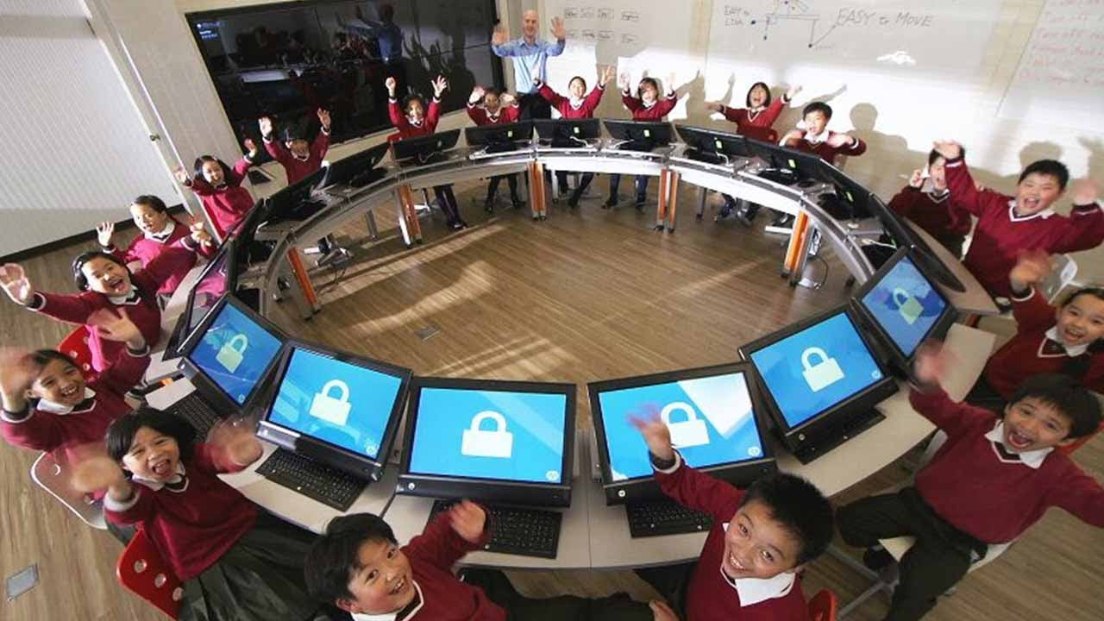
The school should organize more events ( e.g Sport events, Going to the theatre/cinema), where students could get together and enjoy what they are doing.

Source : https://i.ytimg.com/vi/mPUfwX4Nqy8/maxresdefault.jpg

