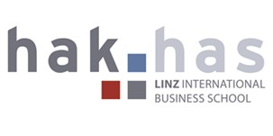
Linz International Business School
Rudigierstraße 6
4020 Linz

26 January 2016

P-eko, d.o.o.
Prešernova c. 6
1000 Ljubljana

Dear Mrs Stanković

Inquiry

We acknowledge with thanks your letter form 5 January 2016.

We should be pleased if you could send us an inquiry of Slovenian food, maybe with recipes. We are interested in delicious food of Slovenia, most in meat.

We would like to offer also vegetarian food. Do you have any specialties in your country, which we could use for our meals? If you offer some vegetables that we don’t have in Austria, we are allowed to order a large amount of them.

We wanted to know what kind of cheese you use for the grilled vegetarian toast and if the cheese is deliverable also the figs because we are also interested in the wheat bread with curd and figs. Would you like to reveal us the recipe?

Please send us your terms of delivery and payment.

We shall be grateful if you could answer our questions promptly. We are looking forward to doing business with you.

Yours sincerely

Julia Lackner

