To built a huge shopping mall on the area of existing local green park with a playground for children, or not?

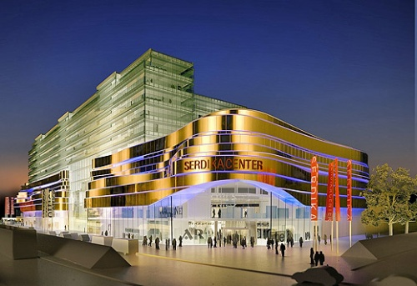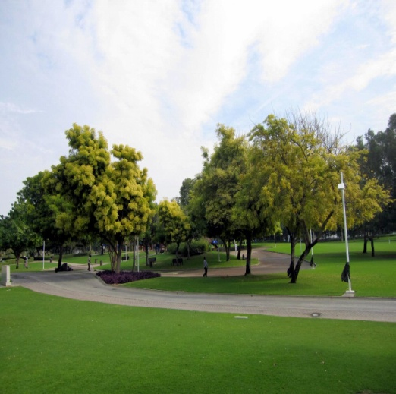
Politicians
Your pros:
- new investors in town, new job opportunities, several services, restaurants, cafés, shops, cinema, gas station, parking place, ...

Citizens, common people
Your task:
- UNEMPLOYED: some of you are unemployed and there are good new job opportunities for you, you can use several services, restaurants, cafés, shops, cinema in your free time, gas station, parking place, ...
- PARENTS: your children lost their place for playing and to be on the fresh air in the park
- GRANDPARENTS, RETIRED PEOPLE: you lost your place you used to spent with your friends, grandchildren, walking with your dogs, sitting on the bench and breathing the fresh air

Experts
Your pros:
- importance of new investors in our town, importance of new job opportunities, several services, restaurants, cafés, shops, cinema, gas station, parking place, ...
- children and ordinary people lost their green place for relaxing and sporting activities
- research, survey and study is needed
Greens
Your pros:
- children lost their place for playing, older people lost their place to be on the fresh air and have a walk, people lost the place of relaxing, less oxygen in the air, less green place, more emissions and engine exhaust gas in the air, more contaminated air, ...
Sportmen and sportwomen
Your pros:
- the loss of green places for sporting activities on the fresh air – running, jogging, basketball, volleyball, yoga, relaxing, handbal, team- and individual activities...
News service – TV, press
Your task:
- make notes about today´s news: discussion of politicians, greens, experts, sportmen and sportwomen, citizens...
- give a short output to the audience about this problemacy and all arose results, findings, opinion and enclosures of today´s meeting

