CHALLENGE
„How to attract Chinese tourists to Tábor”

There are a lot of Chinese tourists in the Czech Republic but unfortunately not so many in Tábor. And because of that, we would now like to propose some solutions to make Tábor more attractive for Chinese tourists.
At the end of March 2016 Chinese president came to visit Czech Republic and discuss some political and business issues with the Government of the Czech Republic. One of the topics was improving air lines between these two countries and therefore a direct air line between Prague and Beijing was established. This improvement makes it much easier for us to travel.
Chinese tourists visit he destinations in big groups and they like to take a lot of photos. Young Chinese like to organize the trips and they like to fill their leisure time with organized activities. More and more Chinese people discover other cultures by travelling abroad.

Main ideas for the improvement

- Interaction with Chinese travel agencies and websites
It would be a good idea for Tábor to interact with China and give them the opportunity to discover the history and interesting sights and places in this town. It would also be good to provide information about local hotels, restaurants and shops. Chinese people often travel to Prague so there could be someone to tell them to visit Tábor and for example, when they are on the way to South Bohemia, they could offer a trip to České Budějovice too because both of these cities might be an interesting place to see.
- Educational summer camps
This would be a good occasion for Chinese tourists to learn about Czech habits, culture, language, food, art etc. It could be fun for Chinese to for example learn how to dance Czech dances, sing songs, make traditional products from ceramics and so on, because they are really interested in art it could be a relaxing and interesting vacation for them.

- Organised guided tours
There are no special guided tours in Chinese language these days. To see and enjoy the town in their own language so they can focus on sights and not have to pay attention to foreign language.

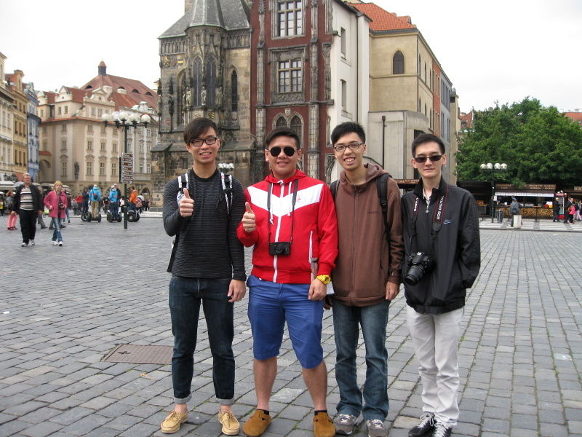
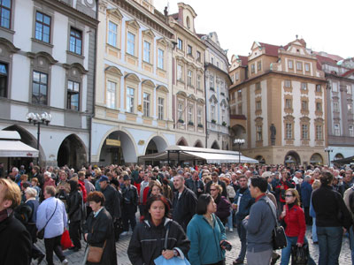

- Yoga zone
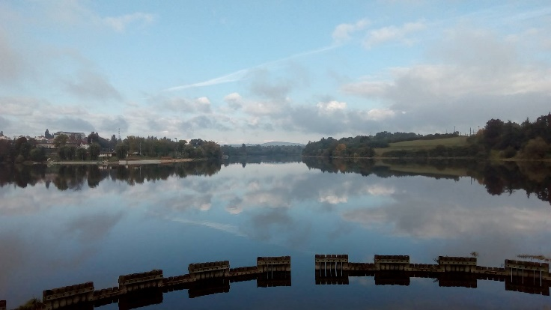
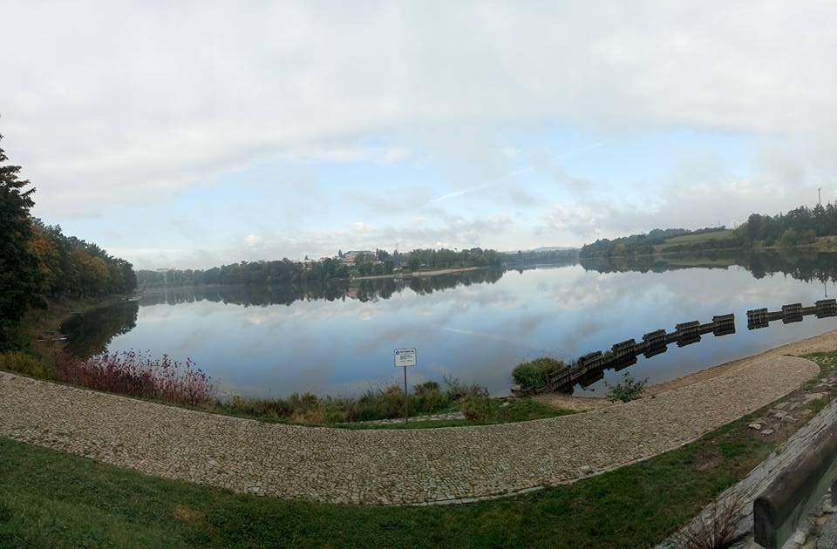
It is known that Chinese people work a lot which means they also need to relax enough. Maybe they would like to relax in the nature and for example the Jordán lake might be a perfect place for that and it also may provide new workplaces in Tábor.
- Every year’s art competition
Tábor could organize drawing competitions where talented tourists, not only Chinese could show their skills. This project might take part every year because it could be an event that brings a lot of attention.
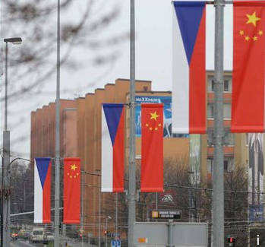

Resources:
https://www.bing.com/images/search?q=chinese+art&view=detailv2&&id=BD83DC9B169A41363661D1C0CED1FE0CA2D7F16F&selectedIndex=22&ccid=%2bMcpK9ZK&simid=608021105191358460&thid=OIP.Mf8c7292bd64ab3d7953907b6af57de58o0&ajaxhist=0
https://www.bing.com/images/search?q=chinese+art&view=detailv2&&id=9B7EF27EF558ED084784E6DBA4DB8F1E974C54FF&selectedIndex=6&ccid=JbLHjRo%2f&simid=608018085832820276&thid=OIP.M25b2c78d1a3f8e97e2b72c76a8738eadH0&ajaxhist=0
https://www.bing.com/images/search?q=chinese+tourists+&view=detailv2&&id=43E9B91A3110E2F32CAEBB111298AC4E4D03EB83&selectedIndex=28&ccid=unMdswAO&simid=85345377971&thid=OIF.oV2PDU0ecaSEek5tEWxqEw&ajaxhist=0
https://www.bing.com/images/search?q=chinese+tourists+&view=detailv2&&id=73D5A2C971C4C16C702A530DA535DE1972210457&selectedIndex=35&ccid=DbhmSyRz&simid=608034157596118158&thid=OIP.M0db8664b24735f2b822af3d55d457a37o0&ajaxhist=0
https://www.bing.com/images/search?q=turiste+staromak&view=detailv2&&id=33375FCDA9539CECCBAA86BE939A8230B6238FD1&selectedIndex=3&ccid=BSdZ9jif&simid=608034647228550118&thid=OIP.M052759f6389f1908b67e793c7ee38c73o0&ajaxhist=0
https://www.bing.com/images/search?q=turiste+cinsti&view=detailv2&&id=1BE139092515022CA5BBE2B909468E4817CF2F07&selectedIndex=2&ccid=CreMK%2bqi&simid=608029038008664682&thid=OIP.M0ab78c2beaa2279577800ee24d026c60o0&ajaxhist=0

