Developing communication skills for job interviews

1a Look at these pictures. Which attributes do you think help people most to get a good job?

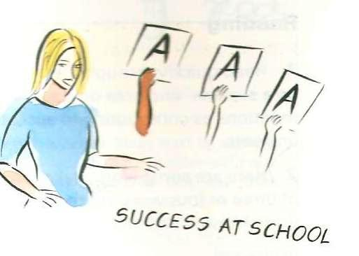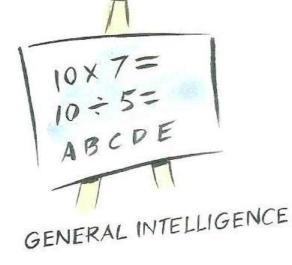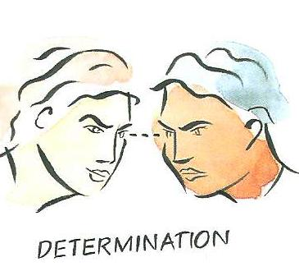

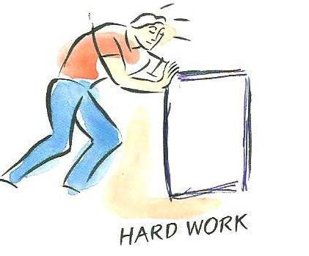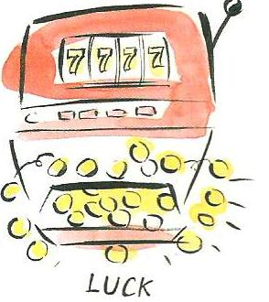

1b Read the advice below about going to a job interview. What does it say about the following areas?

Research

Attitude

Skills and qualities

Questions

The perfect interviewee
As the person applying for the job, you need to do your research before the interview. Check the company’s website, read recent news about the company. During the interview, try to show you have done your research as it means you are serious about the position.
Most interviews have similar questions (e.g. Where did you see the advertisement? What experience do you have? Where have you worked so far? What qualities make you the right person for the job? Why do you want the job?). Think carefully about what quesions you will be asked and prepare positive answers in advance. Be clear about what strengths, skills and qualities you have. If you need to discuss any challenges or weaknesses, then explain how you want to overcome them. In
general, try to present a positive version of yourself. Dress well, try to relax, maintain eye contact, and be friendly and enthusiastic.
Finally, prepare questions which you would like to ask (e.g. What is the starting salary? What hours do I have to work? When can I start?) Remember that good questions will demonstrate that you have done your research and have thought carefully about the requirements of the job.

- Read the job adverts below. Then read and listen to the dialogue. Which job would suit Emily best?

- Confident, enthusiastic assistant bartender required for hotel on outskirts of town. Hours: 18.00-20.00 Monday to Friday. Experience not required. £7 an hour
……………………………………………………………………

- Waiter/Waitress needed for our new café. Hard-working and energetic, you will join our friendly, young team. Must enjoy dealing with customers. Shift work (lunch or dinner). £7.30 an hour plus tips

Manager How did you find about the job?
Emily I saw it advertised on a recruitment agency website.
Manager You’ve worked in catering before, haven’t you?
Emily Yes, I have. I used to help out at my uncle’s restaurant.
Manager What did you do there?
Emily First of all just washing up in the kitchen. But then I took orders, and served food and drinks. Occasionally I answered the phone and took reservations.
Manager Did you enjoy the work?
Emily Yes, I did, though it was very tiring on busy nights.
Manager And you worked there for about a year, didn’t you?
Emily Yes, about a year, part-time.
Manager I see. And why do you think you’re the right person for this job?
Emily Because I’m hard-working and reliable, and I enjoy dealing with the public. I’m also good at working in a team.
Manager Well, thanks for coming in, Emily. We’ll be in touch before the end of the week.

- Check the meaning of these words. Which qualities did Emily mention?

Qualities needed for jobs:
- confident (having a feeling of belief that you can do something well or succeed at something)
- co-operative (working or acting together with others for a common purpose)
- creative (showing an ability to make new things or think of new ideas)
- determined (having a strong feeling that you are going to do something and that you will not allow anyone or anything to stop you)
- energetic (having a lot of energy; active)
- enthusiastic (feeling or showing strong excitement about something)
- fit (being healthy and strong)
- flexible (able to change easily according to the situation)
- hard-working (using a lot of time and energy to do work)
- polite (showing good manners and respect for other people)
- reliable (can be trusted)
- self-motivated (ability to do what needs to be done without influence from other people or situations)
- thoughtful (serious and quiet because you are thinking)
- trustworthy (someone who is honest who can be entrusted with your secrets)

Which qualities are important for these jobs?

architect …………………………..................................................................
banker …………………………………………………………………………..
chef …………………………………………………………………………..
farm worker …………………………………………………………………..
police officer …………………………………………………………………..
receptionist ……………………………………………………………………...
It doesn’t matter if you are not very…

To be an architect you need to be very/quite….

- Listen to the interview for a summer job. Which of the jobs in exercise 4 is it for? ……………………………………….

- Listen again. Number the questions in the order that you hear them. How many answers can you remember?

a What kind of things did you do?
b You’re in good physical health, aren’t you?
c When can you start work?
d You live locally, don’t you?
e Have you got any experience of this type of work?
f Why do you want this job?
g Why do you think you’re the right person for this job?

- Read the following comments by candidates in interviews. Match the personal qualities to the comments.

ambitious enthusiastic reliable flexible decisive determined hard-working creative

- My last manager trusted me and let me deal with clients on my own.
……………………………..
- I like to think that I always start any new task with a positive attitude and a smile.
……………………………..
- I am able to make tough decisions when I have to.
……………………………..
- I think it’s important to achieve your aims and I always try my hardest to make sure this happens.
……………………………..
- I suppose in two or three years time I would hope to see myself promoted to a higher position.
……………………………..
- I am able to work with most people and adapt to different working environments.
……………………………..
- I don’t mind working late or working extra hours when there’s a lot of work to do.
………………………………
- I have been told that I’m pretty good at coming up with new ideas.
…………………………………

