Bulgarian Christmas traditions and customs
On Christmas Eve everyone are happy because of the many presents and delicious food. That’s why Christmas is my favorite holiday. We also esteem the night before Christmas. In Bulgaria we have many interesting Christmas traditions and customs. I will show you some of them.
Survakane
One interesting our tradition is called “Survakane”. This is ritual for health and wealth for the coming year. The children beat the back of all family members with “Survachka” and wish them luck and health. The “Survachka” Is made by three and is decorated with white yarn popcorns, dry fruits and nuts. The family members give to the children money and treats. 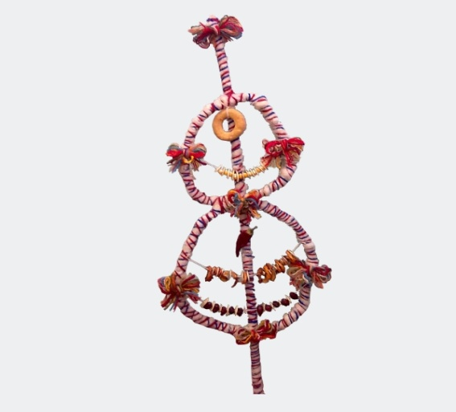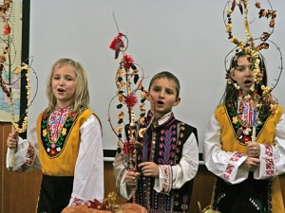
Budnik
In my village we have a tradition to put a big wood in the fireplace called “Budnik” on the night before Christmas Eve. The tradition says that if the wood is still burning on the morning the next year will be good and successful.
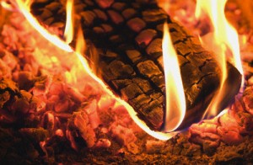
The meals
The meals should always be an odd number, and with no meat. We prepare 7, 9, or 11 meals. All of them are vegetarian as it is the last night of fasting. Usually we cooked beans, rise and spices wrapped in cabbage or vines leaves called “Surma”, salads and most important the Christmas “Pitka” with a coin for luck, or “Banitza” with small notes with wish of good luck and health.. We have a special compote from boiled dried fruits /plumps, apples, pears and apricots with lemon and spices/. And lots of nuts, pop corn and fresh fruit. For a dessert we have fruits and a kind of pastry soaked in a very sweet syrup called “Baklava”