Bulgarians celebrate Christmas on December 25, though this is somewhat unexpected because Bulgaria is an Orthodox country. The traditional Eastern Orthodox celebration of Christmas lands on January 7. Bulgaria's Orthodox Church follows the Gregorian calendar, which means its religious observances are in keeping with those in the West.
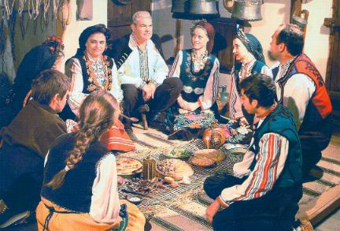
Christmas in Bulgaria is a joyful holyday. Many people and children look forward to this celebration. It's one of the most favorite holidays for children because they get many presents. For adults, mothers, fathers and grandparents this celebration is time to visit their friends and families.
During the Communist era, Christmas was not celebrated openly as a religious festival because Communist doctrine barred the following of a religion and celebrations tended to centre around New Year‘s Eve rather than Christ's Birthday. After the fall of the Communist regime, Christmas was "reinstated" as a religious festival.
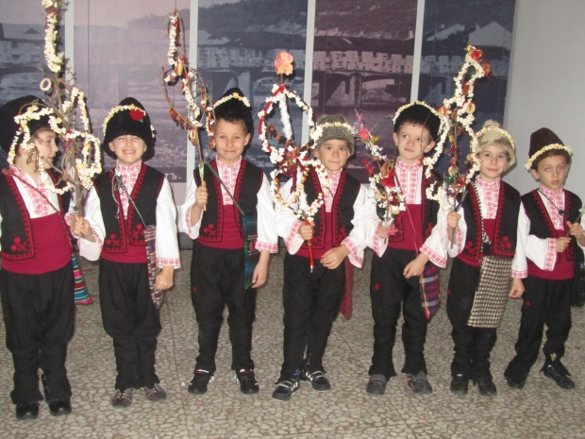
The Christmas traditions are an integral part of the festive season and these typically include fasting, enjoying special meals, attending church and singing carols around the village. Families also get together and decorate Christmas trees with curios. The young men in Bulgaria parade around and sing Christmas carols for random strangers. Family togetherness is also an important aspect of Bulgarian Christmas traditions. Not only do they get together and dine, but they also partake in the 'Survachka'. The Survachka is a tradition where the younger members of the family such as children and grandchildren, pat the elders on their backs/heads while making wishes for their health and prosperity. The patting is usually done with a stick and is signifies good times to come the following year.
Bulgarian Christmas Eve is celebrated with a feast consisting of an odd number of dishes leading upto the forty days Advent fast. On this day, no meats are consumed and the meals are vegetarian. These meals include pulses, grains, vegetables, nuts, wine and an exotic array of fruit. Walnuts, in particular, are a Bulgarian Christmas must-have on the feast table. Another essential component of the Bulgarian meal is a loaf of bread and the 'Banitza', into which a coin is baked. Anybody who finds the coin is believed to be rewarded with good fortune. On this day, the family gathers around the table and eats their food on straw.
Made by: Kalina Pekova

