Bulgarian Christmas Traditions And Customs

Christmas is a holiday that everyone loves. On this day the whole family is together and there are many presents and lots of food. On Christmas in Bulgaria we have some traditions. Here are some of them.

“KOLEDUVANE”
At midnight on Christmas Eve before Christmas started the custom “Koleduvane” - winter ritual for fertility, health and good luck. In this custom participate young men - soon married, engaged or bachelors. They are called “Koledari”.
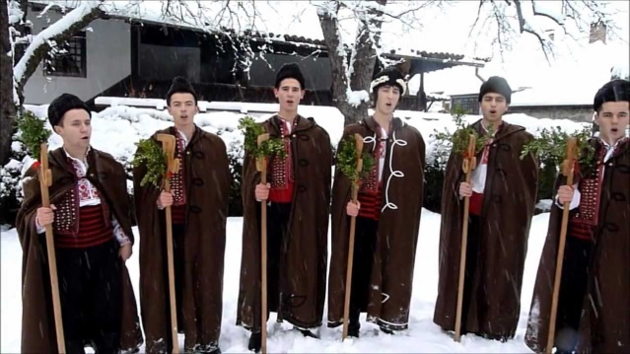
The “Koledari” are singing on the road in front of the door and into the house. Ritual songs they perform are different depending on the place in which they are and the man they sing. They sing songs to each family - from the oldest to the youngest. With songs the “Koledari” wish for a good harvest and health of the family.
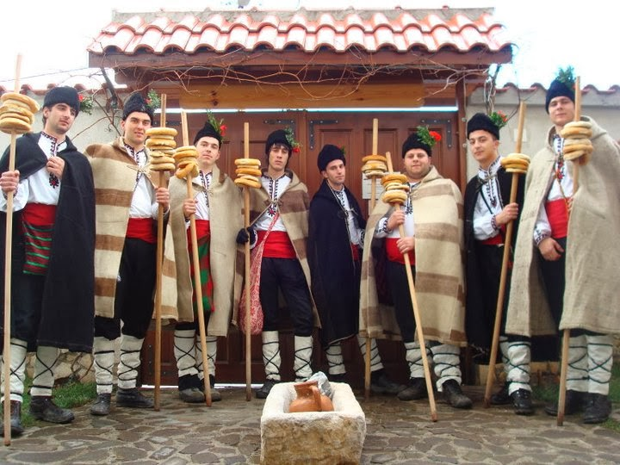

The Food
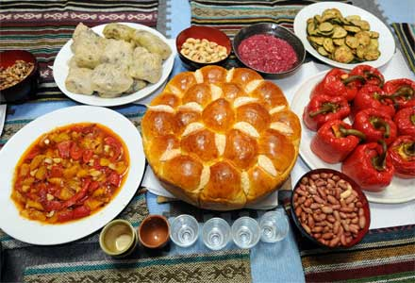
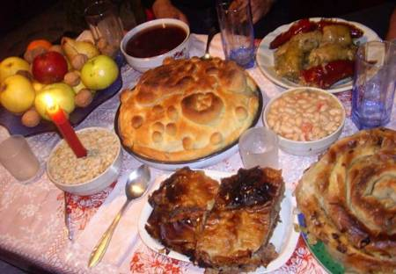
Traditionally the festive table must have 7, 9 or 12 meatless dishes - 7 because so are the days of the week; 9, because this time last pregnancy and 12, as there are months in the year. According to the church, food on the table can be up to 33 - the age at which Jesus Christ sacrificed to save the human race. The table should be rich and includes everything that is produced in the household as boiled corn, boiled beans, peppers stuffed with beans or rice, dried fruit, pickles, onions, garlic, honey, walnuts and wine.

