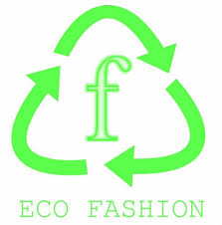 Bredy Style SRL
  - The Spring Collection☼
”You are what you wear!”
∞Start your spring season with motivation! Dress yourself in Stylish,Eco,”Bredish” clothes!∞
- Our clothes are exclusively made for you out of recycled materials which were carefully remade by our Bredi students !

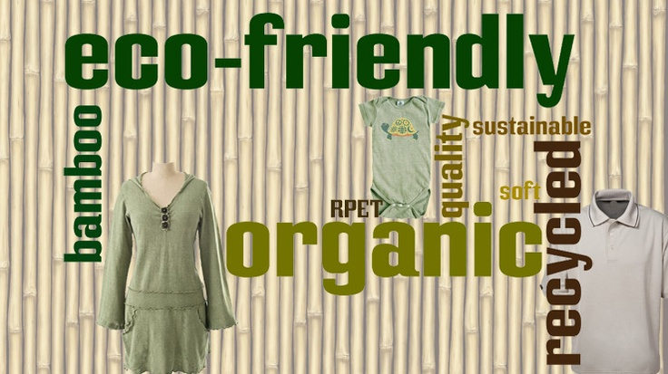
Not only our clothes line is original,but also pur purpose!
Half of the money raised from this commerce are going to the city orphanage and the other half to the school sustaining us! So,do not hesitate,change not only your style but also an orphan child's life!
For more information and promotions contact us on:
- Facebook: BredishEcoClothes
- E-mail: BredyStyleLugoj@yahoo.com
- Contact number:00407******0
Price list
Article | Price
Women Shirt | 12 €
Man Shirt | 12 €
Skirt | 8 €
T-Shirt | 7 €
Scarfs | 5 €

