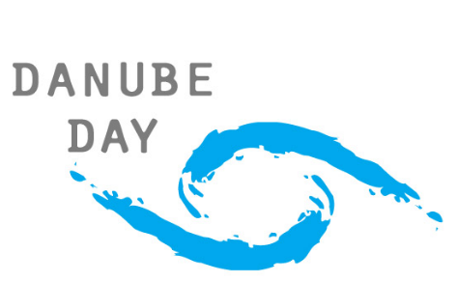
Danube Art Master 2017

Get active for a cleaner Danube!

Background
Jointly organised by the Global Water Partnership Central and Eastern Europe (GWP CEE) and the International Commission for the Protection of the Danube River (ICPDR), the competition encourages children to have a closer look at their local rivers and water bodies, ideally experience them hands-on and reflect on what the environment means to them. Children from all schools, NGOs, day care centres or associations for children in the Danube Basin are invited to create a piece of art celebrating the Danube environment and take part into the Danube Art Master.
Since 2004, this ambitious 14-country competition has united thousands of children from across the Danube River Basin. By taking part in the competition, the participants have the chance to learn more about the Danube river basin and how they can play a role in its protection.
Competition Details
Participants should be between 6 and 16 years old, from a country in the Danube basin (Germany, Austria, Czech Republic, Slovakia, Hungary, Slovenia, Croatia, Bosnia and Herzegovina, Serbia, Montenegro, Romania, Bulgaria, Moldova and Ukraine).
The competition will has two levels: national and international. After being selected at national level, the national winner(s) will then compete at international level.
Participation in the competition constitutes the winner’s consent for their name and contribution picture to be made public in publications of GWP CEE and the ICPDR. The submission deadline is 31 July 2017.
How to take part
To enter the competition, teachers and individuals are encouraged to go to a river bank, ideally the Danube or a Danube tributary and create environmental art using the materials found by the river. This year’s theme is "Get active for a cleaner Danube!” and we encourage the participants to get inspired of what is around them and incorporating materials found at the rivers, to create their unique art.
After creating the artwork, the children or the teacher should take a colour photo of the art and send it to national organiser. The minimum size of the digital photos is 150 DPI. Videos of the process of making the art are also welcome. Drawings and paintings are not the artworks we are looking for and will not be accepted.
This year we are introducing a special subcategory, which is video. The contestants are asked to create a 1-minute video, which should carry a strong message in the frame of the competition theme.
Winner selection
At national level, the artworks will be judged by the national organisers. National prizes vary from country to country, so participants are encouraged to contact their country’s organiser for details.
At international level, the national winners’ artworks will be judged by an international jury. The jury is composed of the national representatives of all IPCDR countries (one per country). For the judging, text or other hints on the national origin of the artwork will be blanked out to allow a neutral assessment. The judges’ decision is final.
The creator(s) of the best international artwork will be crowned ‘Danube Art Master’ and will be rewarded with a motivating prize such as a professional camera and other water-related treats.
The international winner(s) will be notified by e-mail. The prizes can neither be exchanged nor their value paid out in cash. Employees and officers of GWP CEE and ICPDR, as well as the immediate family (defined as parents, spouse, children, siblings and grandparents) and household members of each such employee and officer are not eligible to take part in the competition.

For more information, see www.danubeday.org
or contact Gergana Majercakova, GWP CEE, at gergana.majercakova@gwpcee.org

