1. Photos from the fair in Sturovo
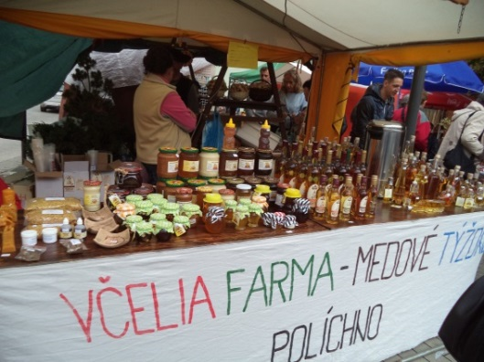 | 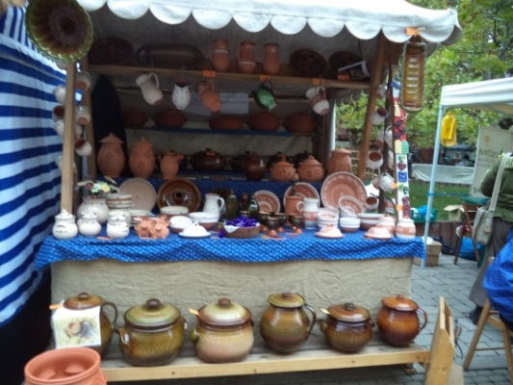
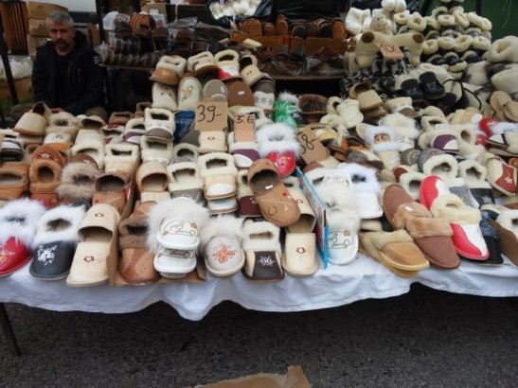 | 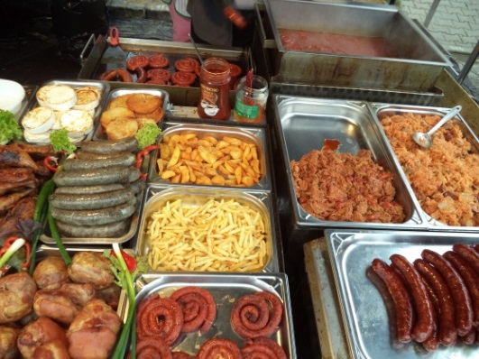
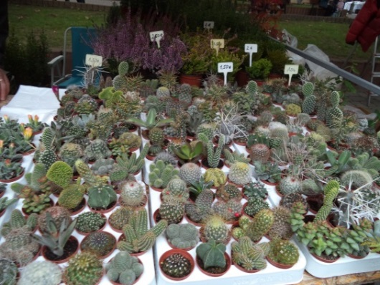 | 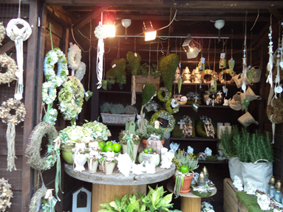
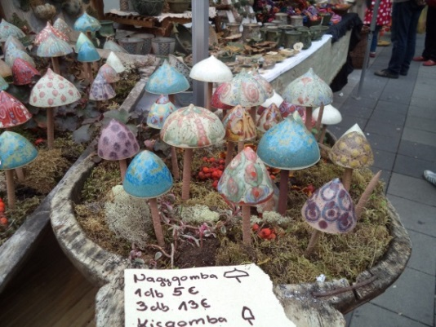 | 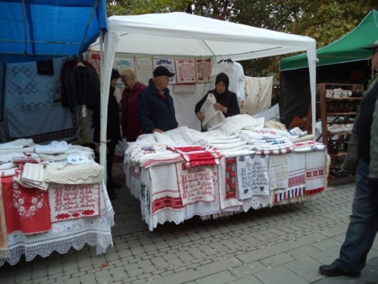
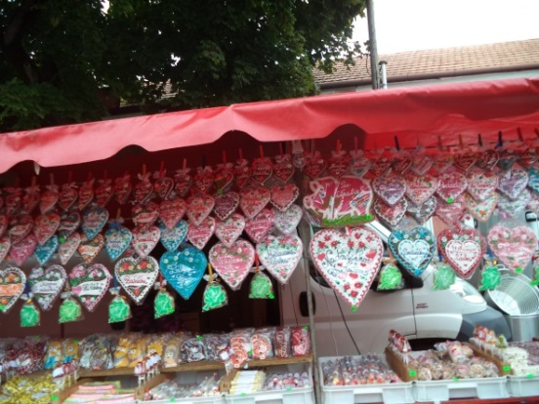 | 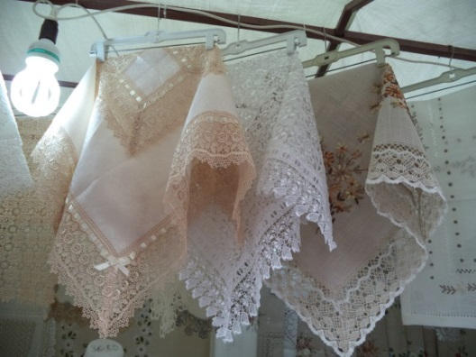

2. Compare prices
Goods | Price in Slovakia | Price in Bulgaria  1 euro = 1.9558 leva
- Woolen socks | 10 euro | 5 leva
- Honey | 8 euro | 8 leva
- Wooden spoons | 1 euro | 2 leva
- Pottery | 50 euro | 20-30 leva
- Slippers | 5 euro | 5 leva
- Lady’s jacket | 40 euro | 40 leva – 60 leva
- Souvenir magnet | 1,50 euro | 1-3 leva
- Pack of sweets | 0.50 euro | 1,50 leva
- Cactus plant | 1,50 euro | 2,50 leva
- Grapes | 2,30 euro | 1,20 leva

3. Description
- Decorative beeswax candles - made in different sizes and resemble art carving. They may be flavored and used in festive occasions.
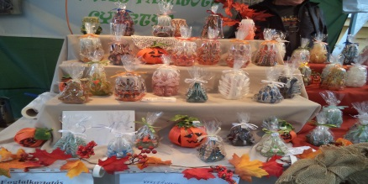
- Flowers wrought iron - souvenirs that are produced manually and have a design approaching to real flowers.
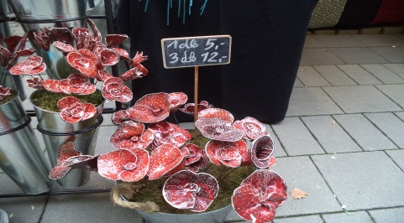
- Wafers - with different flavor, used in the preparation of sweet-salty desserts and appetizers in domestic and industrial environments.
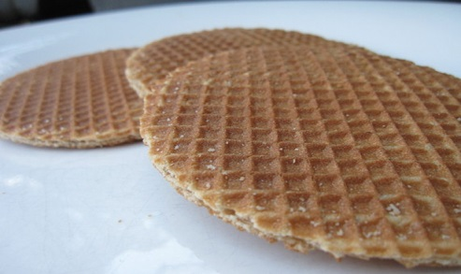
4. No Bulgarian products on the Slovak market.

5. On the fair were:
- producers and officials from Slovakia, Romania, Hungary and Senegal;
- participants from Peru - typical music and dances;
- observers and customers from China - Workers at a Chinese food restaurant.
6. Reflection of the Fair of the lives of the local population:
6.1 Positive
- Perform Intensive business contacts between producers, retailers and consumers;
- reflects positively on the appearance of the place as the development of trade, tourism, transport, hospitality, recreation and tourism;
- Presentation of preserved traditions in craftsmanship;
- Opportunity for social contacts and family meetings;
- Improving the reputation of companies;
- Collection of new market information;
- Receive orders.
6.2 Negative
- Harmful emissions from vehicles, which loaded the temporary sales outlets;
- Damaged lawns and shrubs around the stands;
- Pollution of the environment by traders and visitors;
- Stress from noise, lights and emotions attractions.

