- VLK-WOLF
It is the name of special activity organized twice a year ( October, April) by forest protection organization named Wolf. The aim is to give information about need to protect our forests, their special fauna and flora. We do activity Save your tree - we plant new trees or we look after existing ones.
Learning about trees and bushes in our school grounds is also one of activities we do. We invite workers of protected area Vihorlat to talk about these plants.
Together we specified Slovak and scientific names for each plant and we made wooden labels for them. Trees are lungs of our planet, so we should look after them.
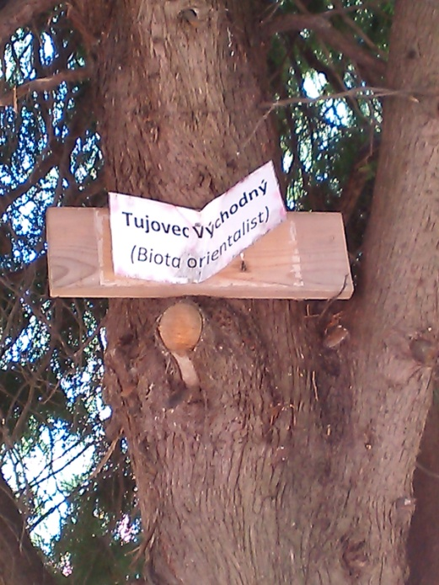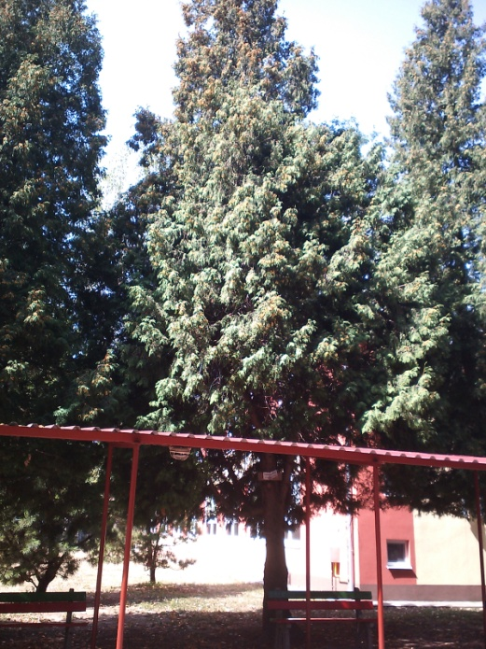
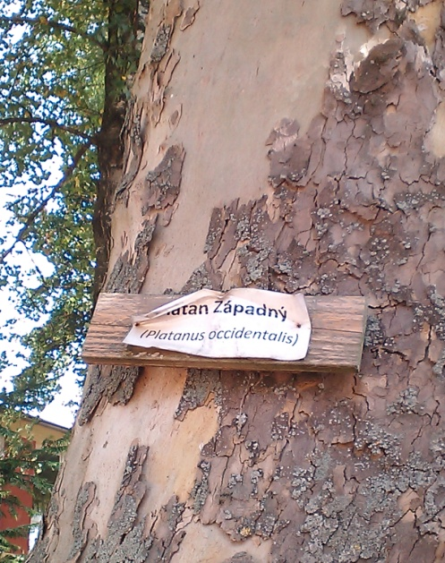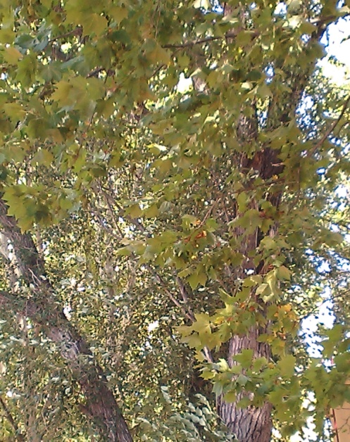
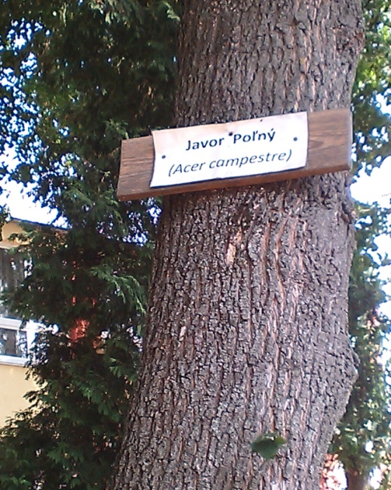
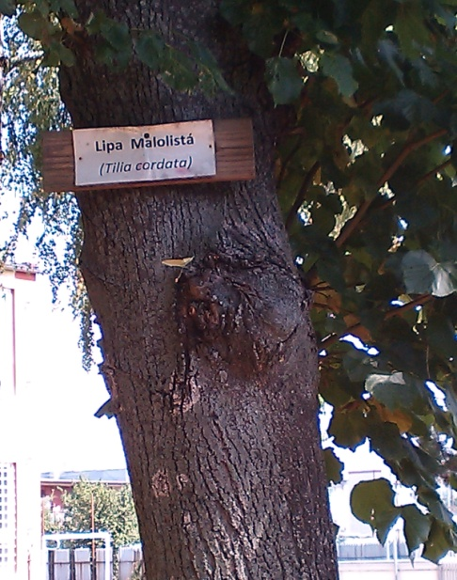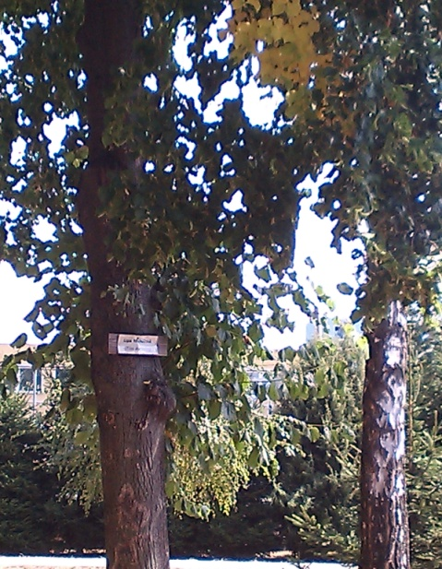

I live in a village near Michalovce, so I go to school by bus. In my family we drive a car to the town to do big shopping once a week . Some students over 18 drive to school, but they take more friends and share money for petrol. In my village I usually walk or go by bike. When we use more public transport, bikes or just walk, we help to reduce air pollution.
Lucia Suraničová 4.

