Where are productes come from?

It comes from Hungary.
it's 811 kms to get to my country!
If this distance was covered by an Aeroplane that would create approximately:
182 kgCO2 or 50 kg Carbon
If this distance was covered by a Car that would create approximately:
146 kgCO2 or 40 kg Carbon
If this distance was covered by a Train that would create approximately:
50 kgCO2 or 14 kg Carbon

It comes from Italy, in Reggio Emilia.
It's 434 kms to get in my city.
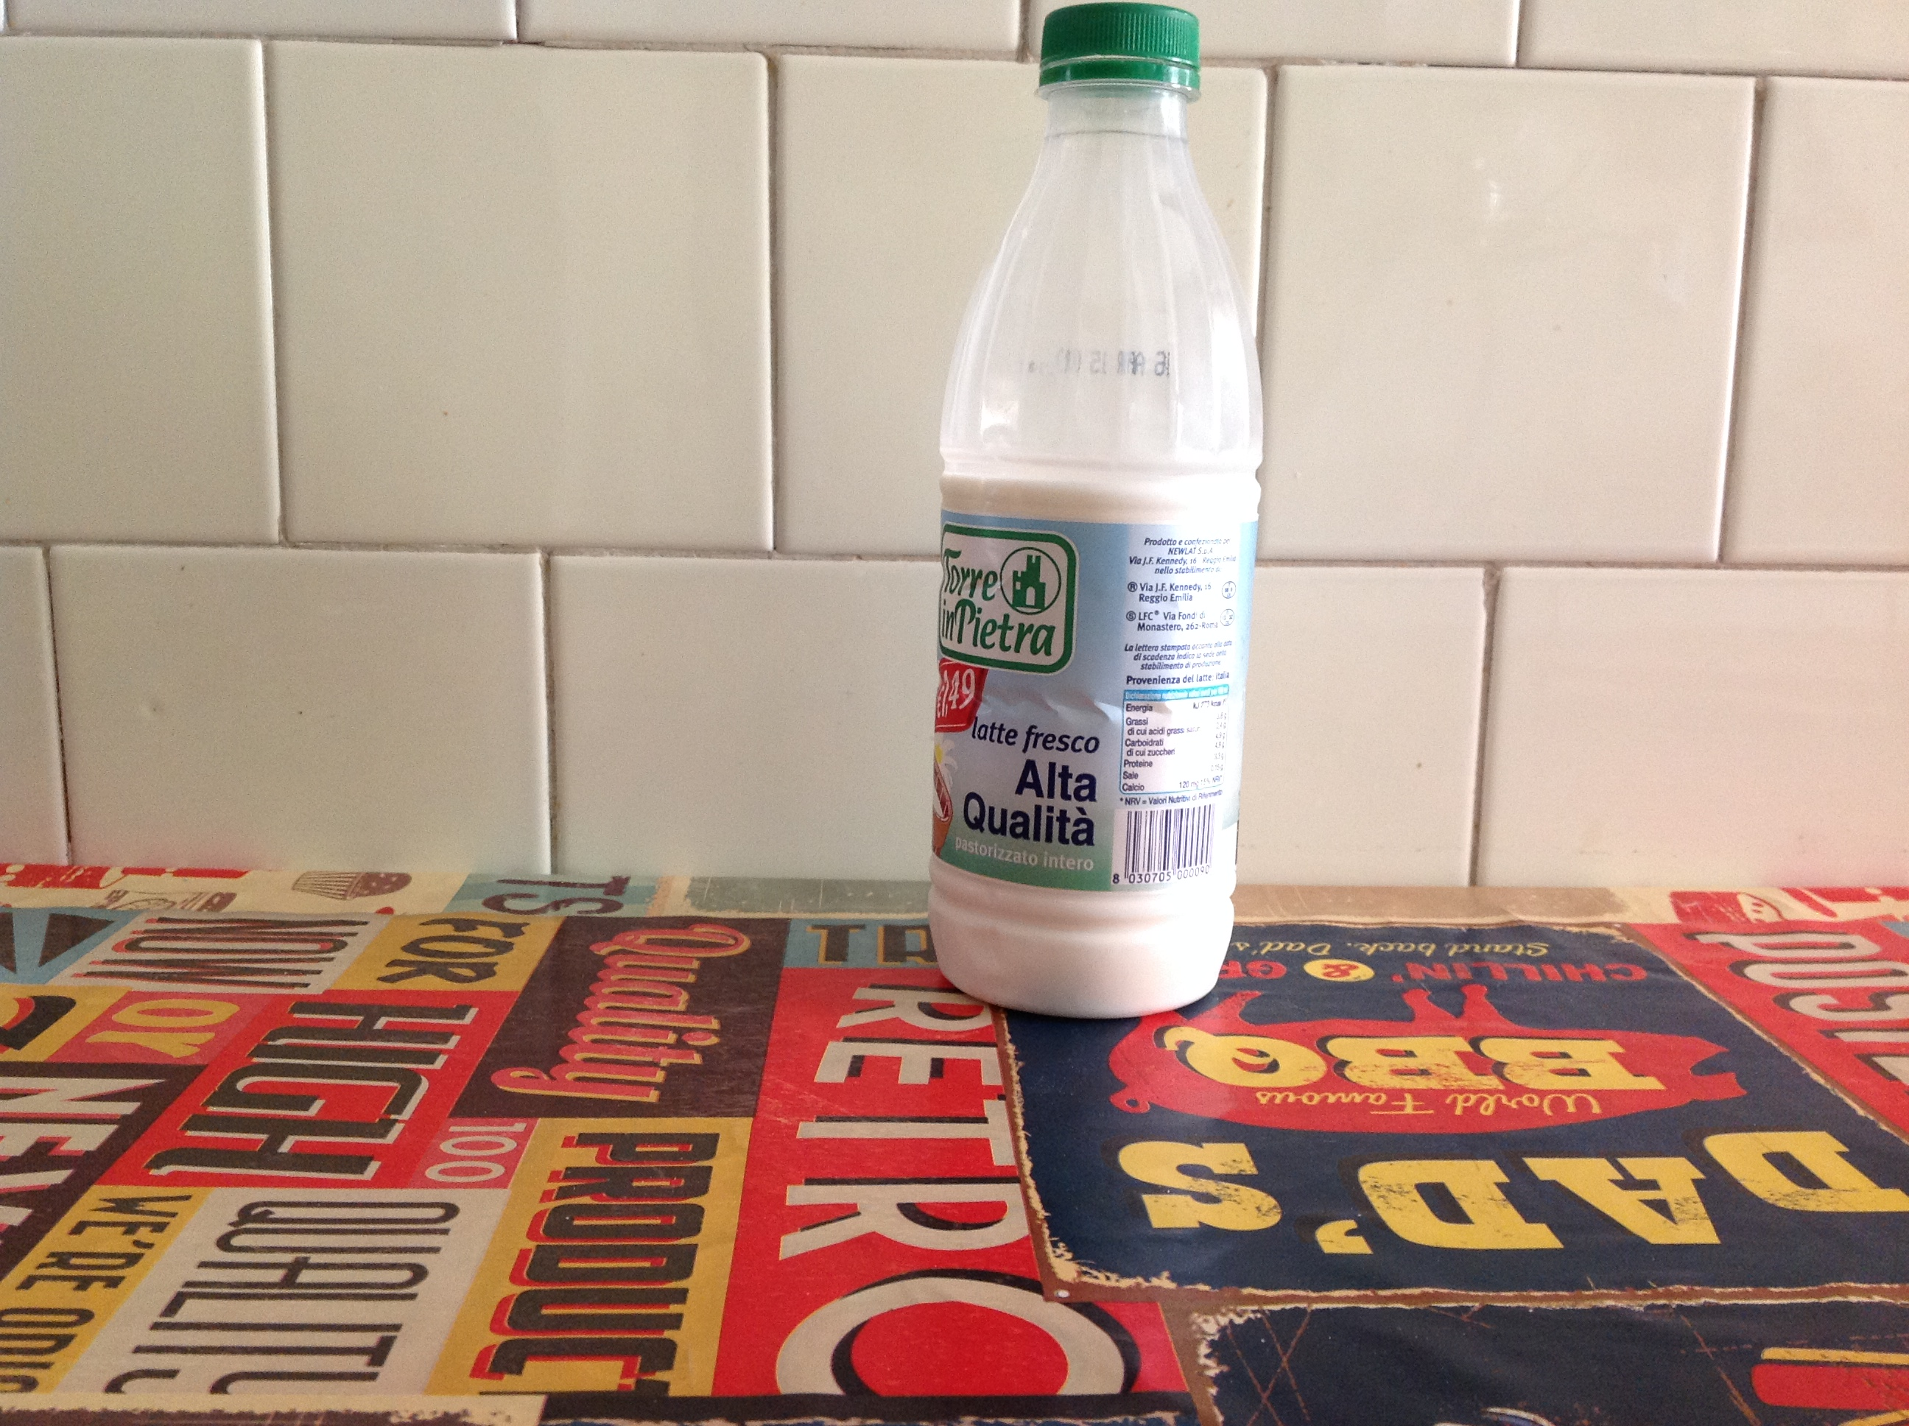

It comes from Germany.
it's 1182 kms to get to my country!
If this distance was covered by a Car that would create approximately
265 kgCO2 or 72 kg Carbon
If this distance was covered by a Car that would create approximately
213 kgCO2 or 58 kg Carbon
If this distance was covered by a Train that would create approximately
73 kgCO2 or 20 kg Carbon

