Commemoration of Atatürk, Youth and Sports Day
The Commemoration of Atatürk, Youth and Sports Day in Turkey features state ceremonies and sports events throughout the country on May 19 each year. Young Turkish athletes carry the Turkish flag from a Black Sea port to the country’s capital to commemorate Turkey’s War of Independence (1919–1923).
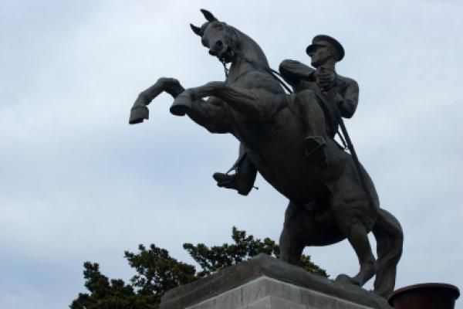
The Commemoration of Atatürk, Youth and Sports Day is annually celebrated in Turkey on May 19.

In the run-up to the May 19 celebrations, young Turkish athletes carry the national flag from Samsun a Black Sea port from where Mustafa Kemal Atatürk started Turkey’s War of Independence in 1919, to Ankara, the country’s capital. The marathon usually takes about 10 days. The Turkish president accepts the flag at a ceremony on May 19.

Various sports events take place on May 19 throughout Turkey. Many people celebrate this day by watching athletes perform at their local stadiums or by participating in sports events that are open to the public, such as half-marathons. University students usually prepare special programs for their teachers and parents on this day.

Many Turks also observe May 19 as Atatürk’s birthday. Although the exact date of his birth is not known, Atatürk used to say he was born on May 19 (referring to his political career). Many people lay wreaths to Atatürk’s monuments and hang Turkish flags outside their windows.

