**Emigrations in Poland**

**Then and now**

**Famous Poles on emigrations**

Even known people leave their motherlands to find better paid jobs, to live a safer and worthy life. They move out usually to better developed countries that can be in the distance from their place where they were raised. The main reasons of emigration have been still very similar for ages: politics and money.

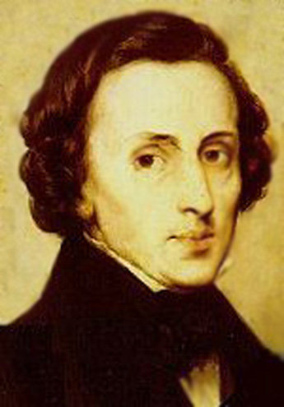

**Fryderyk Chopin** – a Polish worldwide known pianist. His friends convinced him to leave his homeland so that he could give concerts abroad. It was in 1830s not so long before The November Uprising, in that case his friends and family also didn’t want such a talent to be wasted.

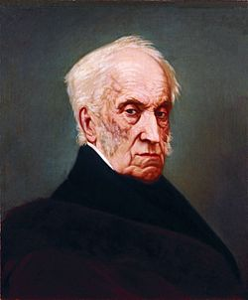

**Adam Czartoryski** – a writer, a poet and a patron of arts and culture. He was travelling through different countries to get experience of learning.

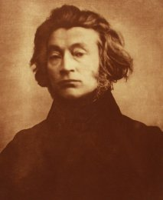**Adam Mickiewicz** – a poet, a translator, a philosopher, a religious activist and also a teacher who had to move out because Poland was in this time under the partition what put him in great danger.

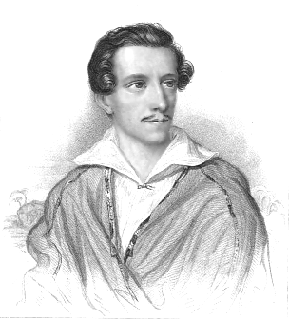

**Juliusz Słowacki** – a well-known Polish poet who also left his homeland because of The November Uprising.

**Czesław Miłosz** – a poet that put Stalin down by his work and because of that he had to leave his homeland. This great artist was awarded by “Nobel Prize” in 1980. The Swedish Academy wrote that he got the prize for “unveiling the danger for humanity in the world full of conflicts”.

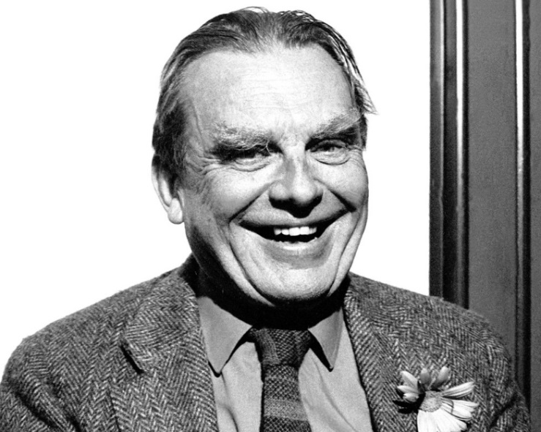

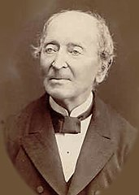**Ignacy Domejko** – a mineralogist, a geologist and a great friend of Adam Mickiewicz; he took a part in The November Uprising. After that he left Poland to finish his study.

**Modern migrations in Poland**

People have been always looking for well conditions of their lives and very often they have decided to leave the homeland to achieve their goals.

Reasons

Now the main reason of emigrations in Poland is money. Unemployment and low wages aren’t an attractive for young people. But the desire of exploration of the world, better career prospects or relatives living abroad affect on the decisions of emigrating too.

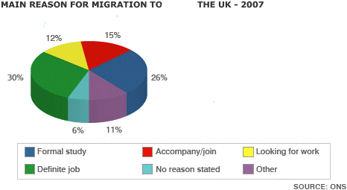

Directions

Certainly, people who left Poland stay in Europe. Poles emigrate mainly to:

**Great Britain** (788 thousand) – high number of compatriots, profitable social system and attractive wages.

**Germany** (687 thousand)– close to homeland, stability of employment and good social system.

Other directions: Ireland, Italy, Spain, USA, Finland, France, Netherlands and Norway in recent years getting more and more popular

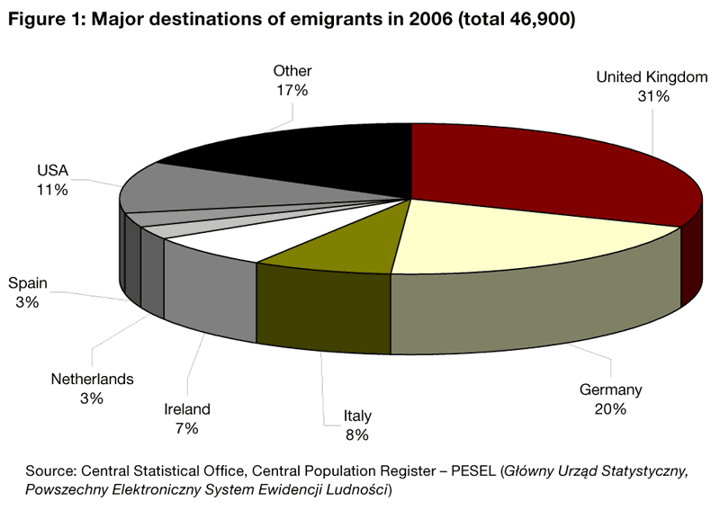

**History of emigrations in Poland**

Poles immigration has changed over the years. In the past it was caused by political factors, but today Poles travel to other countries for profit.

The oldest Polish foreign migrants are Barfar confederates, tribe remembering the partitions, and people from the Great Emigration after 1831. They left the country of educated, eminent people, fighting for Poland’s independence. It was an emigration dictated to the necessity that existed after the fall of the November Uprising. The icons of this emigration include Cyprian Kamil Norwid , Juliusz Słowacki and, above all, Adam Mickiewicz.

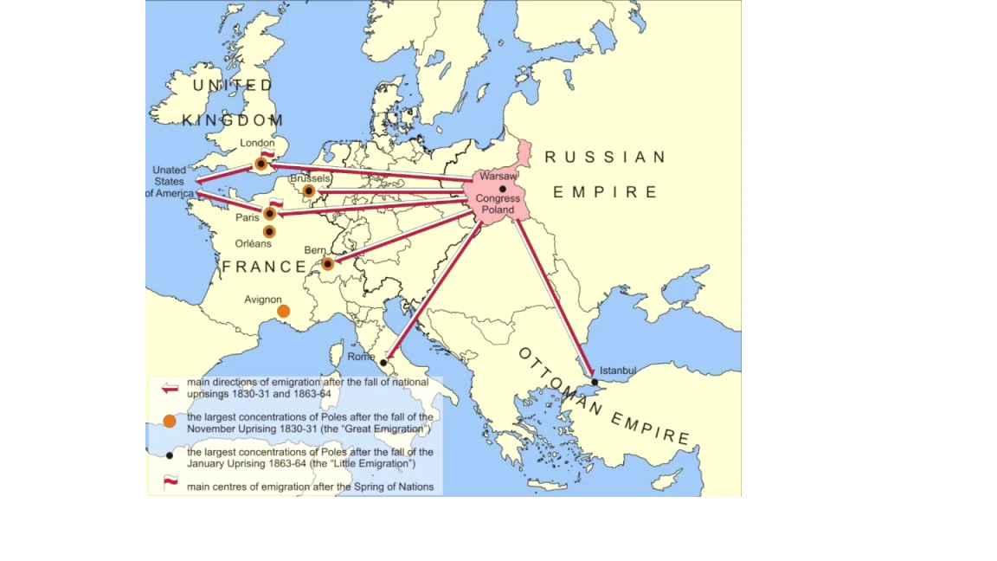

The next great wave of emigrants from Poland appeared in France and England after the fall of the January Uprising. These men, like their elder forerunners, thirty years earlier had to emigrate to save their lives.

During World War I, the Germans led about mass migration by organizing forced labor for the Poles. For the most part, after the end of the war, they were forced to live in foreign countries, often deciding to permanently emigrate.

During World War II, the land of Poland became a huge area of migration. The first wave came in September 1939. In later years, mass evacuation took place in Germany and the USSR. Other areas where Poles were emigrated, among others were: Austria, Brasil, Czechoslovakia, Denmark, France, India, Italy.

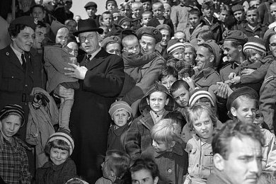

Another great wave of Polish emigration took place in the 80s, especially after the declaration of martial law. Many people who left Poland couldn't return because of closed borders. Later they dislike the country ruled by the harsh generals and because of the totalitarian political system in Poland called communism.

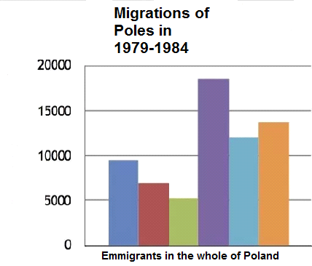

**Humans since they have appeared on Earth they have made decisions that have been seemed to be the best for their being. The natural survival instinct has protected them from any kind of jeopardy. When in place where they were living the sources ended or they were under threat of wild animals or extreme weather conditions, they moved on to other areas where it was safe to resettle. Not so much changed since then.**

By Julia Kamińska, Julia Kwiecień, Dominika Majchrzak



Projekt „Migration Matters”- współfinansowany w ramach programu Unii Europejskiej Erasmus+

Publikacja odzwierciedla jedynie stanowisko jej autorów i Komisja Europejska oraz Narodowa Agencja Programu Erasmus+ nie ponoszą odpowiedzialności za jej zawartość merytoryczną

