A SHORT INTERVIEW WITH OUR TEACHER, MATIJA KRHAČ
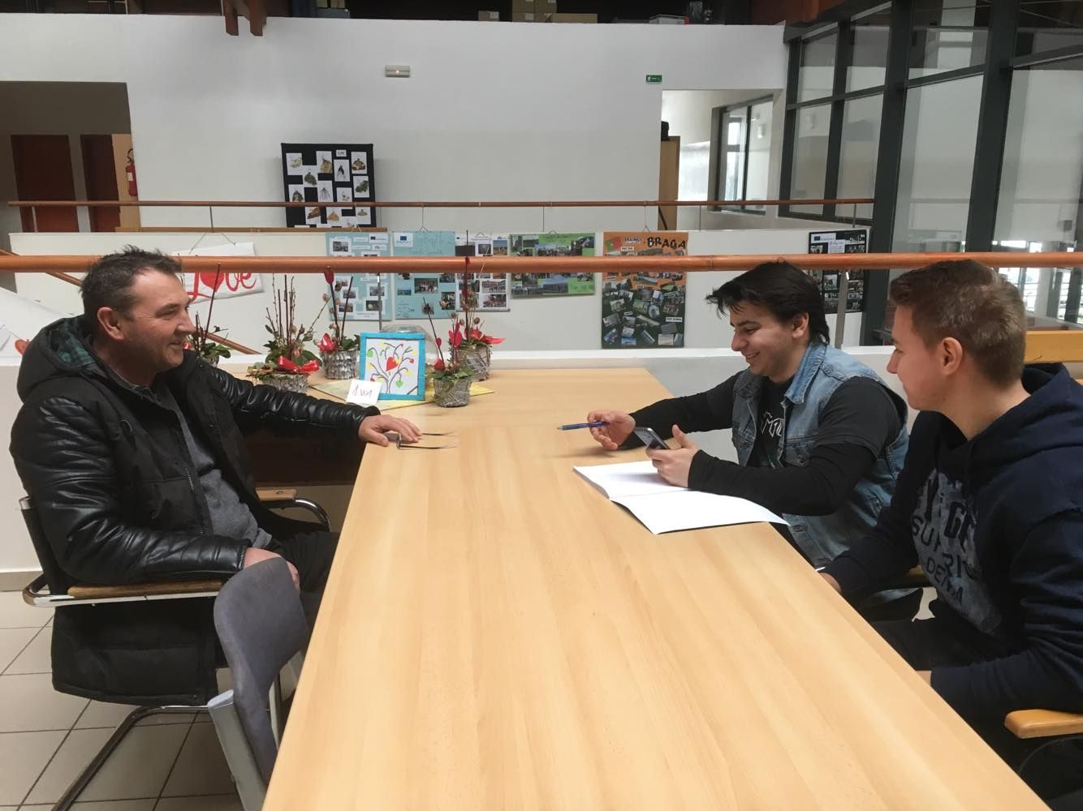

What circumstances made you leave your native region and when did you do it?
- In 1991 the war broke out and my native region, Baranja, was directly affected by the conflict. First, we moved to Osijek in September that year. Later on, due to the fact that many state-owned companies were going bankrupt, and so was the one I used to work for, Belje, we decided to leave for Međimurje in 1994.

What did you do and what was your life in Baranja like?

- I worked for Belje Sugar Refinery. We had everything there, family, friends and a relatively good standard of living. It is an agricultural region with excellent food and wines. People in Baranja are hard-working but also laid-back and cheerful in their free time.
Did it take you a long time to get on in Međimurje? How did your family get on here?
- I didn't have any problems when we got here because it was relatively easy to get a job. There were a lot of successful small private companies which needed people like me. My wife and my children also got used to Međimurje relatively quickly.
Was that a major change? What was the most difficult thing in the beginning?
- Of course it was! We had to adapt to completely different circumstances and embrace a completely new lifestyle.
Are there any significant differences between the lifestyle and mentality of the people here and in your native region?
- Yes, there are. In Baranja, all the land and factories are owned by one big company, Belje, and here in Međimurje the situation is completely different and it definitely has a certain influence on the mentality. On the other hand, people here are also hard-working and open-minded and that is important. We have made a lot of friends here and friendship is something that is really cherished here. We feel at home.
Would you choose Međimurje again if you were in a similar situation?
- I probably would because my parents come from Međimurje.
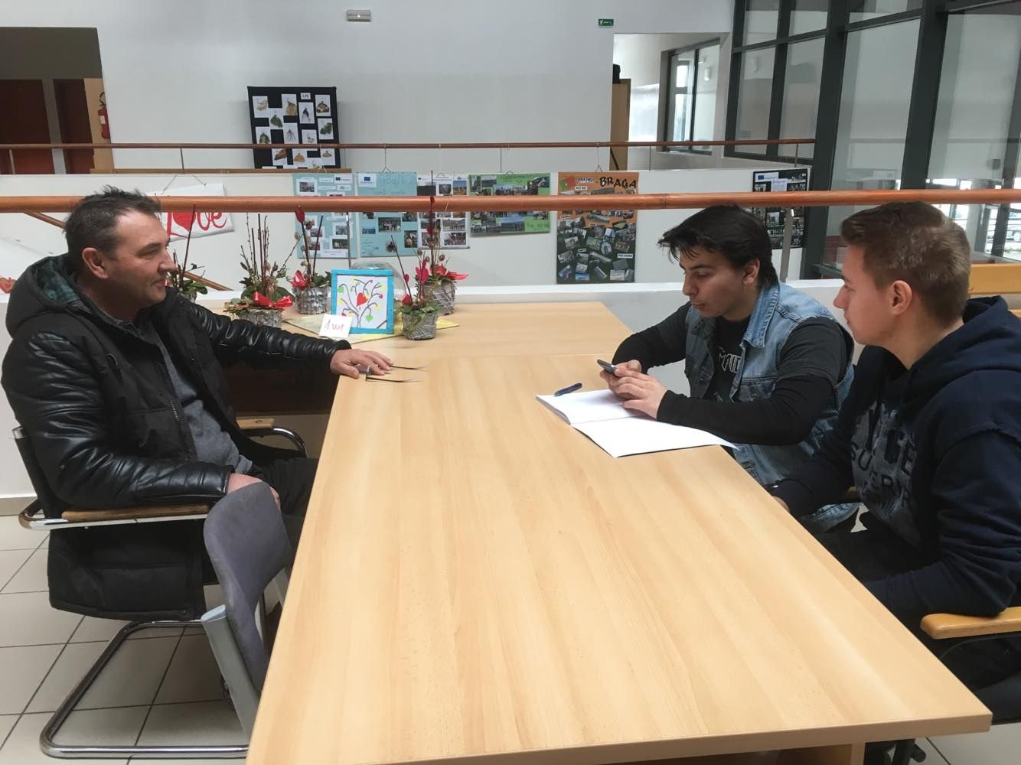

Viktor Mesarić, 3.PT

