Hi everybody!
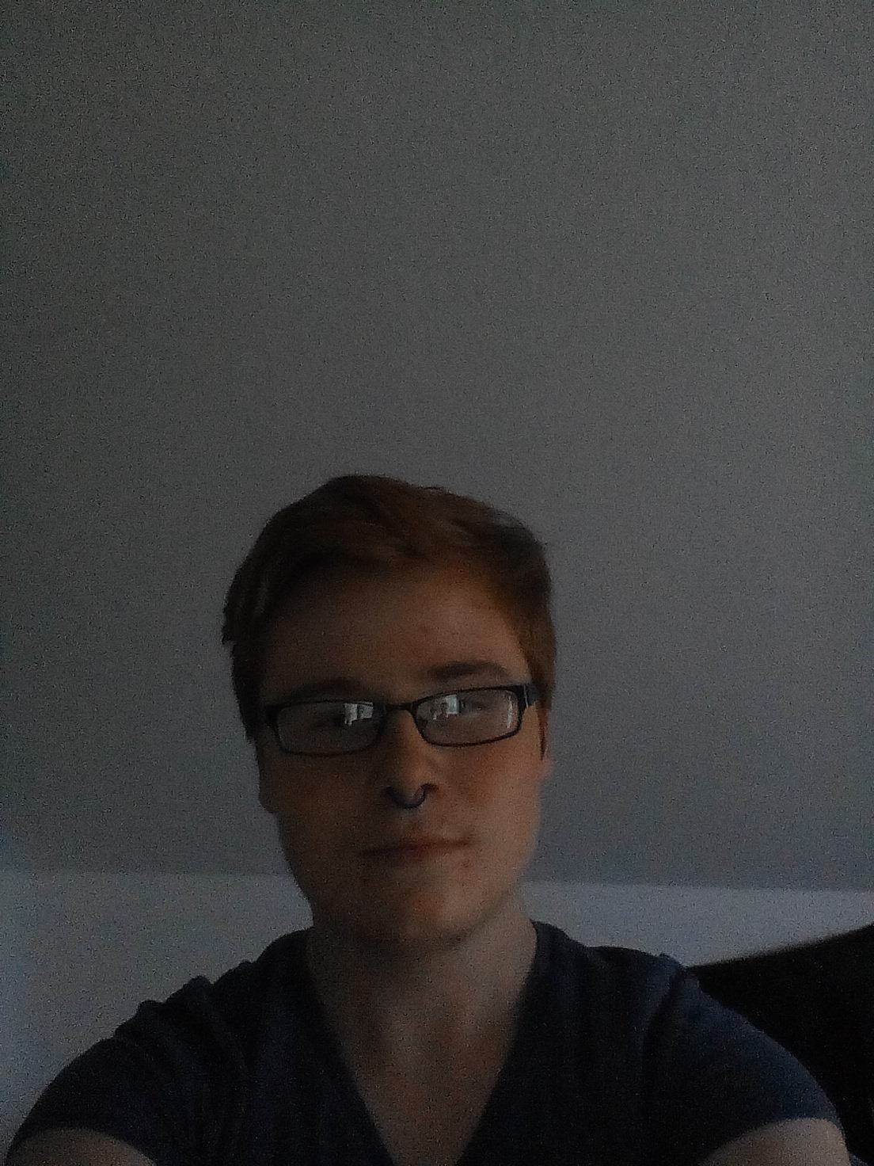
My name is Filip and I´m from Czech republic. I live in Dobříš, a pleasant little town, near our capital Prague. I live with my parents and younger brother in our own house with big garden (still with no pool☹). I visit grammar school in same.
At school I don´t like chemistry, P.E. (I don´t like sports) and I.T.. I like languages (English and German, czech just time to time☺) and art.
And what I like to do in my free time? I like reading books (I prefer detective stories – my favourite author is Agatha Christie) and drawing. Last but not least my big hobby is a fashion. In the future I want to be a fashiondesigner.
I should say I´m little bit of crazy! So that won´t be surprise for you when I say that my life inspiration is Lady Gaga! I like Tim Burton too.
I like communication with everybody and that´s one of many reasons why I´m in this project. I prefer commutication on Skype with webcam but it doesn´t mean if you don´t have webcam or wanna just chat with me I don´t wanna communicate with you! No, I like chat too☺.
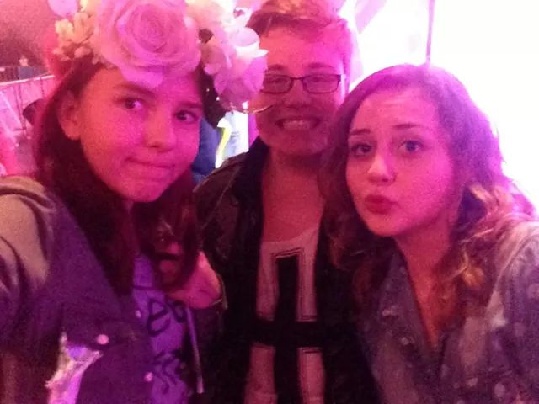
So if we have same hobbies or just you wanna write to me I´ll be so glade. I´m looking foward to communication with you.
Have a nice day☺,
Bye

Me and my friends at Artrave, the concert of Lady Gaga☺
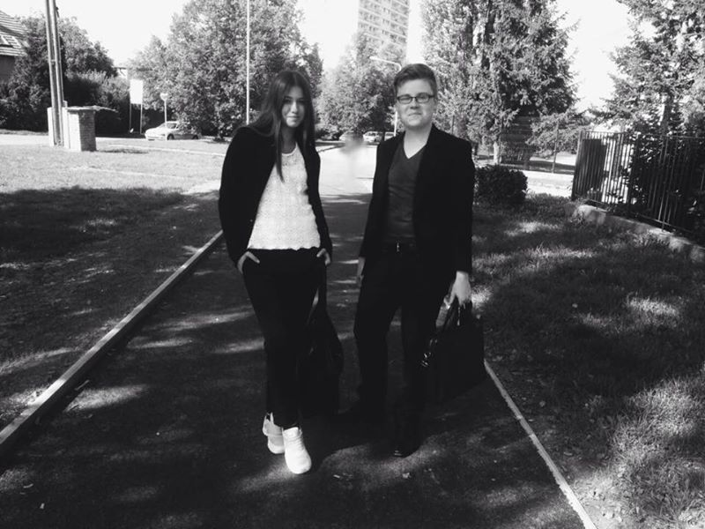

Me and my friend Naty after school with smiles on our faces ☺

