Chiro Baqiri

Me
My name is Chiro Baqiri I am 17 years old. I was born in Erbil, Irak. I don’t really have ‘sport’ hobby’s but I like to do people’s hair and make-up because it’s a really fun thing to do. I’m a very adventurous person. One of my goals would be traveling the world and being in touch with different cultures. I can speak 5 languages: Kurdish, Dutch, French, English and Turkish.
My family and friends
My mother’s name is Zivar and father’s name is Hossein. My dad is 50 and my mom is 47. We’re a Kurdish family we’ve been in Belgium for 8/9 years.
I also have a sister, she is 23 years old.
My friends are; Nora, Noa, Kristina, Febe, Femke, Melissa, Sien, Sanae… I mostly see them at school but we can hang out on the weekends and vacations…

My neighbourhood and my school
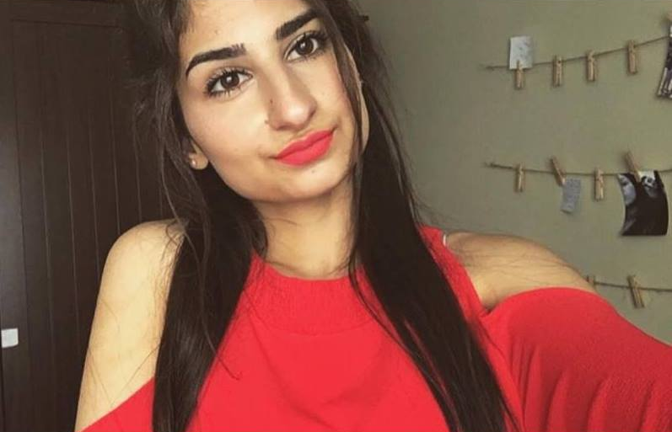
I live in Mechelen. I really like my flat because it’s very cosy. I go to Ursulinen Mechelen. From where I live to my school is not that far, it’s like 10-15 min with the bike. I fullow STW stands for; social, technical, studies and I’m in eleventh (5th) grade.
