THE RAIN STICK

A long time ago, the rain stick was allowing

whoever was holding it to speak

without being interrupted as long as the

seeds were falling down into the tube.

For this reason it is also

called “speech stick”.

To build a rain stick :
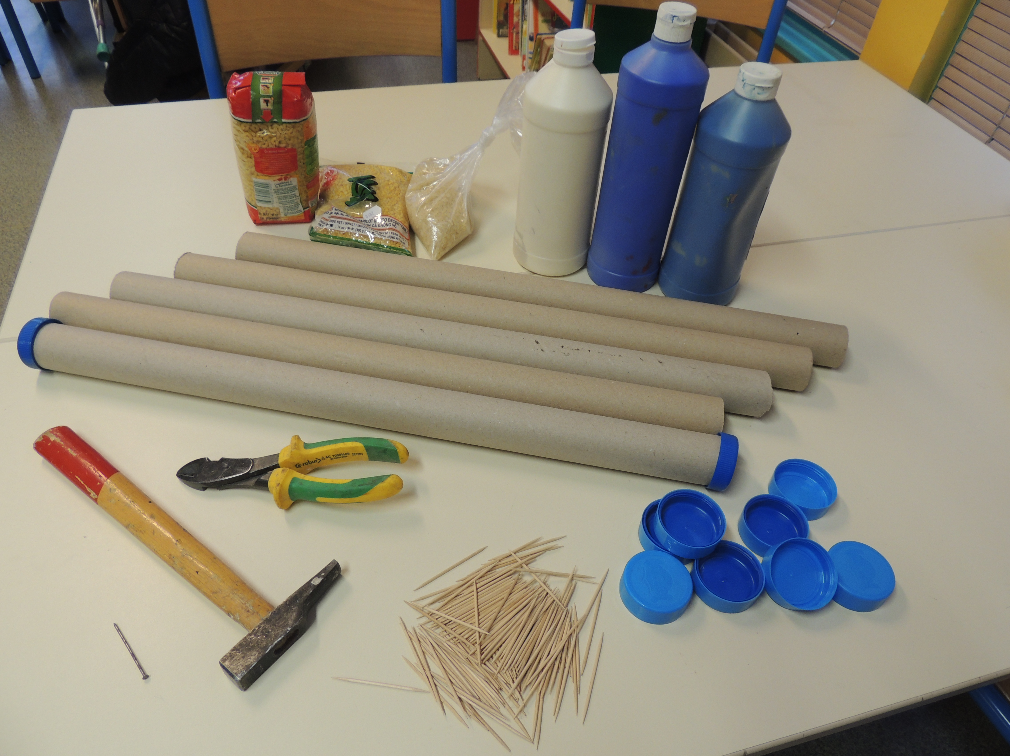

You need :

- A long strong cardboard tube
- tooth picks
- seeds
- a cutter
- strong glue
- a nail
- a hammer
- 2 bottle caps
- paints
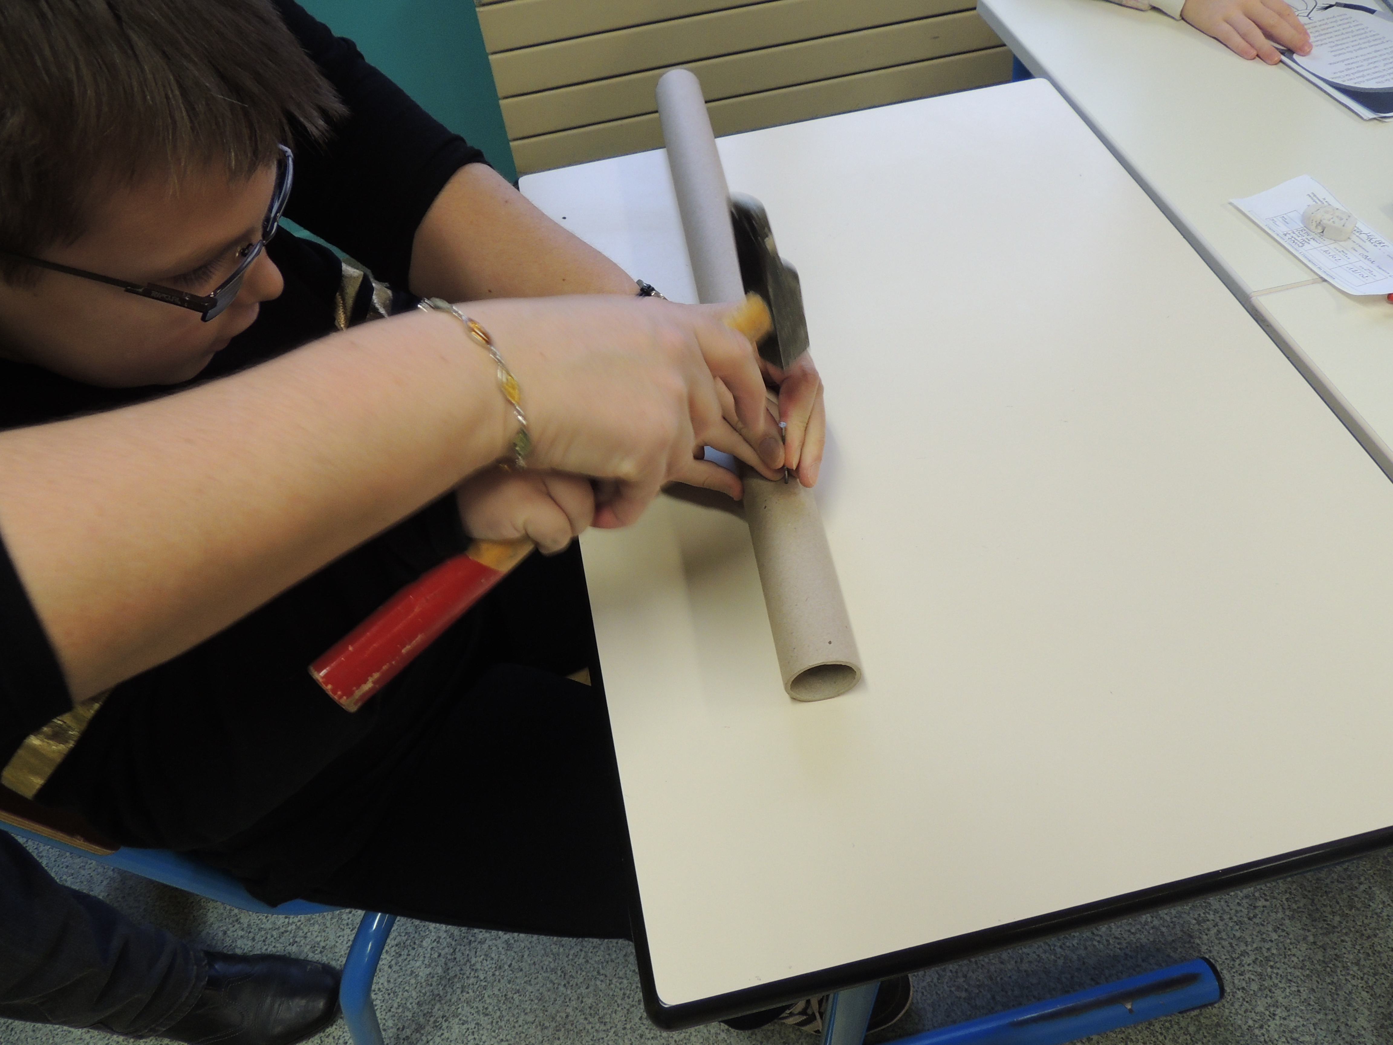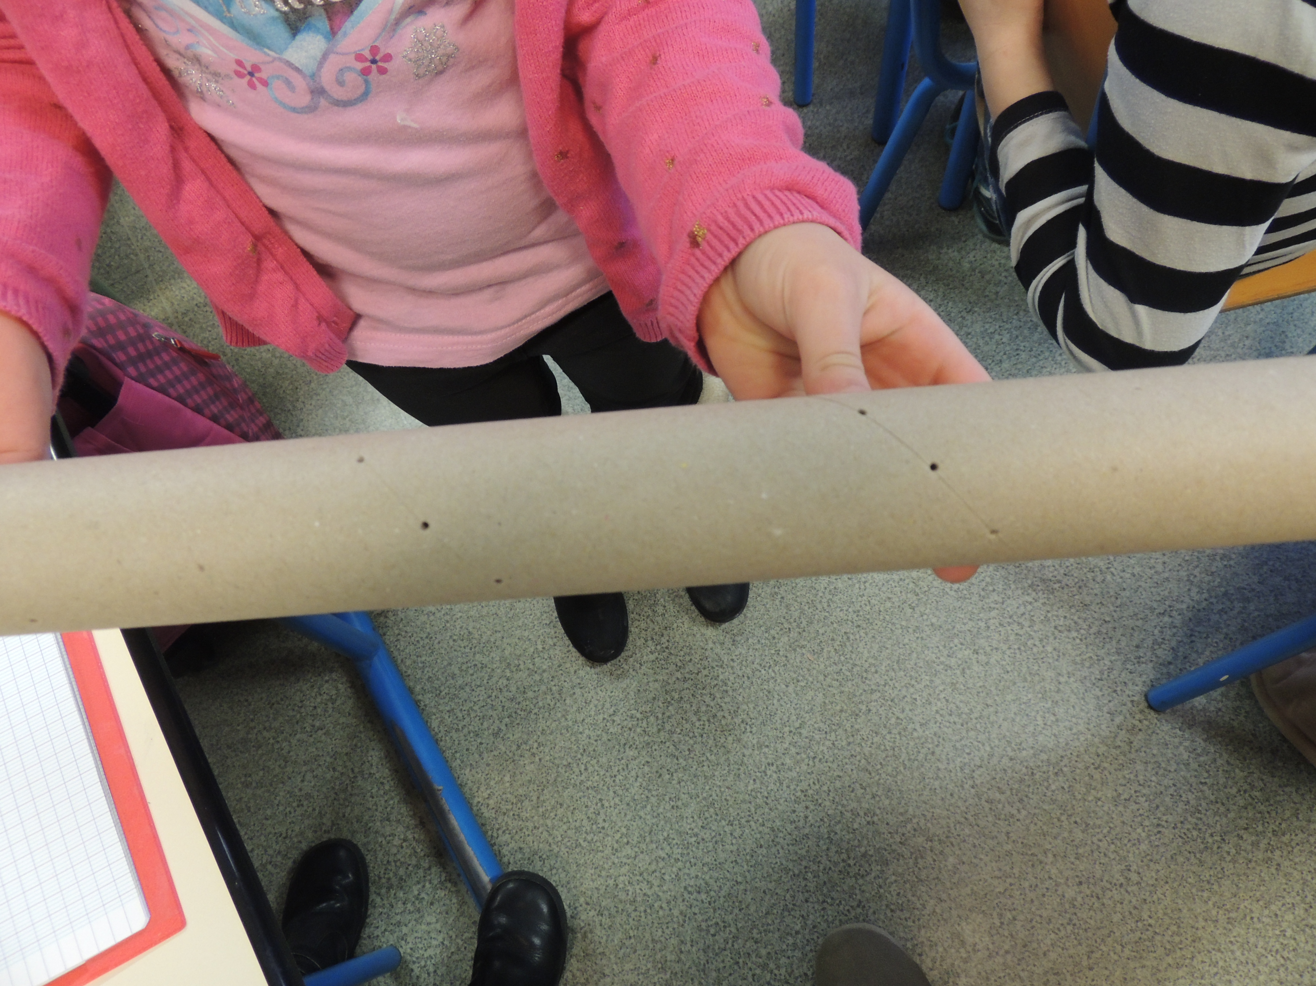

1 Drill holes, using the nail, every 1,5 cm

along the tube.

2. Push a tooth pick into each hole, cut

the piece sticking out.

3. Paste a plug at one end of the rain stick.
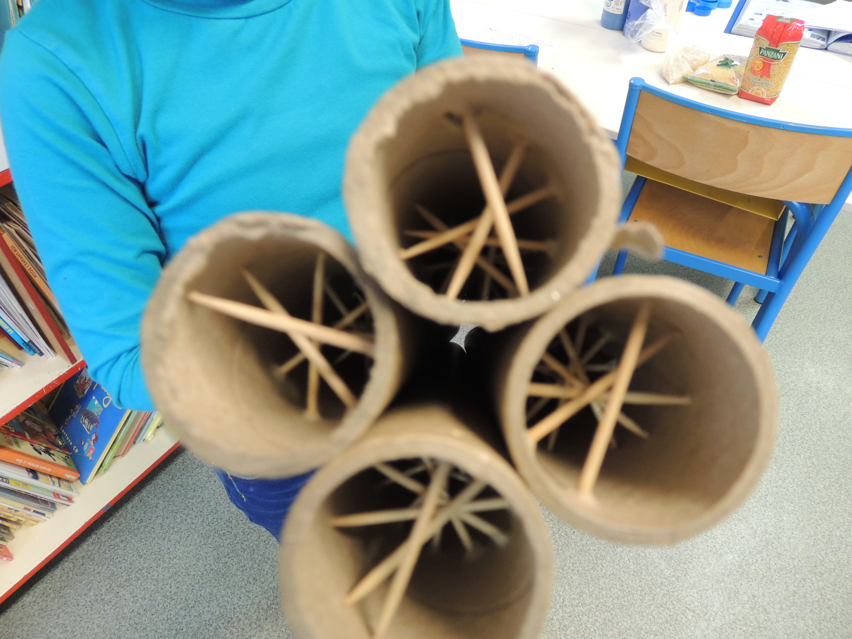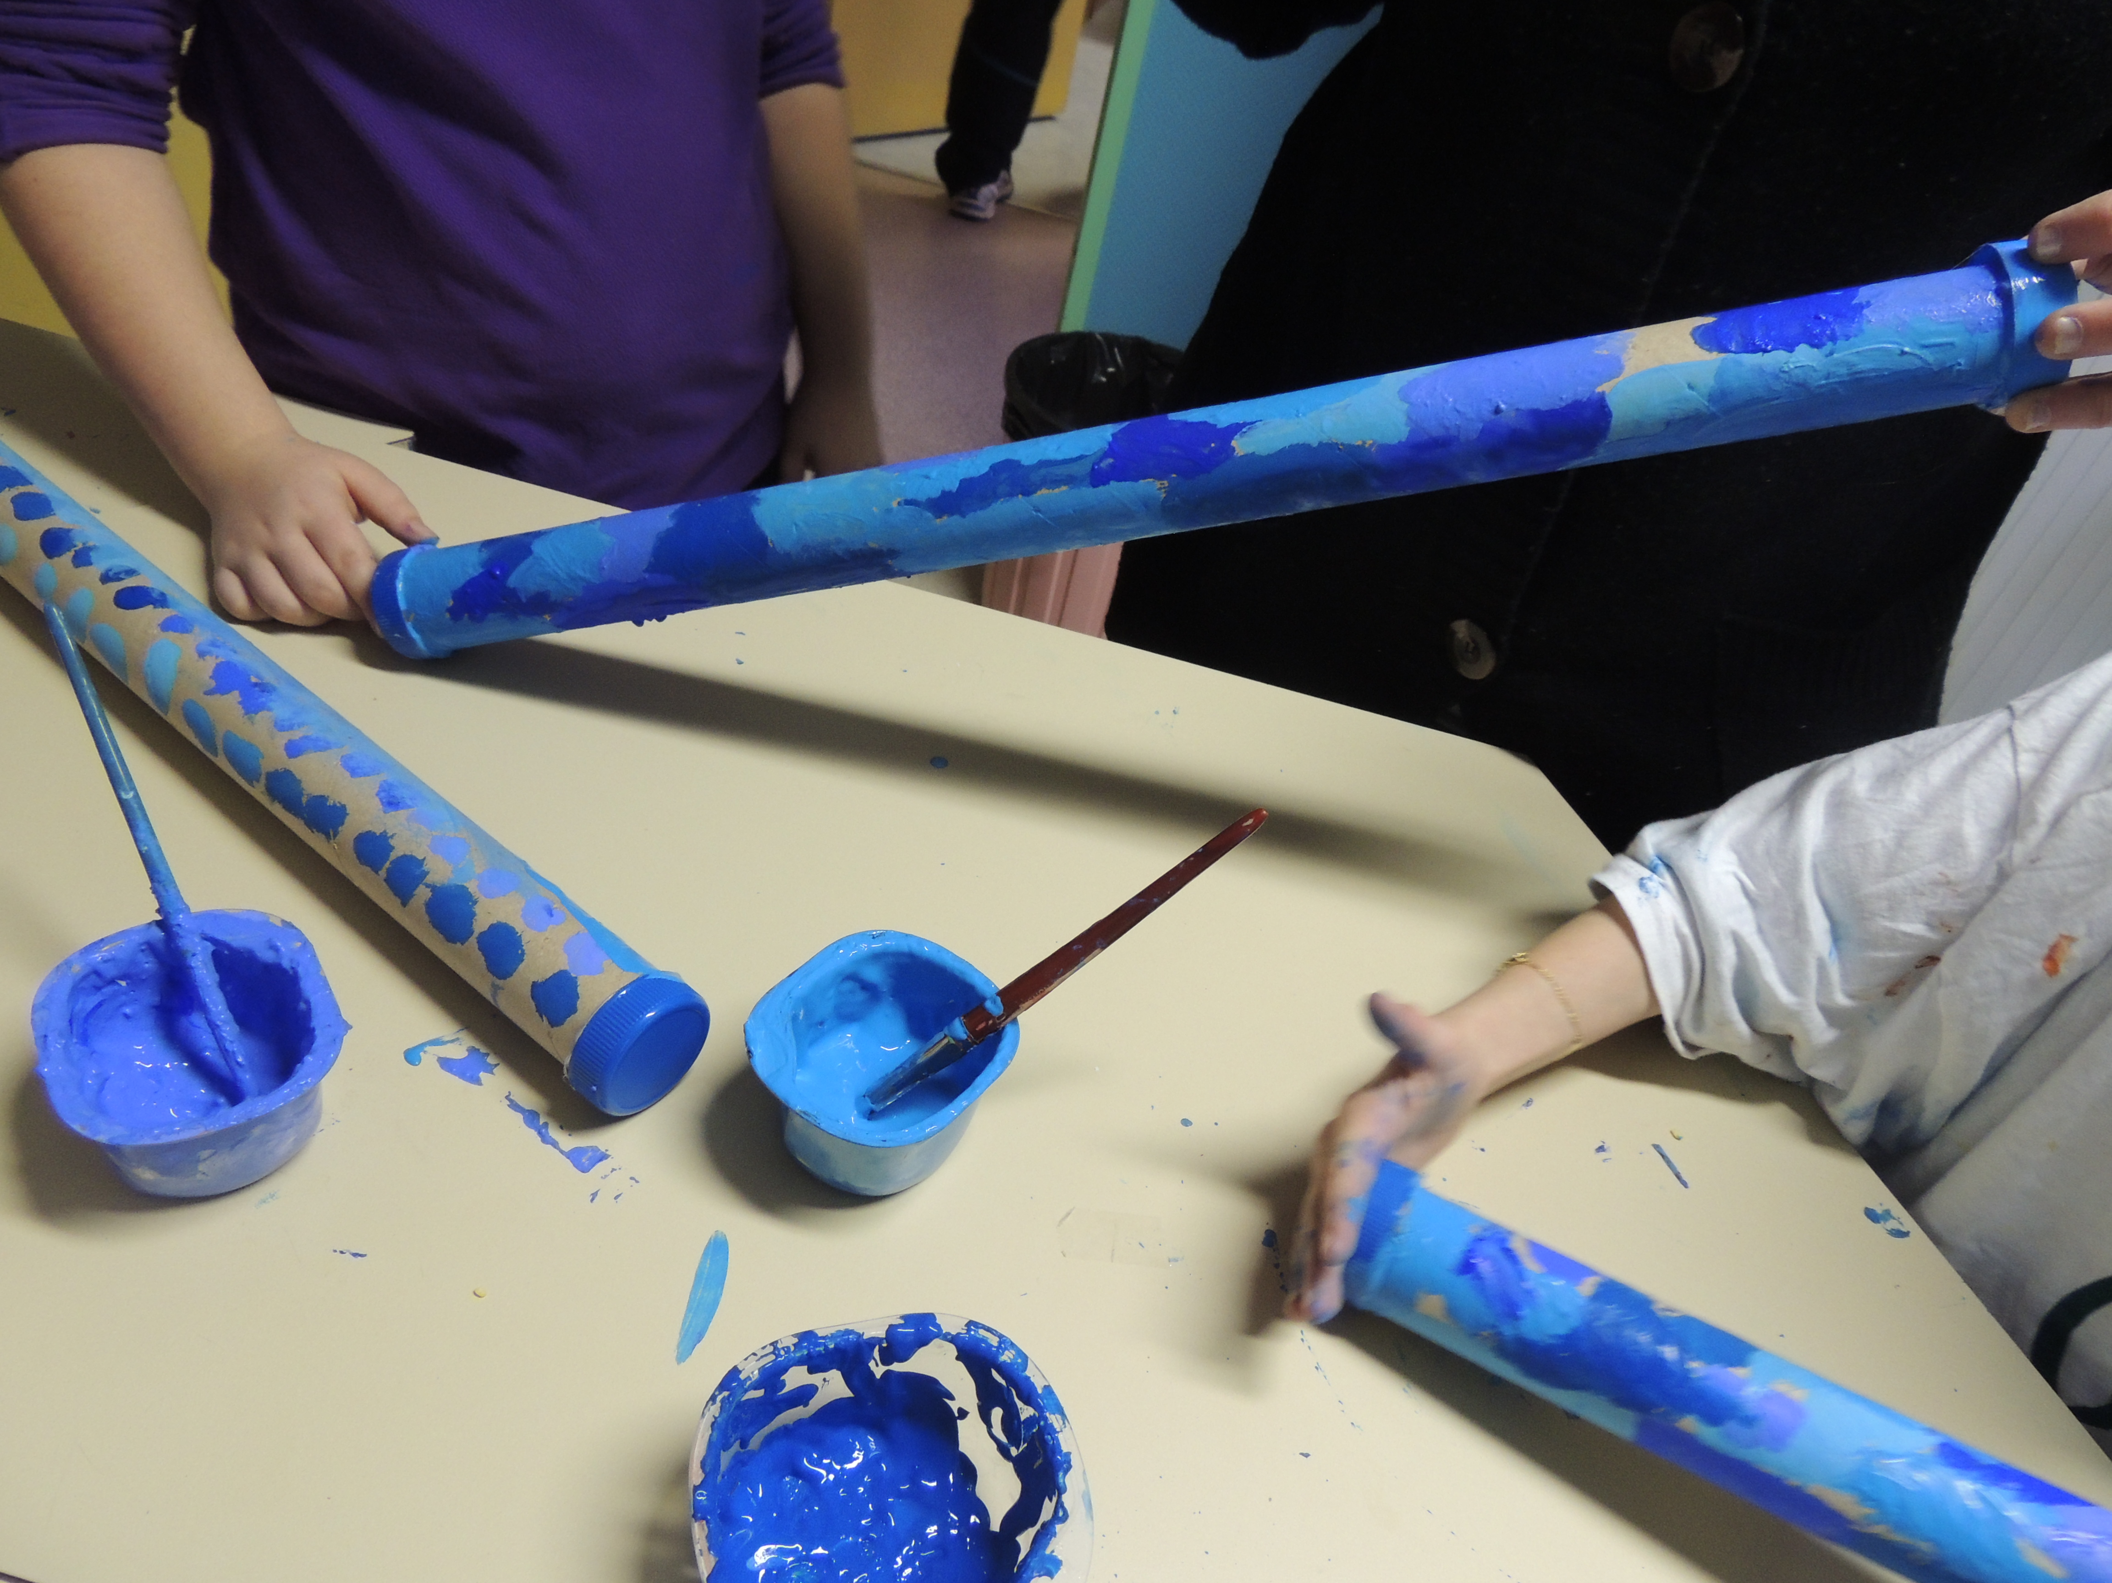

4. Fill the tube (3 tablespoons) seeds.

5. Close the rain stick.

6. Now you can paint it and decorate it the way you

like…

