eTwinning+ countries  Identify countries with 4 directions: North South East West  1 Norway  2 Iceland  3 Tunisia  4 Azerbaijan | 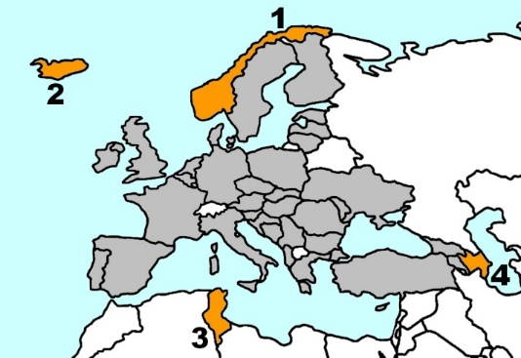

Countries of the Eratosthenes Project  Identify the country with the numbers 1 2 3 4  Brazil  Argentina  India  Malaysia | 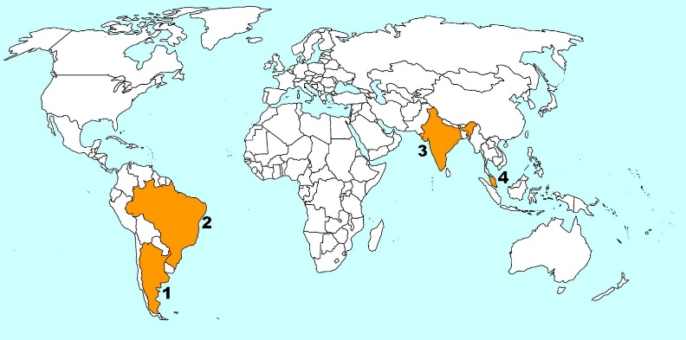

The instruments | What tool to use to check the verticality of an object?  What tool to use to check the horizontality of an object?  What tool to use to measure an angle?  What tool to use to verify that an angle is right?
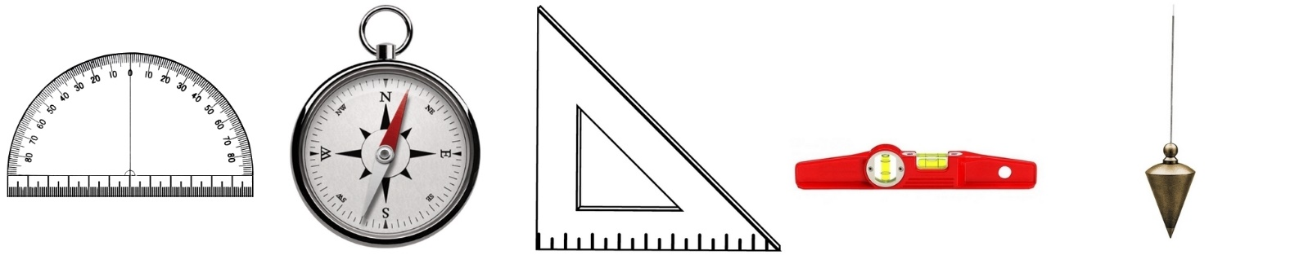
Protractor Compass Set square Spirit level Plumb bob

Geometry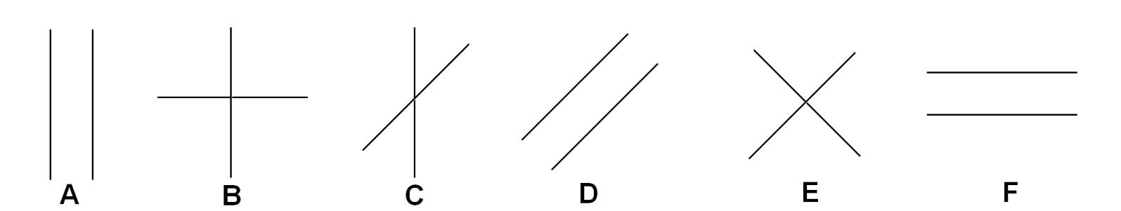

Which of these lines are parallel?
Which of these lines form a right angle?
Zorro
Look at the three stages of construction of this funny "Z".
The two angles colored in black have a particularity: which one?

The Earth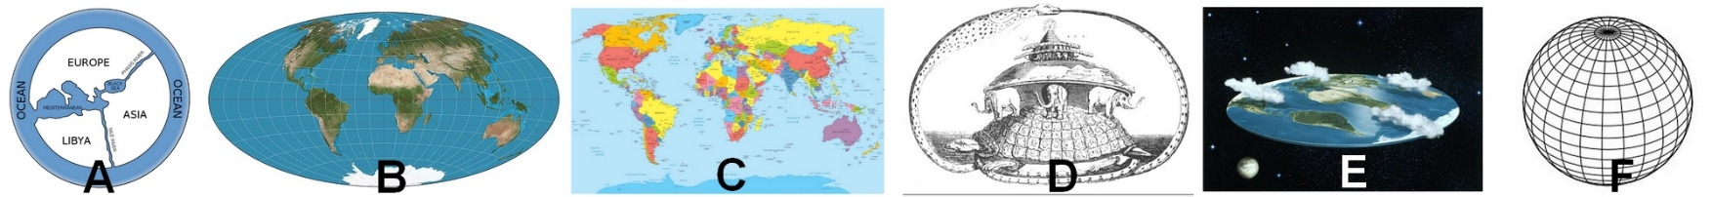
Which image is most similar to the shape of the Earth?

The Sun
In which direction do we see the Sun rise?  Nord  Sud  Est  Ouest | In which direction do we see the Sun set?  Nord  Sud  Est  Ouest | In an eTwinning country, in which direction do we see the Sun at the highest point in the sky?  Nord  Sud  Est  Ouest

The day and the night
How to explain the alternation of day and night:

Earth revolves around the Sun
The Sun revolves around the Earth
Earth revolvesaround itself

