Kirsi Neuvonen

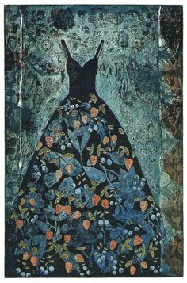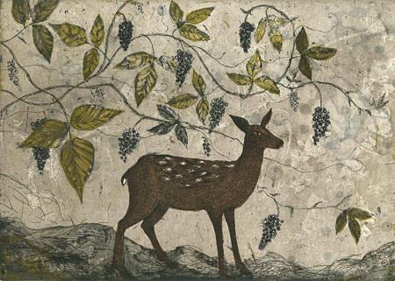

She was born in 1960 in Keuruu. Right now, she lives and works in Jyväskylä.
Studied at Senior High School of Arts, Savonlinna 1976–1979, Department of Visual Arts, the College of Orivesi 1979–1980, Lahti School of Arts 1980–1984.
Participated in numerous Finnish group and collective exhibitions, international exhibitions of Finnish Art, Printmaking Biennials and Triennials e.g. in Jyväskylä, Finland; Belgium, Italy, Yugoslavia, Poland
Japan, Holland, France, Norway, England and Ireland.
Private exhibitions in France, Sweden, England and Scotland
Kirsi Neuvonen’s production is often serial. Her recurring basic themes include dresses, houses, trees, fountains, pitchers and strong classical maidens. Her lines are delicate and the backgrounds of rich autumn colours are given their timeworn effect by patination.

