MIGRATION
The EU is planning to achieve by 2020, compared to 2010:

The proposed actions focus on the following key areas:
A. Integration through participation.
B. More action at local level.
C. Involvement of countries of origin.

Immigration in Europe in 2015
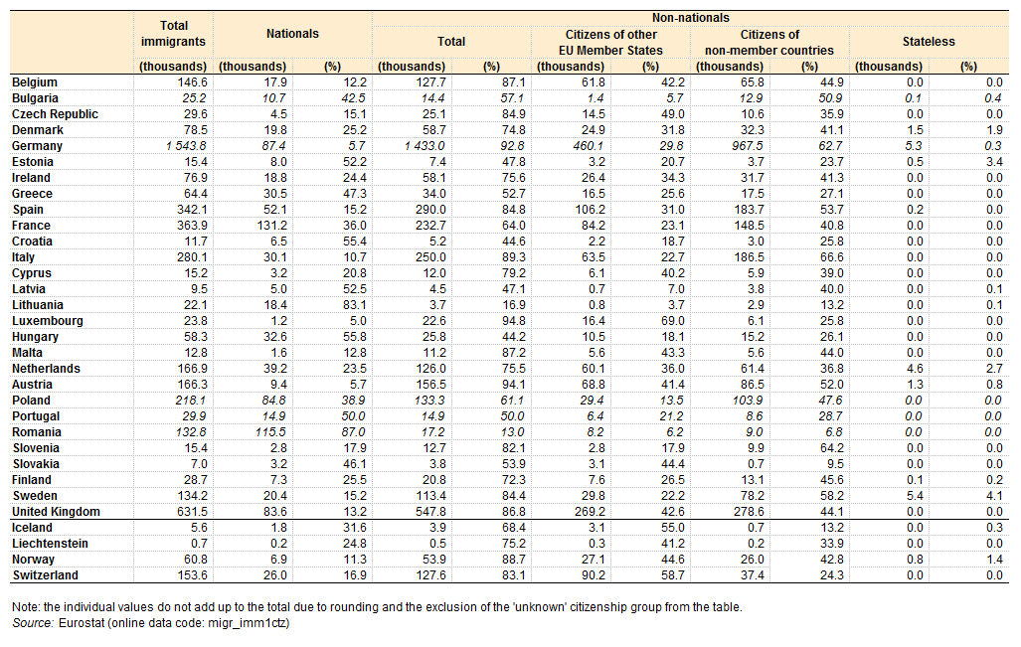
There was about 214 million International migrants and 42 million refugees in the World in 2017. According to European Commision there are approximately 4.5 million illegal refugees living in different EU countries, mostly in Germany, Italy and France. Many Europeans think that migration policy should be more strict, because many EU countries have problems that affect their own citizens drasticly.
The Asylum, Migration and Integration Fund (AMIF) was set up for the period 2014-20, with a total of EUR 3.137 billion for the seven years. It will promote the efficient management of migration flows and the implementation, strengthening and development of a common Union approach to asylum and immigration.
Basic allocation for Latvia under AMIF fund is €13.751.777,00.

Migration in Latvia from 1986 to 2011
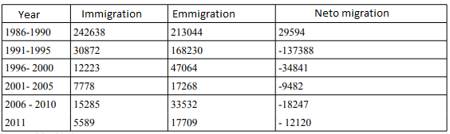
In accordance with data provided by the Office of Citizenship and Migration Affairs, 73 965 third country nationals are registered in Latvia as at 1 January 2017. About 258 thousand people are foreign-born, which is 13,1% of population. Many non-nationals are former Soviet Union citizens. They are permanently resident in Latvia but have not acquired Latvian citizenship. Citizens of Latvia are recognized by Citizenship Law. Many chose to receive Russian citizenship, be categorized as a non-citizen, or become a citizen of other country rather than go through the complicated process of naturalization.

Main countries of citizenship and birth of the foreign-born population in Latvia in 2016
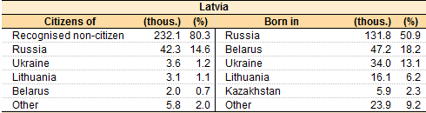
From 2010, more than 110000 or about 8 percent of inhabitants emigrated from Latvia and after regaining independence in 1991, Latvia has lost around 30 percent of its population. Economic migration, low birth rates and high mortality are main contributing factors to that. Borders are open, information about life in other EU states is available and that’s why people are leaving country, looking for a better life conditions. Main leavers are people aged 25-49 and the most important fact is that they are a majority of working power in Latvia. They choose not to come back after migrating, simply because they don’t see reason for that. Smallest cities and poorest regions are mostly affected by people emigration, losing more of its population than other regions. In 2017 population of Latgale decreased by 6300 people, which was the largest number of all other regions, but Riga, Capital city of Latvia, lost 1800 people, which was the smallest number. Main destinations for Latvians are Germany, United Kingdom, Ireland and Sweden in Europe, CIS countries like Russia and Ukraine, USA and Canada.
Migration paths in Latvia
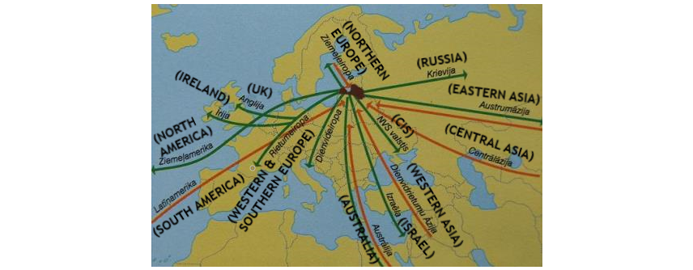

Latvia took part in the refugee crisis in 2015, agreeing to admit 531 refugees from Greece and Italy. In 2017, 346 refugees were admitted, but most of them left country. People with a refugee or alternative status have the same rights and obligations as everyone else, as stipulated in the Latvian Constitution. Latvians, like many other people in Europe, are against admitting refugees, 55% of Latvians think that Latvia should not accept any refugees at all.

