3. Fighting poverty and social exclusion
Europe 2020 is the European Union’s ten-year jobs and growth strategy. It was launched in 2010 to create the conditions for smart, sustainable and inclusive growth. Five headline targets have been agreed for the EU to achieve by the end of 2020. These cover employment; research and development; climate/energy; education; social inclusion and poverty...
I.EU PLANNED TO INTRODUCE
One of the targets of the Europe 2020 headline indicators is to reduce poverty by lifting at least 20 million people out of the risk of poverty or social exclusion by 2020.

II.SITUATION IN LATVIA AT 2010 AND WHAT IS MEANT TO BE ARCHIEVED

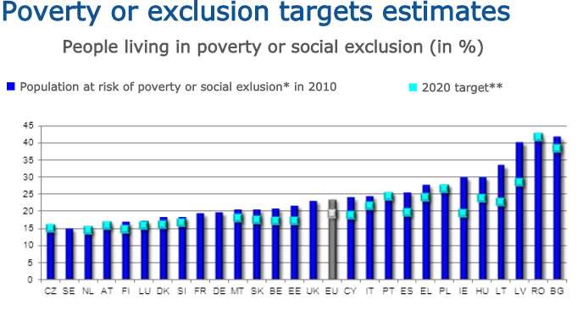
III.SITUATION IN LATVIA FOR 2017./2018.
National target: 121 thousands less people in combined poverty.

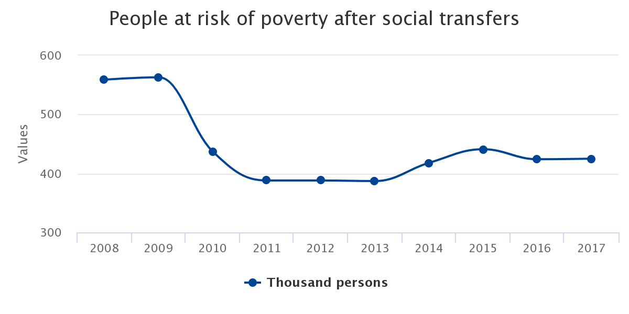
People at risk of poverty or social exclusion

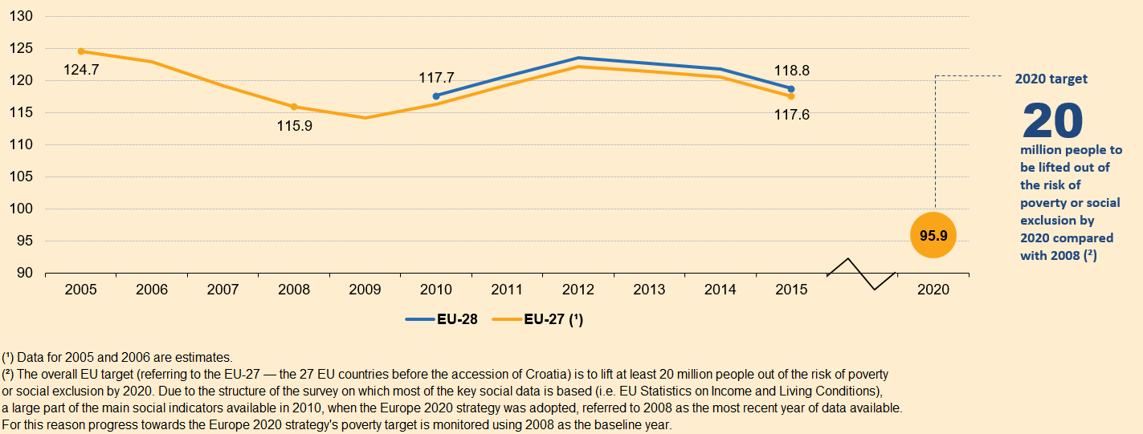

Inability to face unexpected financial expenses
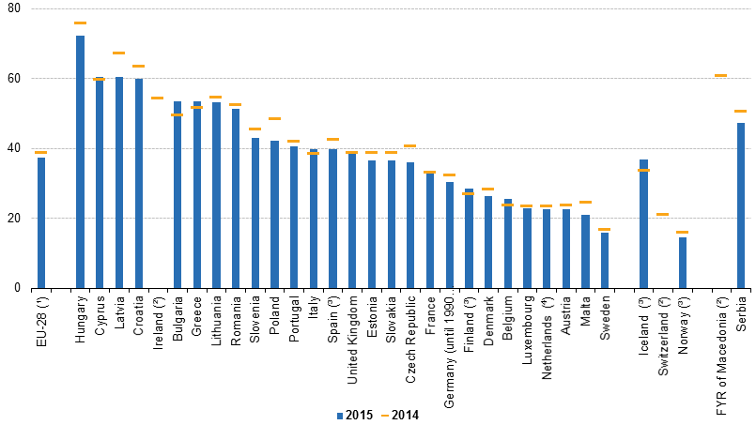
People (aged under 60) living in households with very low work intensity
