The EU is planning to achieve by 2020, compared to 2010

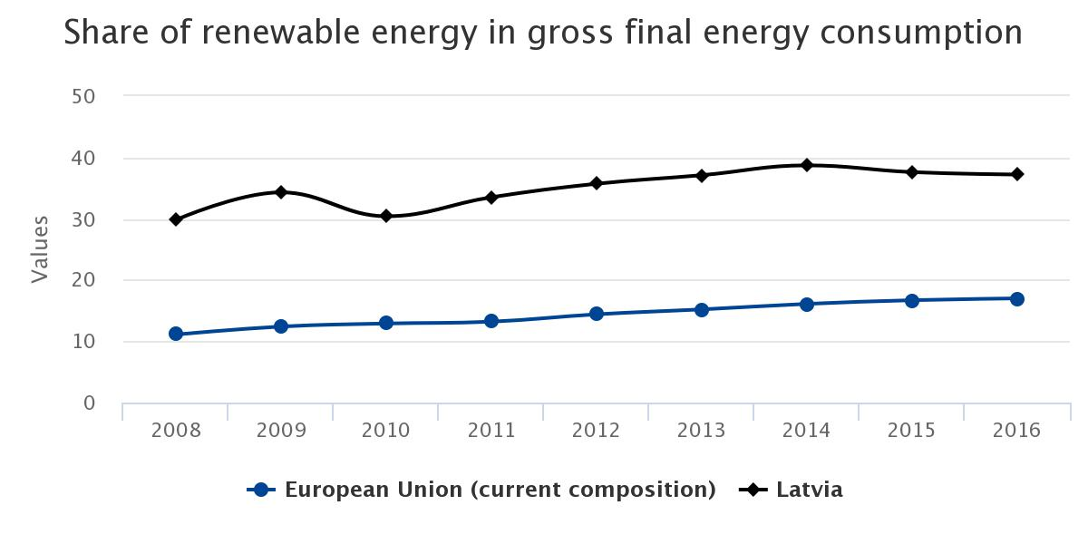
- EU target: 20 % from renewable sources
- National target:40% from renewable sources
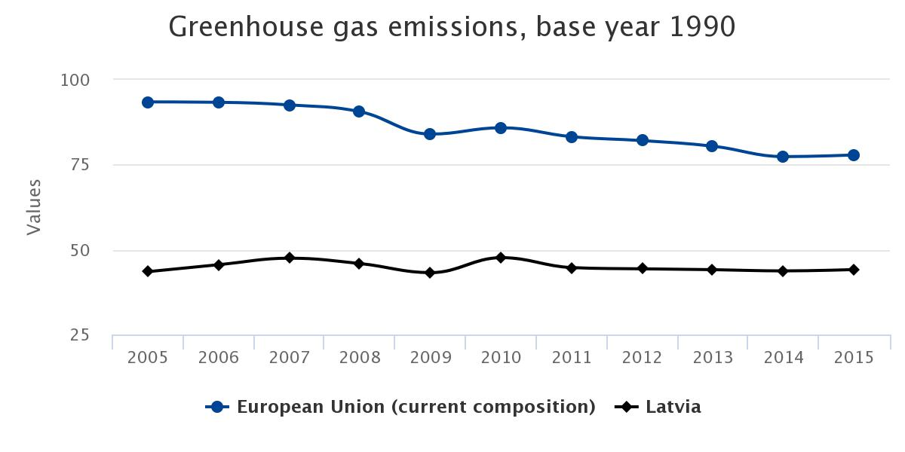
- EU target: 20% less
- National target: 17% more comparered to 1990 levels

Conclusion
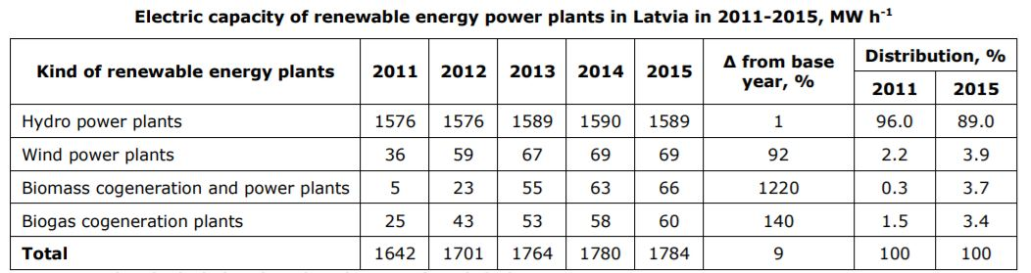
52% of energy produced in Latvia comes from hydroelectric power stations

The country’s GHG emissions did not rise notably between 2010 and 2012, staying within the national target to limit emissions increases to 17 % by 2020. Since 2008, Latvia has fulfilled its commitment on primary energy consumption and has steadily moved towards its target of 40 % renewable energy in gross final energy consumption; this is the second most ambitious target for this indicator in the EU.
The construction of new large HPPs is not planed in Latvia. For this reason, any increase in electric capacity is possible if increasing the capacity of biomass, wind and biogas RES plants.

Key policy directions and measures for achievement of the target to limit GHG emissions:
Limitation of non-ETS sector emissions
The aim is to reduce GHG emissions in the non-ETS sectors – small-size energy
production, small industry, transport, agriculture, households and waste management. The planned measures:
– To foster the use of RES in production of heat and electricity
– To introduce a sustainable transport system – to foster development of the public
transportation, use of RES and electricity in the transport sector
– To increase the energy efficiency in the production and use of heat and electricity
Research, innovations, public information

The aim is to promote transfer of products and technologies reducing GHG emissions in Latvia, as well as to support measures in order to change public behaviour. The planned
measures are as follows:
– Raising of public awareness regarding the importance and possibilities of GHG
emission reduction;
– Development of technologies reducing GHG emissions, including implementation of
pilot projects.
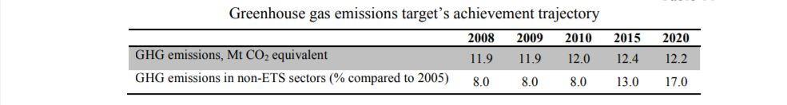

The structure of Latvia‟s emissions has several peculiarities that should be taken into consideration when planning further measures of emission limitation. The ETS as an emission reducing mechanism covers only 23% of the GHG emissions of Latvia, which is the second lowest share in the EU. It means that such non-ETS sectors as the small-size energy production, small industry, transport, agriculture, households, waste sector are of key importance in reduction of the overall emissions of Latvia. Moreover, the largest part (62%) of the emission structure of the abovementioned non-ETS sectors is comprised by sources in transport and agriculture that are hard to be influenced. Other non-ETS sectors, where emissions are usually decreased by measures for fuel changes, in Latvia already widely use environmentally friendly fuels – wood and natural gas.

