2. Youth employment
Europe 2020 is the European Union’s ten-year jobs and growth strategy. It was launched in 2010 to create the conditions for smart, sustainable and inclusive growth. Five headline targets have been agreed for the EU to achieve by the end of 2020. These cover employment; research and development; climate/energy; education; social inclusion and poverty...
I.EU planed to introduce
- 73% of people aged 20-64 must be working
- Education
  - - reduce the number of early school leavers to just 10%
  - - at least 40% of people aged 30 to 34 must have achieved higher education

II.SITUATION IN LATVIA AT 2010 AND WHAT IS MEANT TO BE ACHIEVED 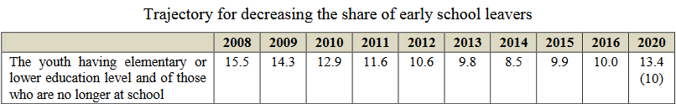

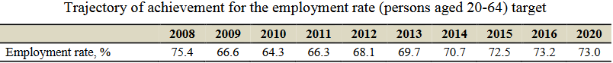

III.SITUATION IN LATVIA FOR 2016/2018
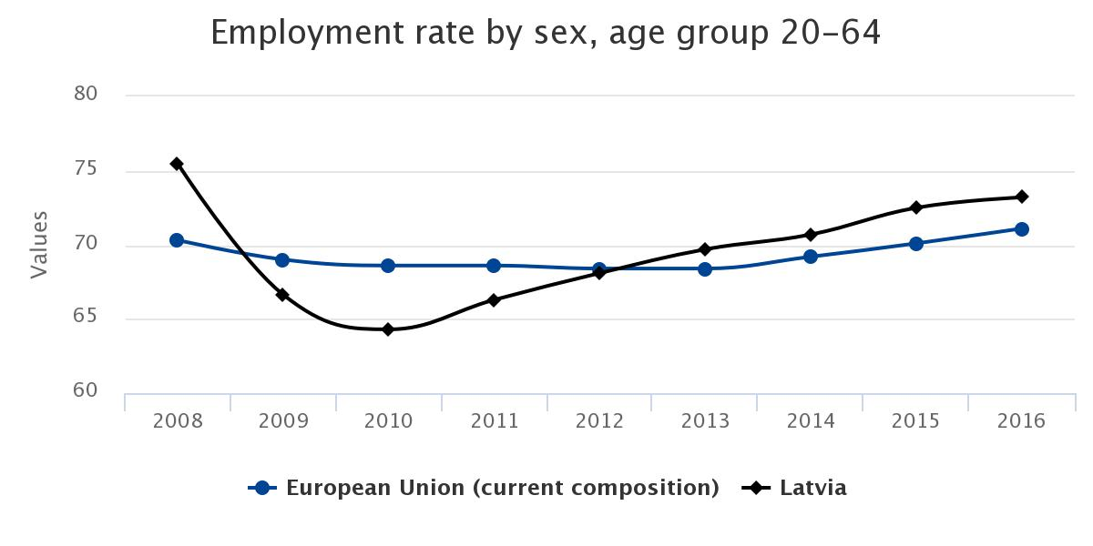
In 2016,the target set for 2020 has already been exceededin relation to the level of employment. Economic growth is expected to further boost the employment increase,however, the growth rate might slow down as the growth will be mainly determined by the increase in productivity. The increase in employment rate will be partially affected by theexpected decline in the number of working-age population.

IV.SITUATION IN THE REST OF EU FOR 2018
The euro area (EA19)includes Belgium, Germany, Estonia, Ireland, Greece, Spain, France, Italy, Cyprus, Latvia, Lithuania, Luxembourg, Malta, the Netherlands, Austria, Portugal, Slovenia, Slovakia and Finland.
The European Union (EU28)includes Belgium, Bulgaria, the Czech Republic, Denmark, Germany, Estonia, Ireland, Greece, Spain, France, Croatia, Italy, Cyprus, Latvia, Lithuania, Luxembourg, Hungary, Malta, the Netherlands, Austria, Poland, Portugal, Romania, Slovenia, Slovakia, Finland, Sweden and the United Kingdom.

Among the Member States, the lowest unemployment rates in February2018wererecorded in theCzech Republic (2.4%), Germany and Malta(both 3.5%)as well as Hungary(3.7% in January 2018).The highest unemployment rates were observed in Greece(20.8% in December 2017) and Spain(16.1%).

Compared with a year ago, the unemploymentrate fell in all Member States except Estonia where it increased (from 5.8% to 6.5% between January 2017 and January 2018). The largest decreases were registered in Cyprus(from 12.6% to 9.6%), Greece (from 23.4% to 20.8% between December 2016 and December 2017) and Croatia(from 12.0% to 9.6%).

