Music in the kitchen
Materials:
- Household liquids of different densities (water, dishsoap, honey, alchocol, oil, syrup)
- Glass Funnel
- Food coloring
- Glass bottles
- Graduated cylinder
- Beaker (100 or 200 mL)
- Wooden and plastic mallet (stick)
- Sewing thread
- Coat rack (hanger)
- Phyphox app for measuring frequency

Instructions:

You will explore how density of fluids affect their frequency. For this experiment you will use 6 liquids of different densities.
In order to measure the frequency of the sound you will use the Phyphox application. Download the app on your mobile phones. For measurement you will use the audio autocorrelation meter.
Sketch:

Questions:
1. What is density and what does it depend on?
_________________________________________________________________________________
_________________________________________________________________________________.
2. Suggest two ways of determining the density?
_________________________________________________________________________________
_________________________________________________________________________________.
3. How can you determine the liquid density using only graduated cylinder and funnel?
_________________________________________________________________________________
_________________________________________________________________________________.
4. Complete the sentence:
What is the liquid ____________________, the frequency of the sound we produce is ______________.
5. Sort the default liquids from least to the highest density and then check your predictions by experiment. Show the results in the picture below.

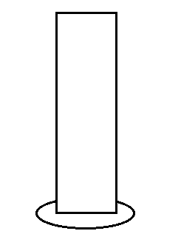
Predictions: Results:

1. __________________ 1. __________________
2. __________________ 2. __________________
3. __________________ 3. __________________
4. __________________ 4. __________________
5. __________________ 5. __________________
6. __________________ 6. __________________
7. __________________ 7. __________________

Put each of the 6 liquids in a separate bottle and hang them on the holder by the sewing thread. Strike with a wooden or plastic stick on the marked place on the bottle to produce the sound. Measure the sound frequency by using a cell phone. Three measurements are required for each fluid.

6. Write the results of the measurements in the table below.
Liquids |  | Frequency (Hz)
 |  | Measurement 1 | Measurement 2 | Measurement 3 | Measurement 4 | Measurement 5 | Mean value
1. | wooden stick
 | plastic stick
2. | wooden stick
 | plastic stick
3. | wooden stick
 | plastic stick
4. | wooden stick
 | plastic stick
5. | wooden stick
 | plastic stick
6. | wooden stick
 | plastic stick

7. Observation:
_________________________________________________________________________________
_________________________________________________________________________________.
_________________________________________________________________________________
_________________________________________________________________________________.

8. Conclusion:
What is the liquid ____________________, the frequency of the sound we produce is ______________.

