Various parts and layers of a coconut

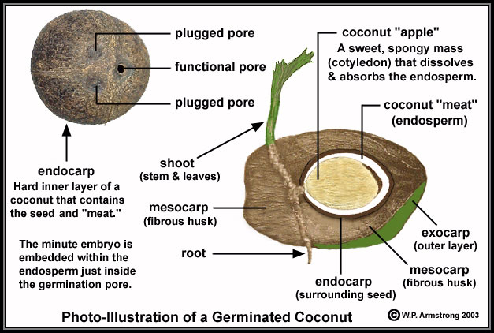
taken from: http://4.bp.blogspot.com/-A2bjxcWFNFo/Th5SKwE5IeI/AAAAAAAACtE/yU451xC6lh4/s1600/coconut_milk.jpg (09.02.2015)

