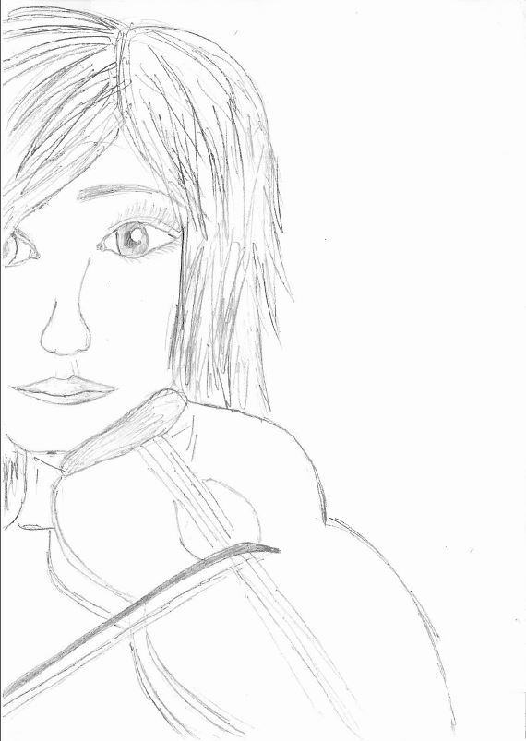

Grace Kind is a high school student and she studies music at conservatory. She is good at all her subjects . She is quite successful and very polite. She is 16 years old and she is tall,but feeble with hazel eyes and short fair hair.
It is 9 o’clock in the morning and she comes to the bus stop with some books and a violin case in her hands so as to go to school. The bus stop is too small and crowded.She starts waiting for the bus like the other people at the bus stop. She has got a very important practical exam and she wants to go to school as soon as possible on that day. The bus arrives at the bus stop after twenty minutes. When the bus arrives at the bus stop,people try to get on the bus by pushing each other. Grace waits patiently for her turn to come.Just as she tries to get on the bus,a rude man with a huge body pushes Grace,says “sorry I’m in a hurry”,jumps the queue and gets on the bus.
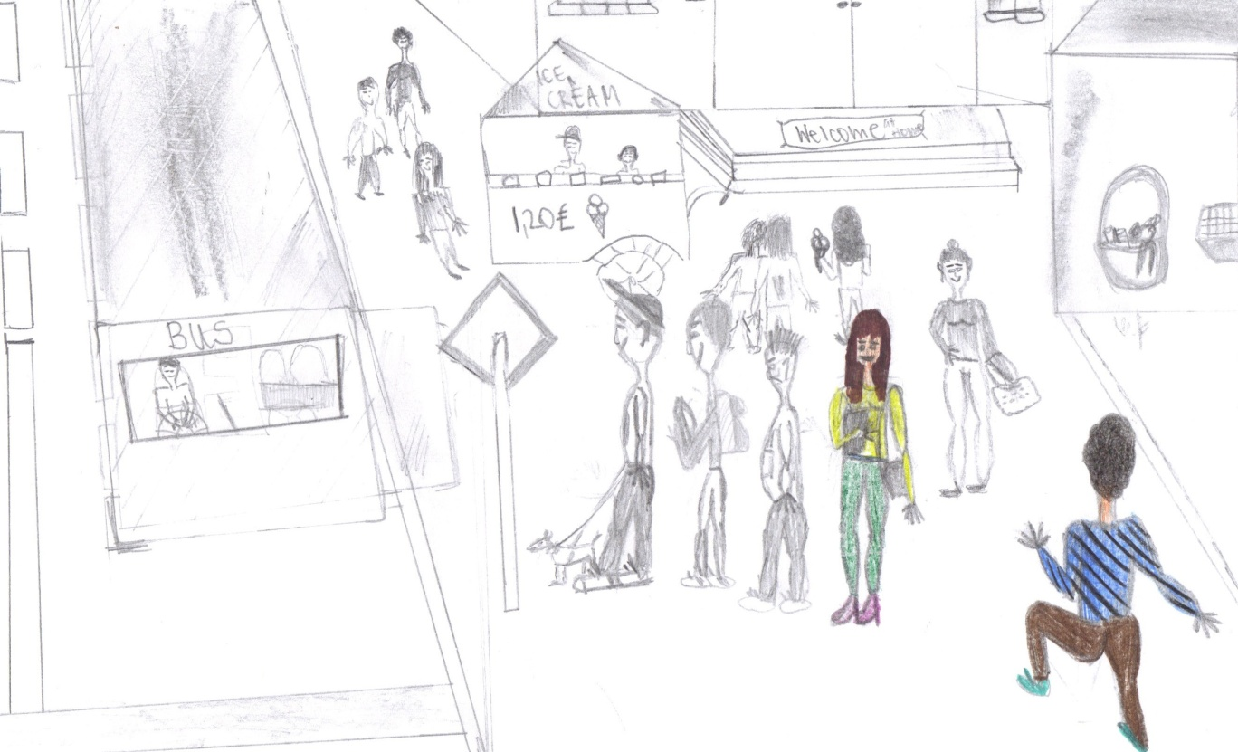

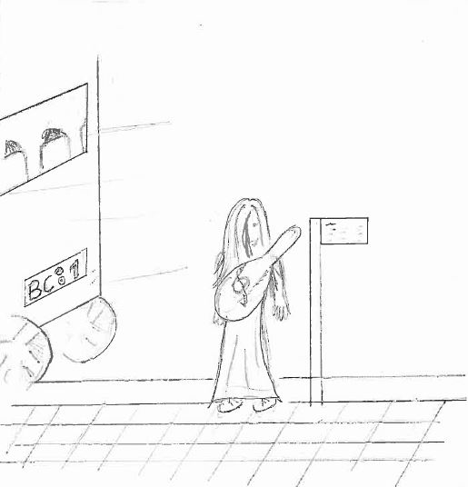
When the man pushes Grace ,she backs a few steps and falls down.Nobody helps her stand up. In the mean time the bus leaves the bus stop.Grace is shocked and furious and she says nothing,but represses her anger.She thinks she hates men. She checks her watch .It is 8.20 a.m. She knows that the next bus will be at the bus stop in half an hour . She starts waiting impatiently,but she cannot help thinking her exam starting at 9 o’clock.She hasn’t got enough money to take a taxi either.
The second bus comes at 8.50 and she gets on it. She sees all the seats in the bus are full and most of the passengers are students. She stands near a seat and holds it. A septuagenary man gets on the bus at the next bus stop. He is too old to wait standing ,but no one gives him a seat. She can’t stand and she says ;
--why don’t you give your seat to that uncle ?
--What’s that to you? One of the students replies and adds
--- This old boy does not need to sit anywhere as he will die in a few years.We are more weary than him.If you like,you can get him to sit on your lap.
The other boys nod him and look at Grace angrily. Grace is speechless , says nothing and looks at the old man desperately.
---“Do not worry,dear and I will tell you a short Indian story.When you listen to it,you will understand what I have felt” says the old man and begins to tell the story.

One day a sadhu goes to the river and there he notices a scorpion struggling in the water.The scorpion cannot swim and if the sadhu does not save it,it will drown.The monk rescues it,but the scorpion stings him.The sadhu flings his hand in pain and the scorpion goes flying back to the river.This drama goes on for several times….
Then a hunter watches the sadhu and the scorpion.He comes closer and says
---Forgive me for my frankness,but Why don’t you give up and let the scorpion drown as it is going to sting you again ?

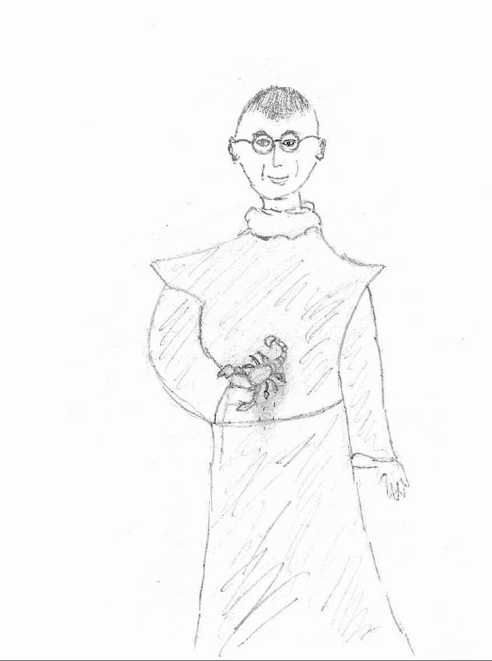
The sadhu replies ;
-----My dear child,it is the scorpion’s nature to sting.My dharma is to help any creature of any kind-human or animal. Just as he is not leaving his nature ,why should I leave my nature?????
That is the story,my dear.I love today’s youth.I am sure they will learn through experience one day.Why should I hate him? I feel I am young at heart.
While the old man is telling the story,the young boy and his friends eavesdrop on the story too.After a while……………..

After a while, they ( the young boy and his friends) realized the morality of the Indian story and the boy decided to let his seat to the old man :
----"OK, old man. Have my seat! I understand I'll be old one day too. I get it! I must help my neighbour".
Grace was extremely happy for the old man and thanked the students.
But unfortunately for her, misfortune was going on : the bus broke down and had to stop in the middle of nowhere! She thought she would never be on time for her exam! Sadly, she went down the bus.
While she was walking on the zebra crossing, a car stopped by and she heard the driver ask :
---- "Where are you going, young lady?".
She really thought the driver was a mean guy who was hitting on her but after glimpsing the man through the window of the car, she realized he was her music teacher! He asked again :
---- " Are you going to school, Grace? Because I am! I can give you a lift to school if you want."
Of course, she needed this lift! Thanks to her music teacher, she was on time at school for her exam.
Then, after her exam, she thought of the old man and his story and of her teacher and the lift. She was thankful. Her heart was fulfilled with happiness because at the beginning of the day, she was pessimistic about the society she was living in, thinking selfishness was the current social phenomenom whereas at the end of the day, optimism was back!
She knew young and old people could still help each other on bad times.

