LEARNING FROM FAILURES
Walter was a small boy with long curly hair : he was smaller than the other boys of his age and
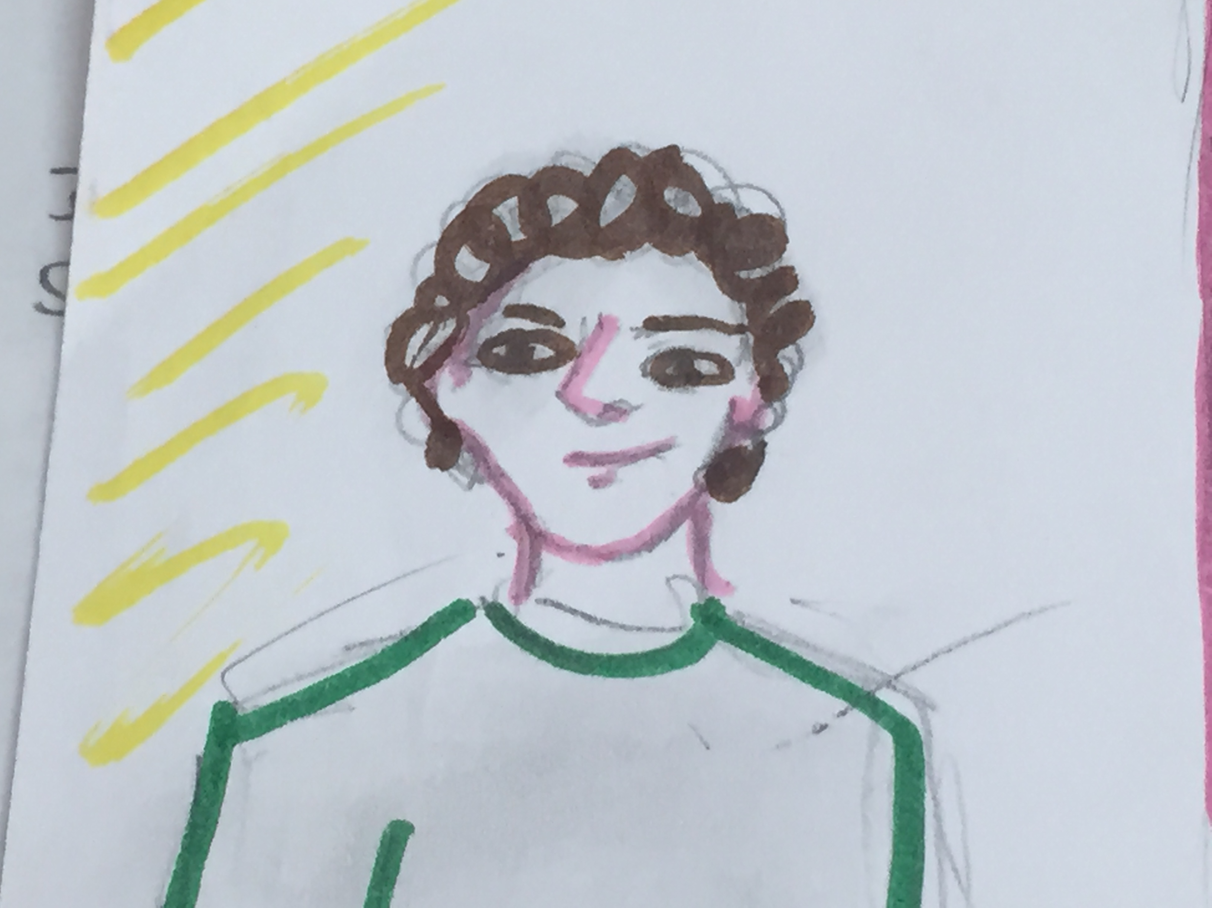
looking like a girl. At school, he was bullied by the other pupils of his class because of his look.
Jenny and Paul were the worst bullies ever. Jenny was older and Paul was taller than Walter. And they were always hanging around together : it was impossible to see Jenny without Paul and Paul without Jenny.
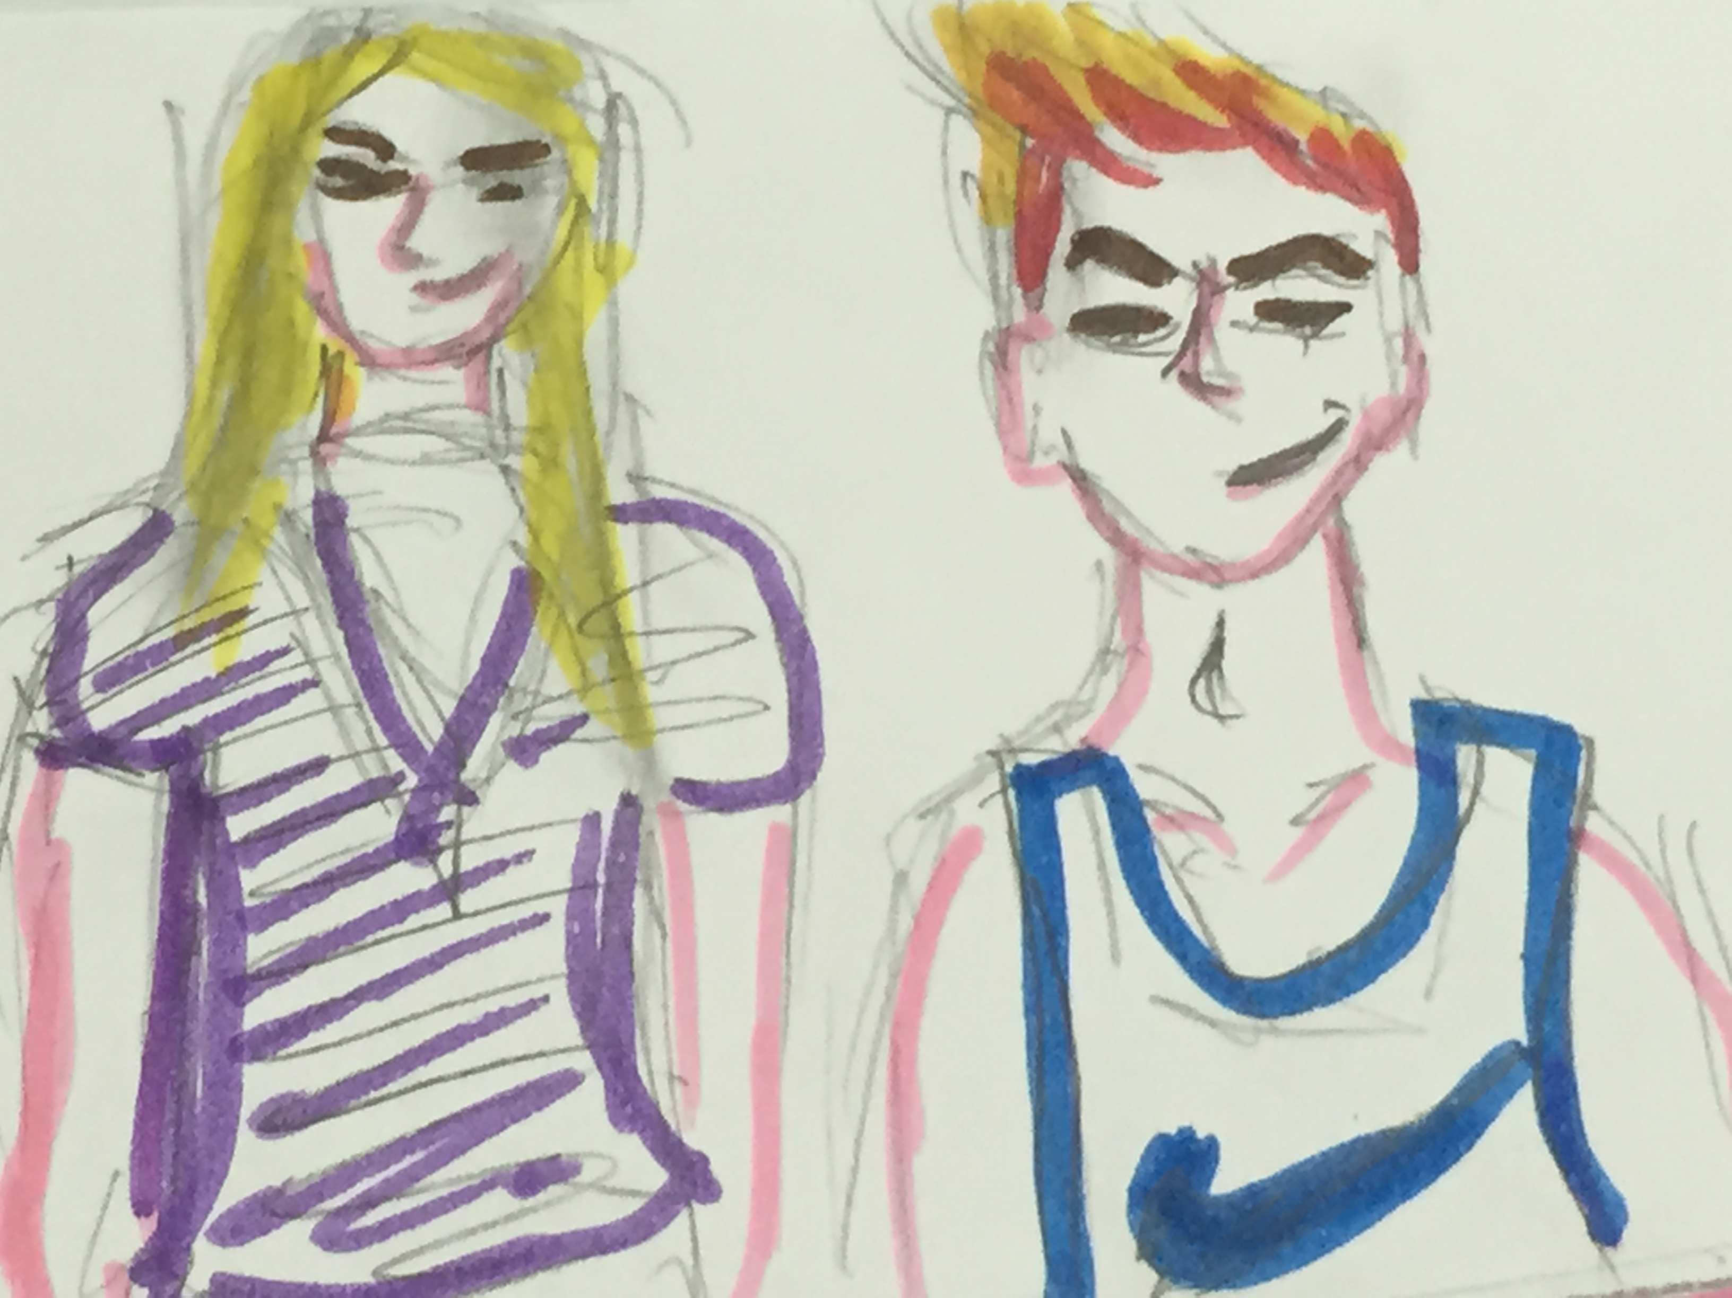
Here's what happened to Walter one day. The scene took place in winter, in December, last year :
Walter looked depressed and was in a sad mood that afternoon because at noon, Jenny and Paul were very naughty towards him and made fun of him at the canteen :
'Give me your lunch ! You're such a loser !' Jenny said.'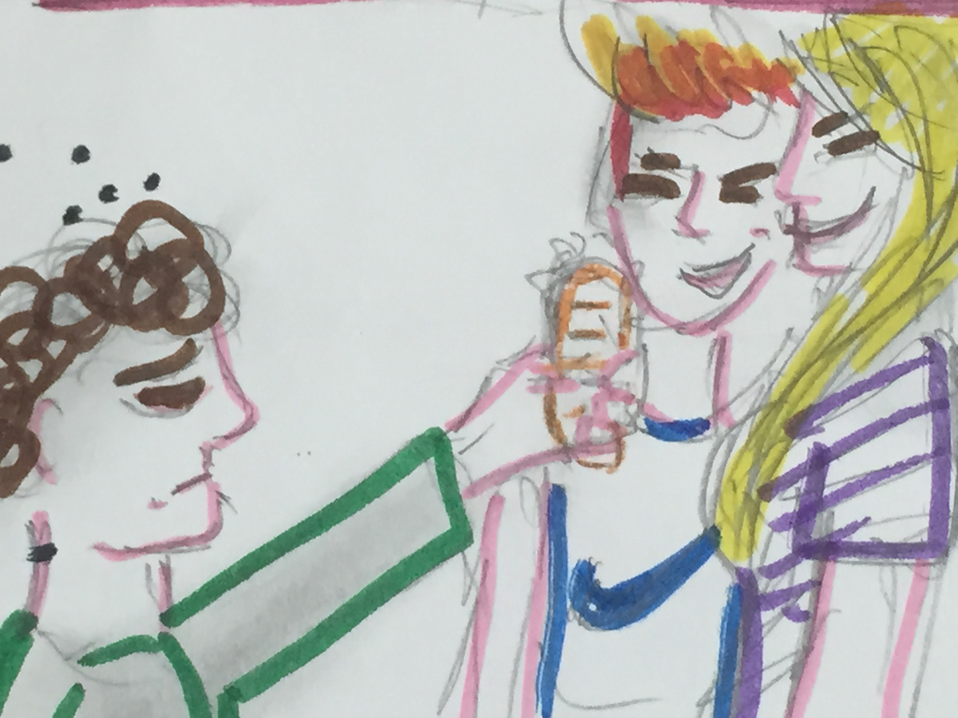But I'm hungry ! I can't give you my lunch !' Walter answered.
'I don't care you're hungry !You have no choice : you must give us your lunch or you will have loadsof problems.' Paul said.
'But ...' Walter tried to answer but Jenny and Paul took the glass of water and spilled it on him before he could finish his sentence.

Everybody was watching the scene and laughing at Walter, so Walter had to escape from the canteen without eating, alone.
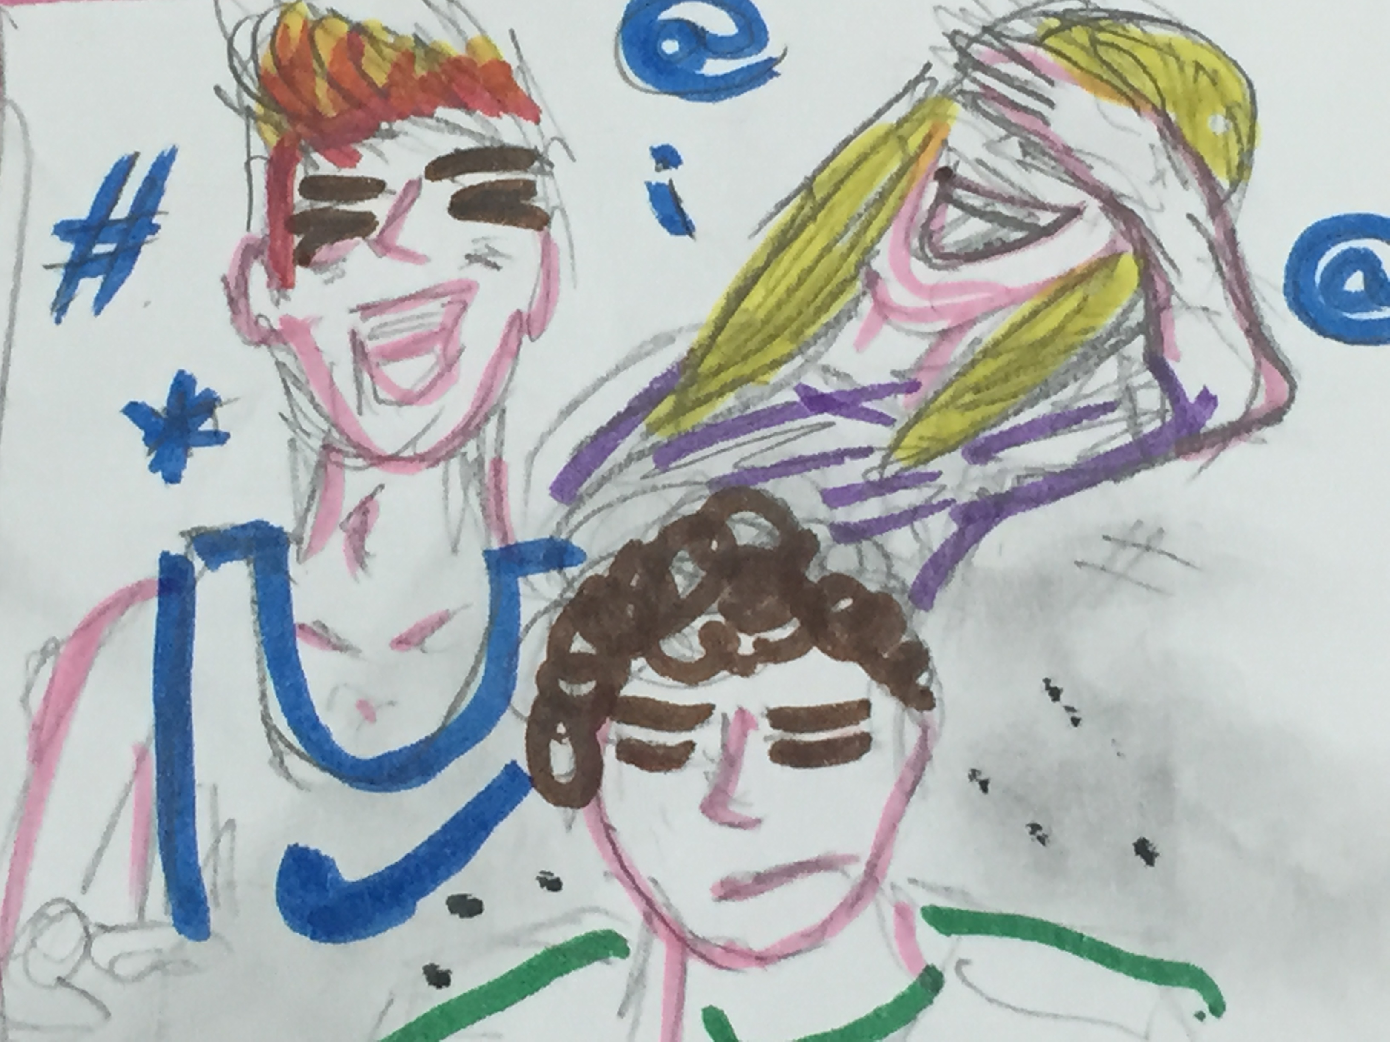
Next, later on that same day, while Walter was quietly walking in the corridor to go to the English class with Mr Benton, their English teacher, Jenny and Paul insulted and annoyed him :
'How are you, girly boy ? What's wrong, little dwarf ?' They both asked.
Walter started to cry.
Mr Benton, who was waiting for her pupils, heard someone crying in the corridor. 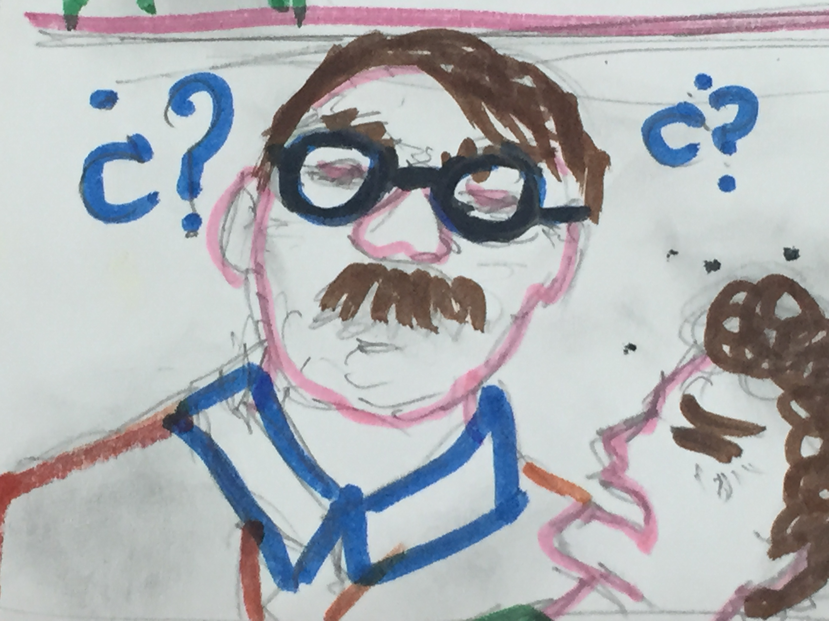
He went to the corridor and saw Walter crying. He asked : - What's the matter , Walter?
He answered: - Nothing Mr Benton. I'm not well.
But he had seen Paul and Jenny laughing and entering the classroom rushing.
As Mr Benton was a very alert teacher and he had already suspected some kids of making fun of him because of his height and his looking, he said : - Walter, trust me! I can help you. Tell me the truth and I won't betray you !
When Walter heard those words and looked at his loving gaze, he started to tell him about the vexations and the abuses he suffered by Paul and Jenny, he told everything speaking as in flood.
The next day, at lessons Mr Benton read a story about bullying at school, then all the students expressed their own comments and ideas : every student disapproved bullies and bullying. At last he asked if someone had got bullied. Nobody answered. 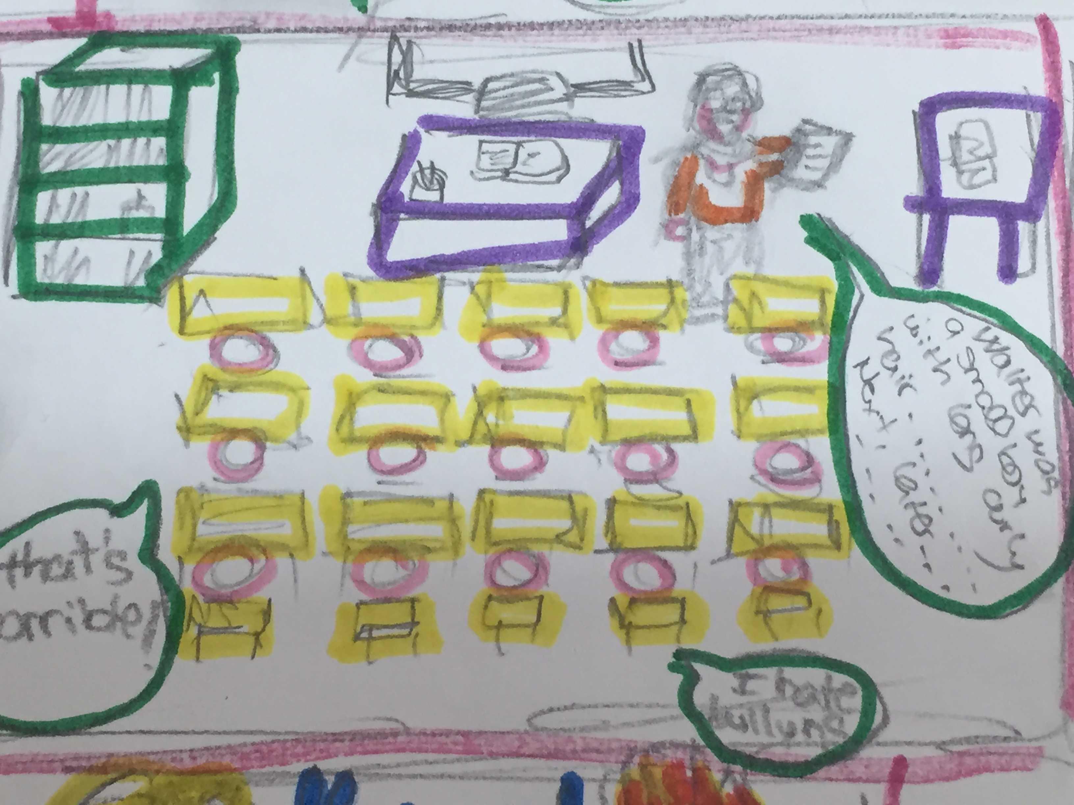
- I know that some of you have acted as bullies at school but I believe your words and what you have stated today and from now on nobody will get bullied or will be a bully anymore. Mr Benton said.
Differently , I will scourge you because I've got some proofs and I've seen something.
Paul and Jenny were stroken by Mr Benton's speech 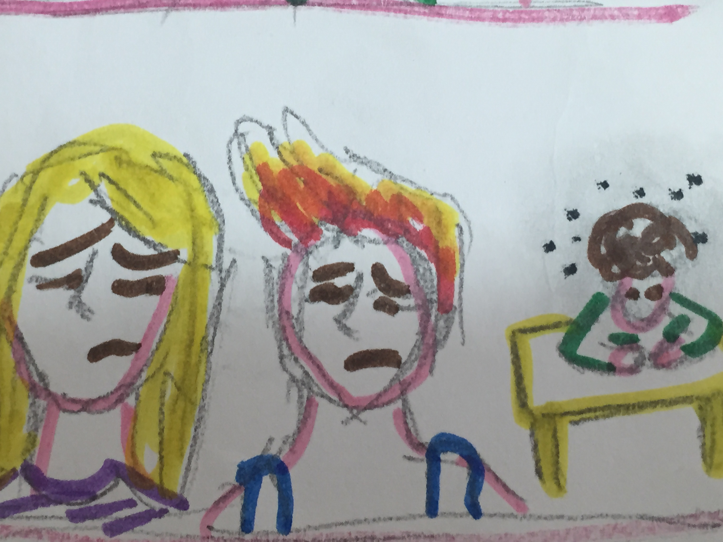and they understood how bad and stupid they had been and, since then ,in order to release themselves , got friends with Walter protecting him from other possible bully- guys .
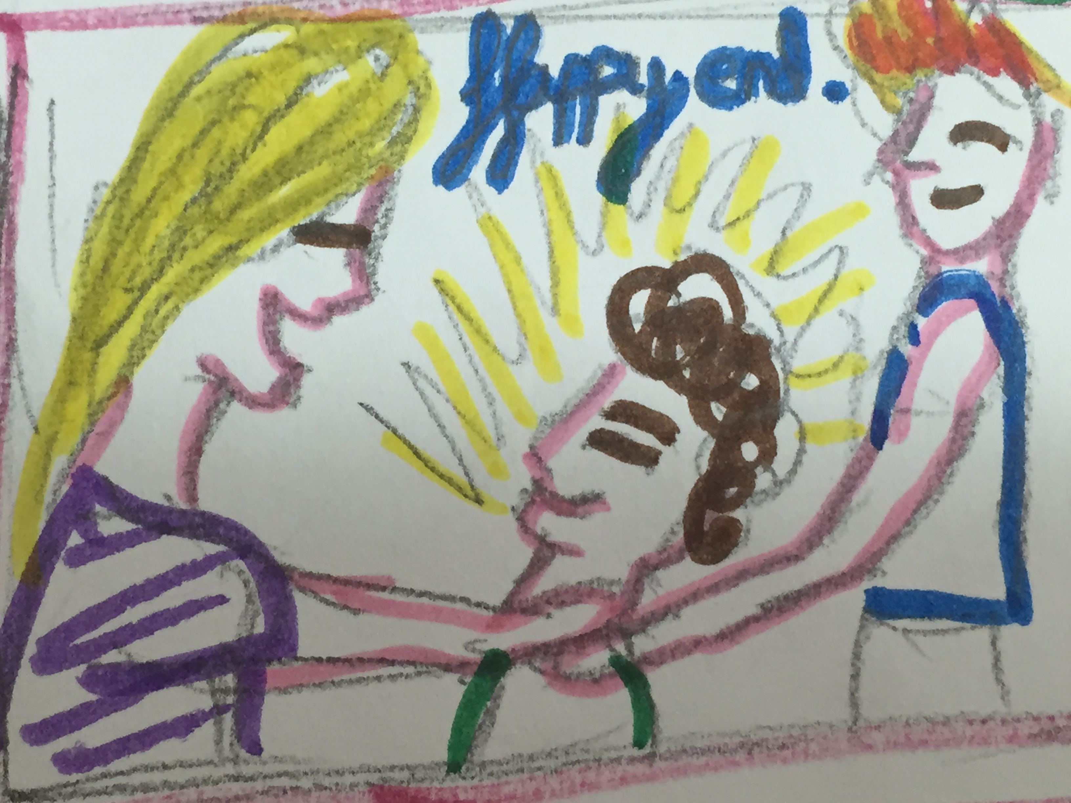
THE LAST UNDESIRABLE LETTER
Walter was a small boy with long curly hair : he was smaller than the other boys of his age and
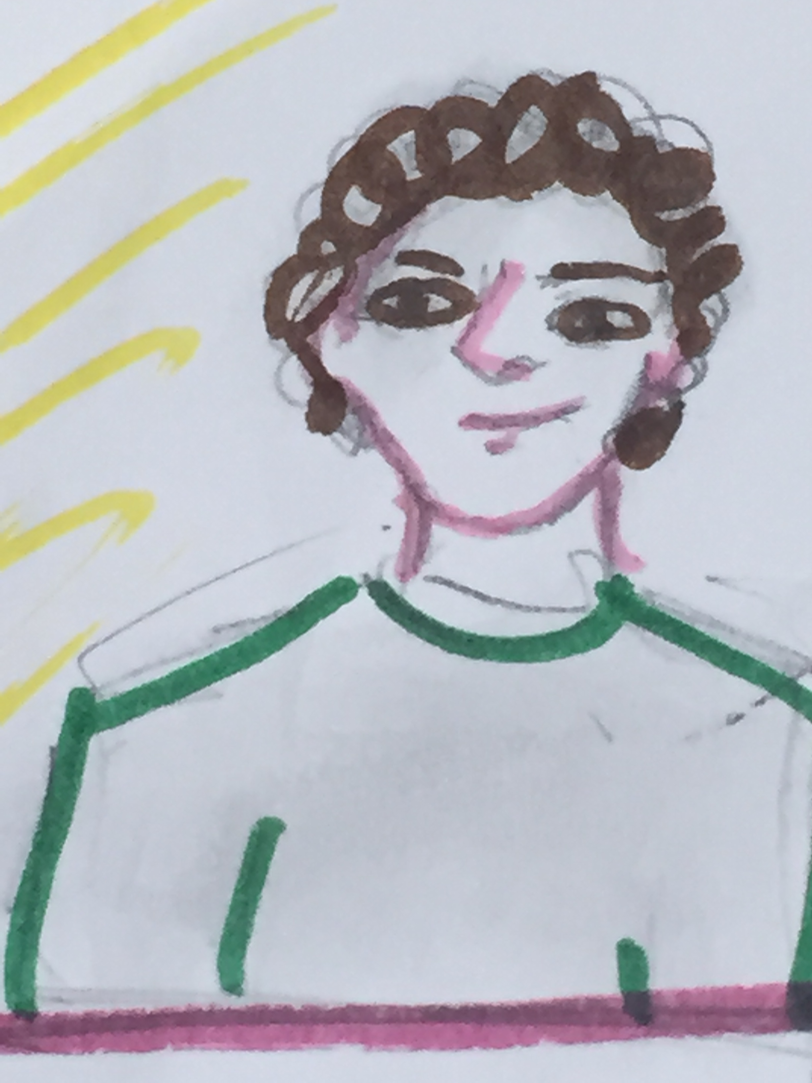
looking like a girl. At school, he was bullied by the other pupils of his class because of his look.
Jenny and Paul were the worst bullies ever. Jenny was older and Paul was taller than Walter. And they
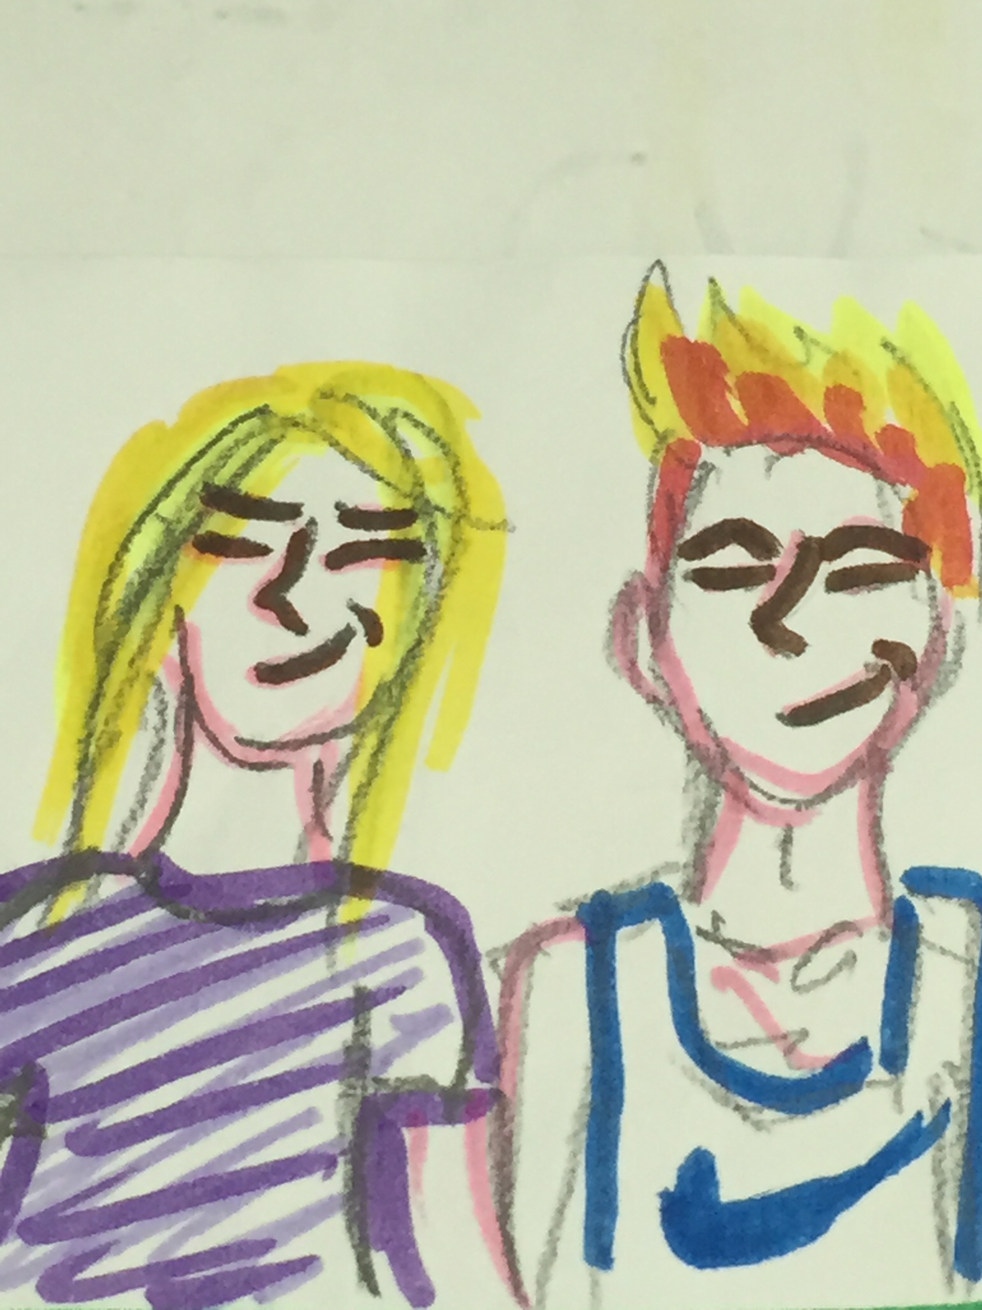
were always hanging around together : it was impossible to see Jenny without Paul and Paul without Jenny.

Here's what happened to Walter one day. The scene took place in winter, in December, last year :

Walter looked depressed and was in a sad mood that afternoon because at noon, Jenny and Paul were very naughty towards him and made fun of him at the canteen :
'Give me your lunch ! You're such a loser !' Jenny said.
'But I'm hungry ! I can't give you my lunch !' Walter answered.
'I don't care you're hungry !You have no choice : you must give us your lunch or you will have loads of problems.' Paul said.
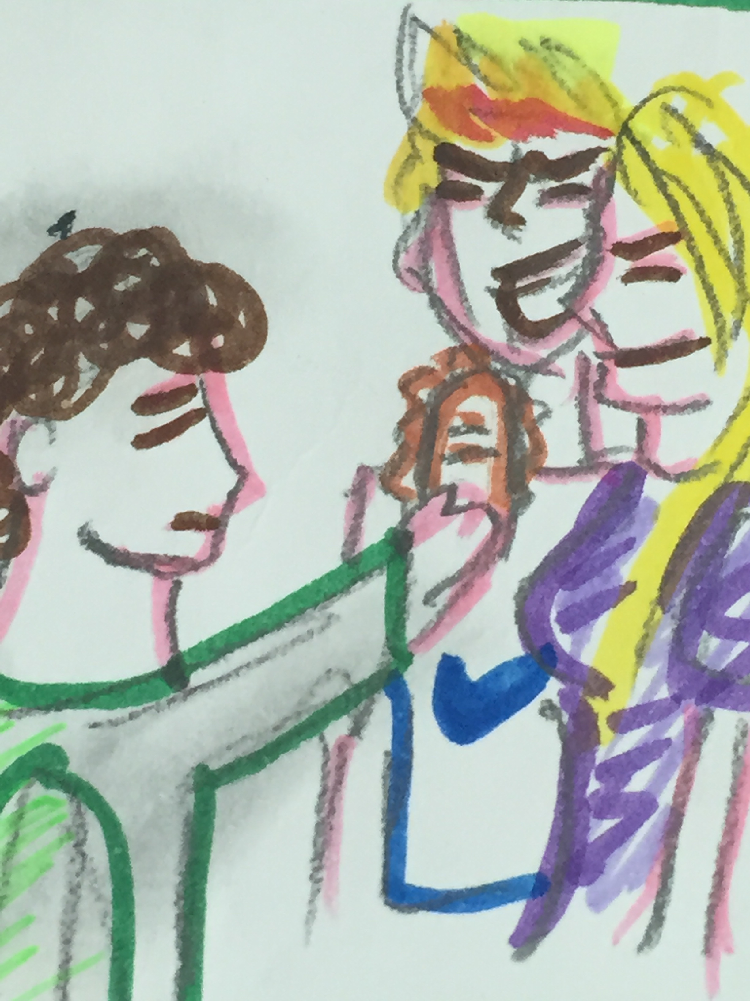
'But ...' Walter tried to answer but Jenny and Paul took the glass of water and spilled it on him before he could finish his sentence.
Everybody was watching the scene and laughing at Walter, so Walter had to escape from the canteen without eating, alone.
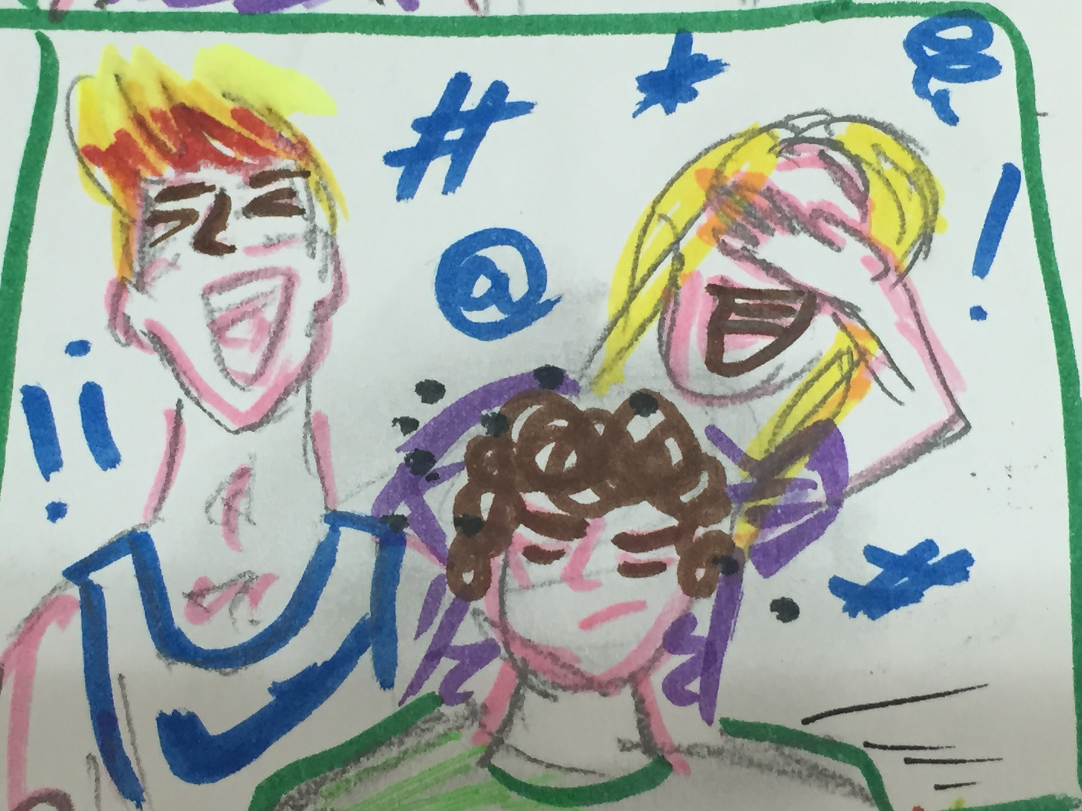

Next, later on that same day, while Walter was quietly walking in the corridor to go to the English class with Mrr Benton, their English teacher, Jenny and Paul insulted and annoyed him :
'How are you, girly boy ? What's wrong, little dwarf ?' They both asked.
Walter started to cry.

Mr Benton, who was waiting for her pupils, heard someone crying in the corridor.
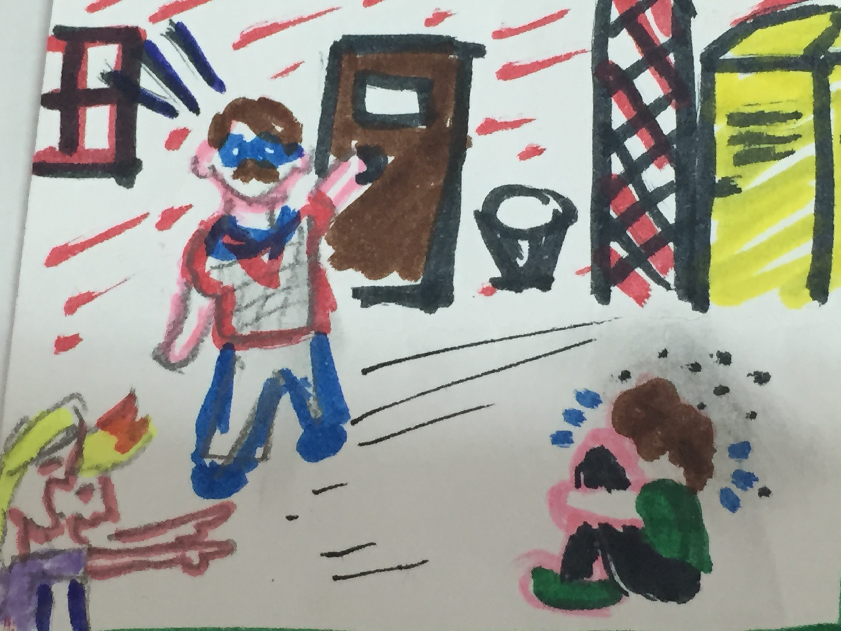
Mr. Benton went out of the classroom and saw Walter crying. Then he saw Jenny and Paul laughing and he looked angry. 'Paul! Jenny! What's happened?' Paul and Jenny stopped laughing. 'Mr Benton, Walter has made jokes about Paul and me. Then he pushed Paul and Paul pushed him too. Then Walter tripped over something and dropped on the floor and cried' said Jenny. Mr Benton looked angrily to Walter. 'But...' Walter tried to answer. 'No Walter, ' said Mr Benton ' go to the headmaster and tomorrow you will be kept in. And now Jenny, Paul, come into the class.'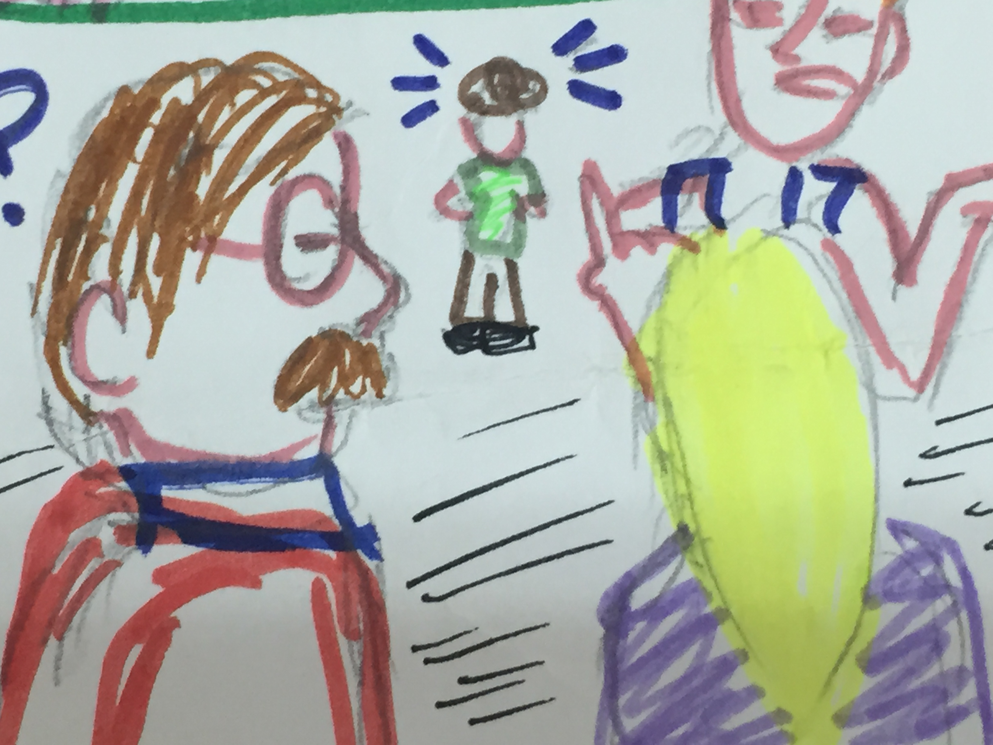
Walter stood up and ran away. He ran out of the school and went home. 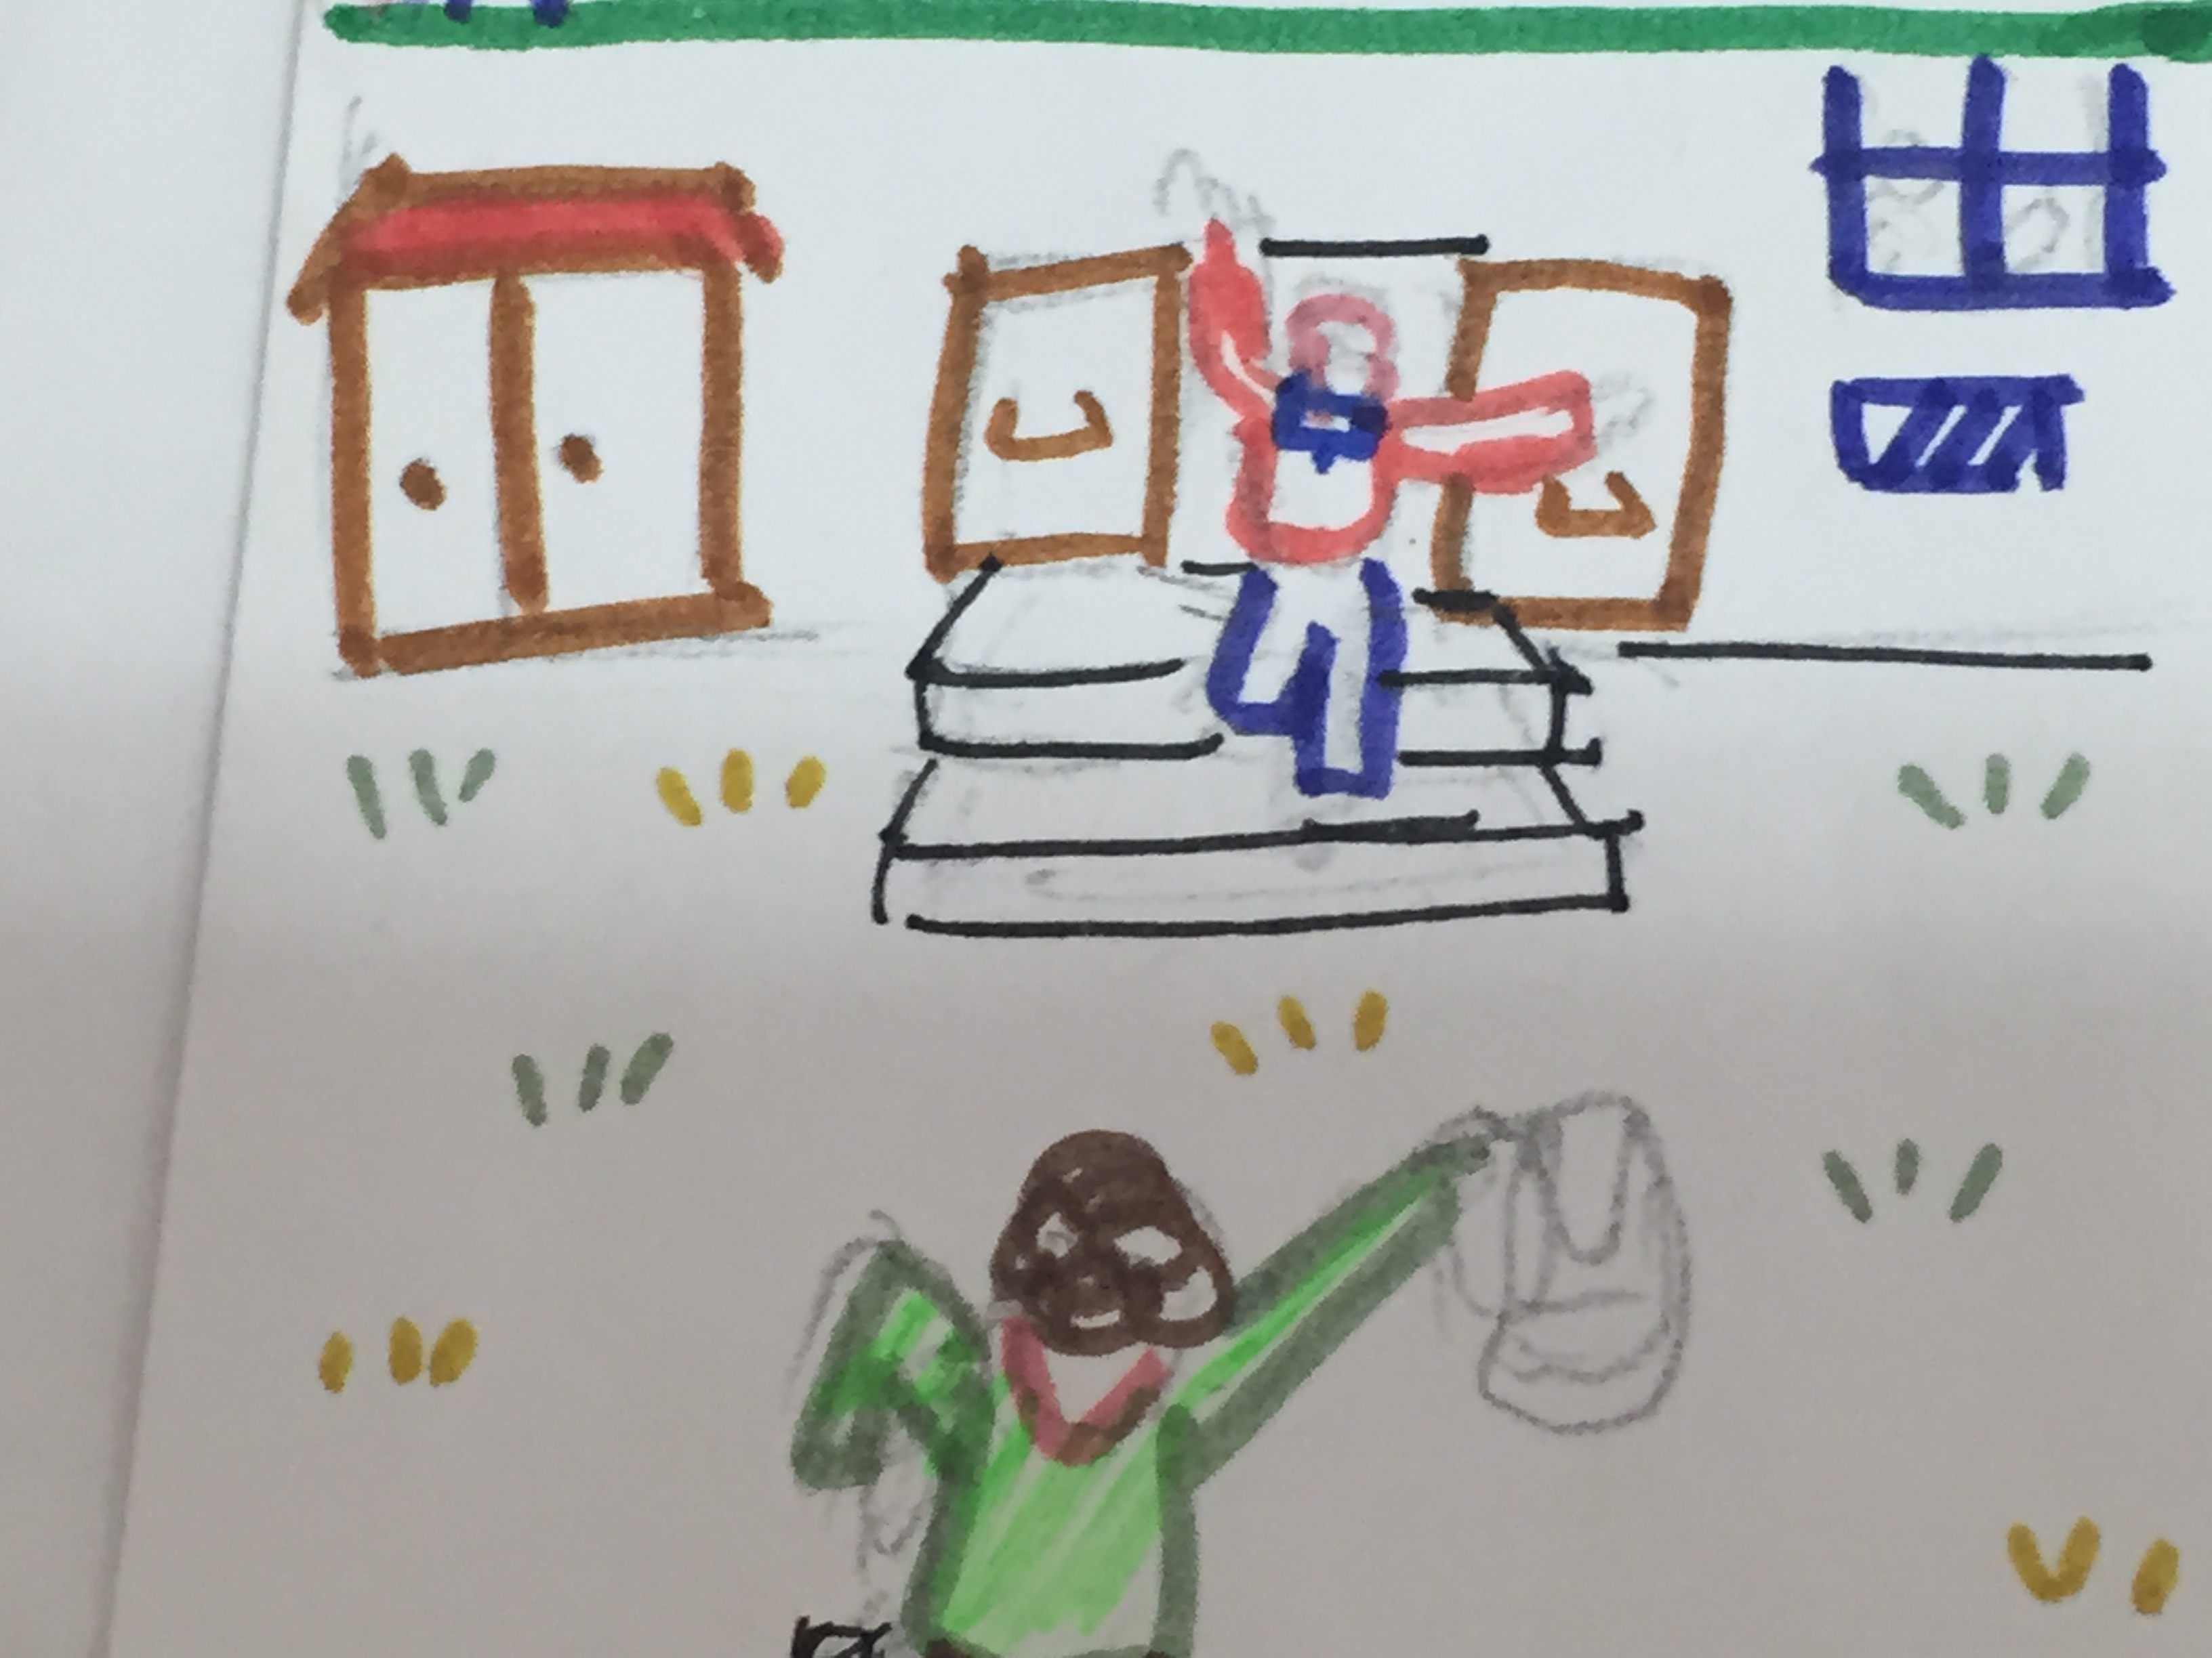

His parents weren't at home, so he went to the bathroom. 'I’ve had enough!' he said and took a razor blade from his dad and went to his room. He went to his desk, took a piece of paper and wrote a letter for his parents. He put the letter on the desk and lay down on his bed. Then he took the razor blade and carved his arm. As he was at his artery he stopped for a moment. But then Walter carved, harder than before.
In the evening, his parents came home. Walter's mum, Caren, shouted at Walter but he didn't answer. She went to his room and screamed. Walter's dad ran to his wife. 'What's happened?' he asked. His wife pointed at Walter's bed. Her husband ran to his son. 'Call the emergency!' he shouted. But it was too late. Walter was dead.
As the parents were at home again from the hospital, Caren went into her son’s room. She cried and cried. Suddenly she saw a piece of paper on Walter’s desk. She took the letter and read:

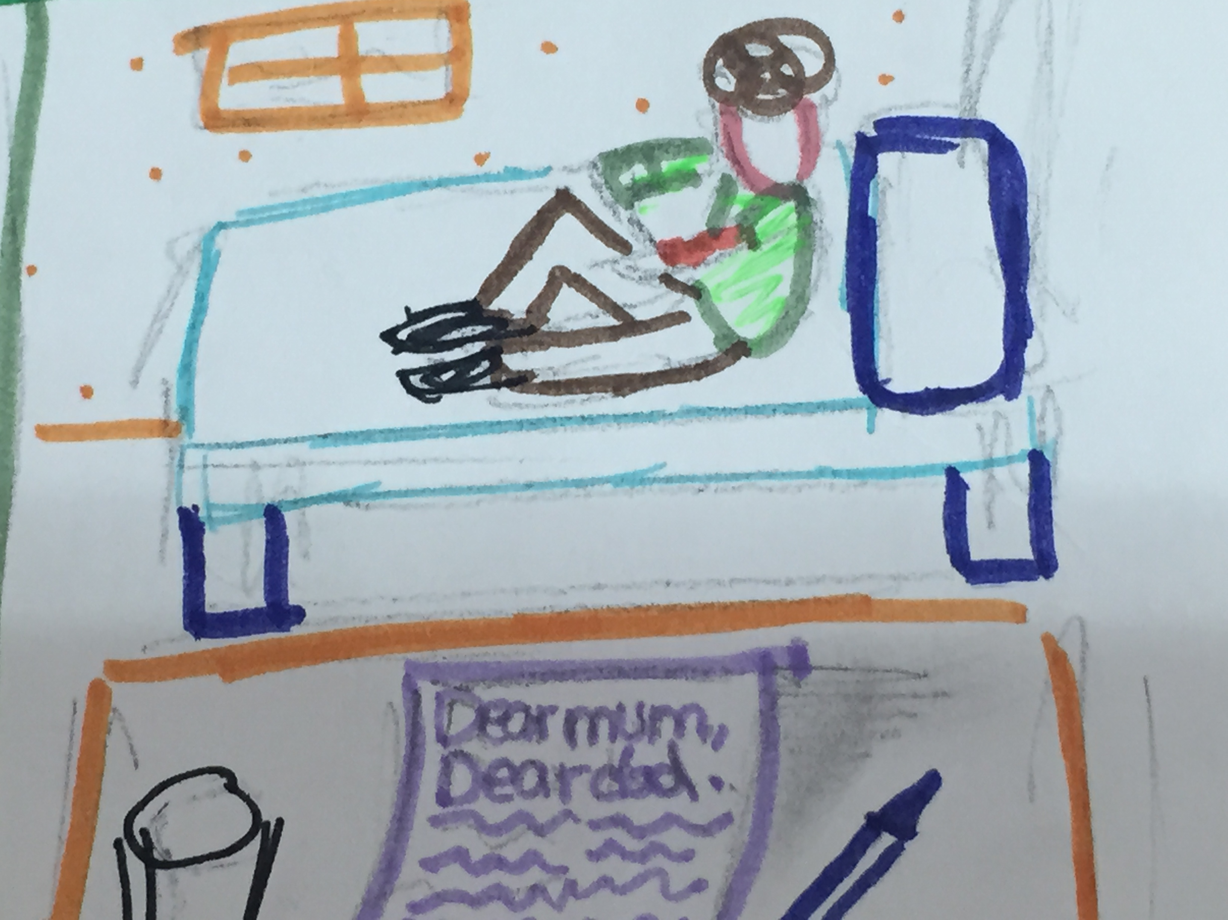Dear Mum, dear Dad,

I can't stay alive. At school I was bullied by all the children. They made jokes about me for so long. I didn't have any friends. Two of the children took my lunch away and all children laughed. I've had enough. Nobody likes me and nobody understands me. I hate my life. You don't blame anybody.

I love you forever.

Walter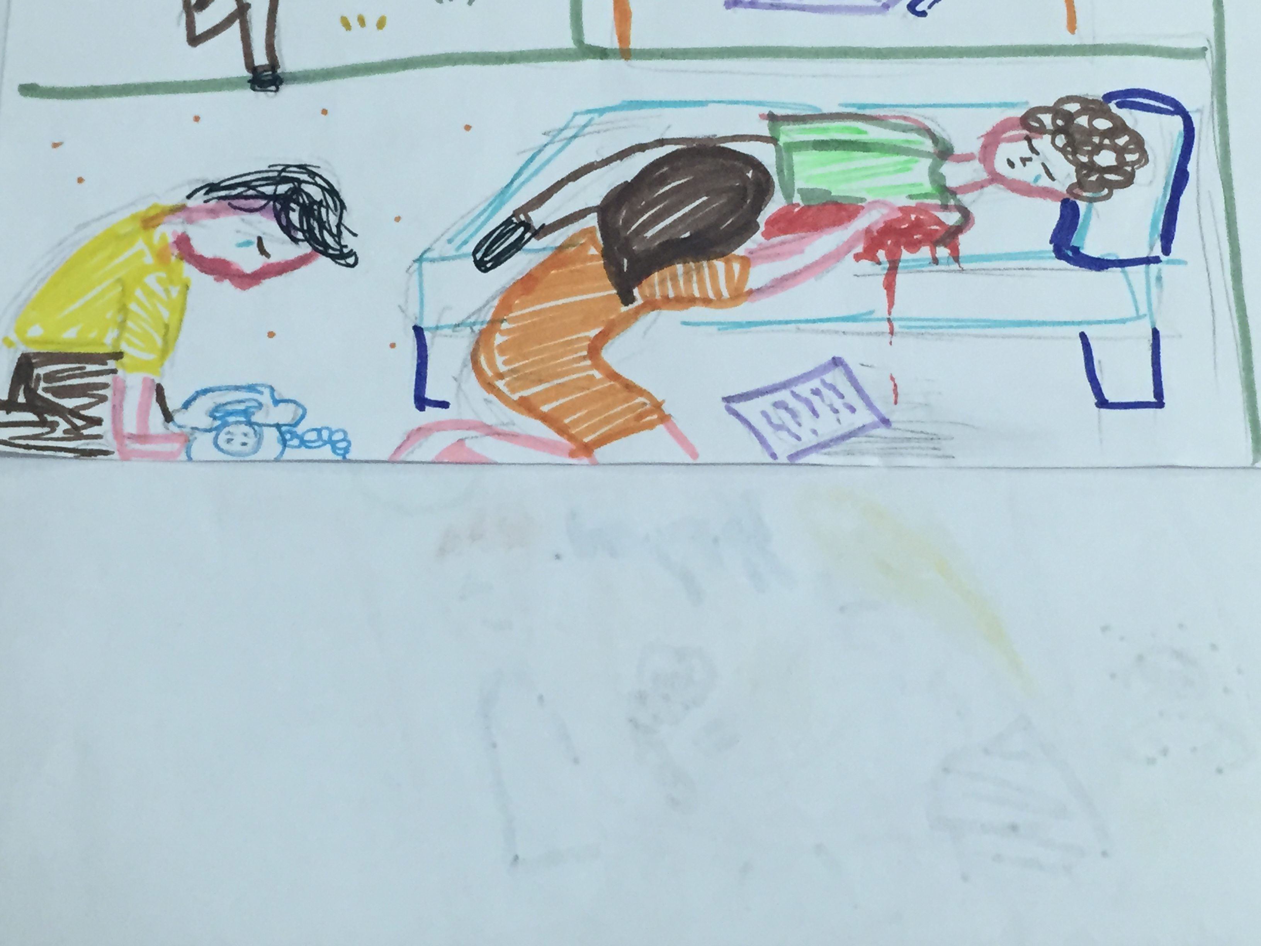

THE END
The beginning of the story
The happy ending

The sad ending

The illustrations

The titles

