A FRIEND IN NEED

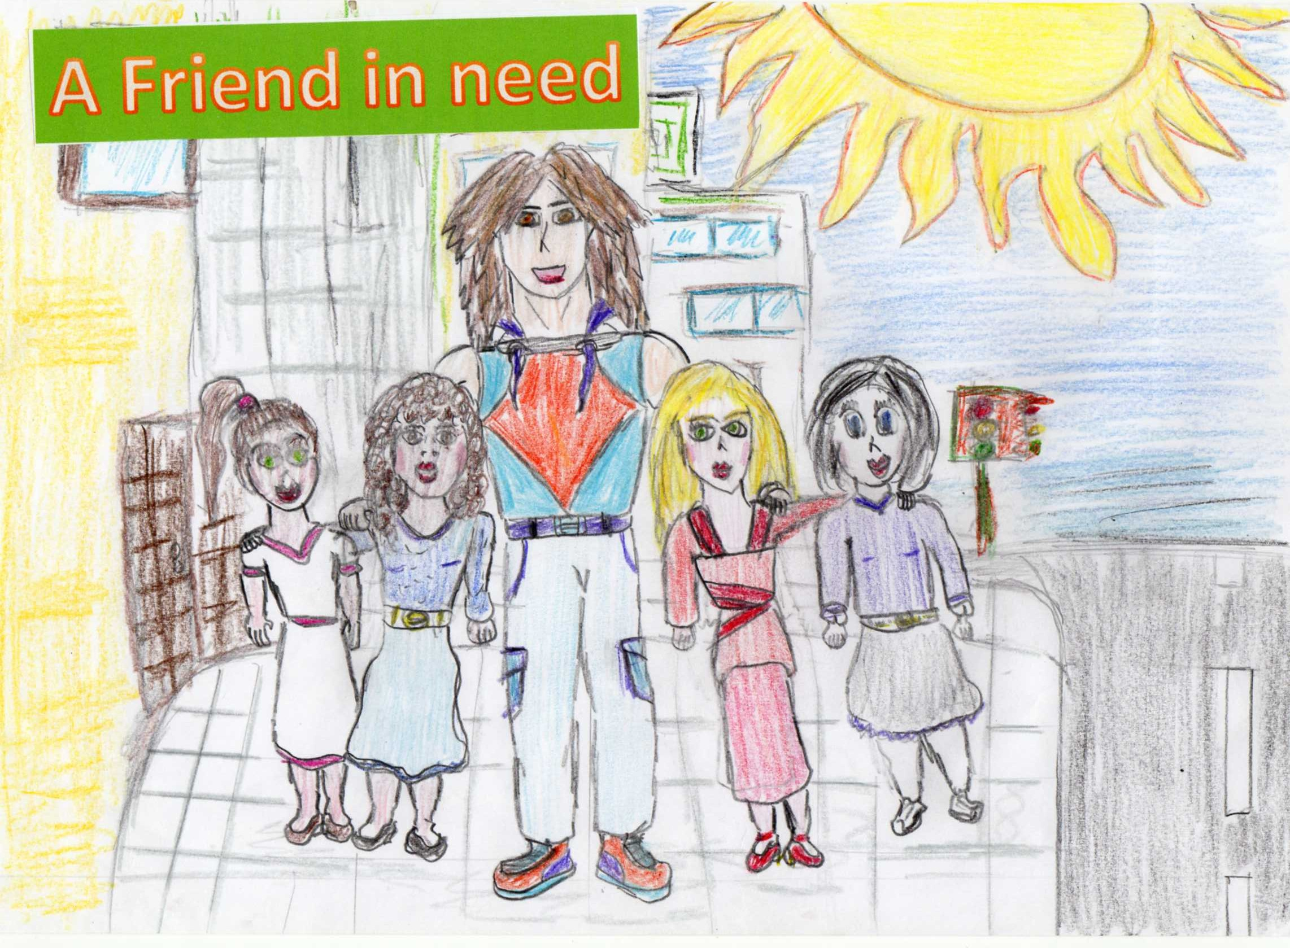
It´s the last day of high school and Oliwia, a student, is very exicted because the head master, is going, to offer to the best students a trip to a campsite. Oliwia is a girl with black hair as coal, her eyes are round and blue as the sea. She has a sweet sight. Her skin is white, so she looks like a vampire. She is really quiet and unsociable, because she is shy. Her dad died when she was little since her dad died her mother started drinking.

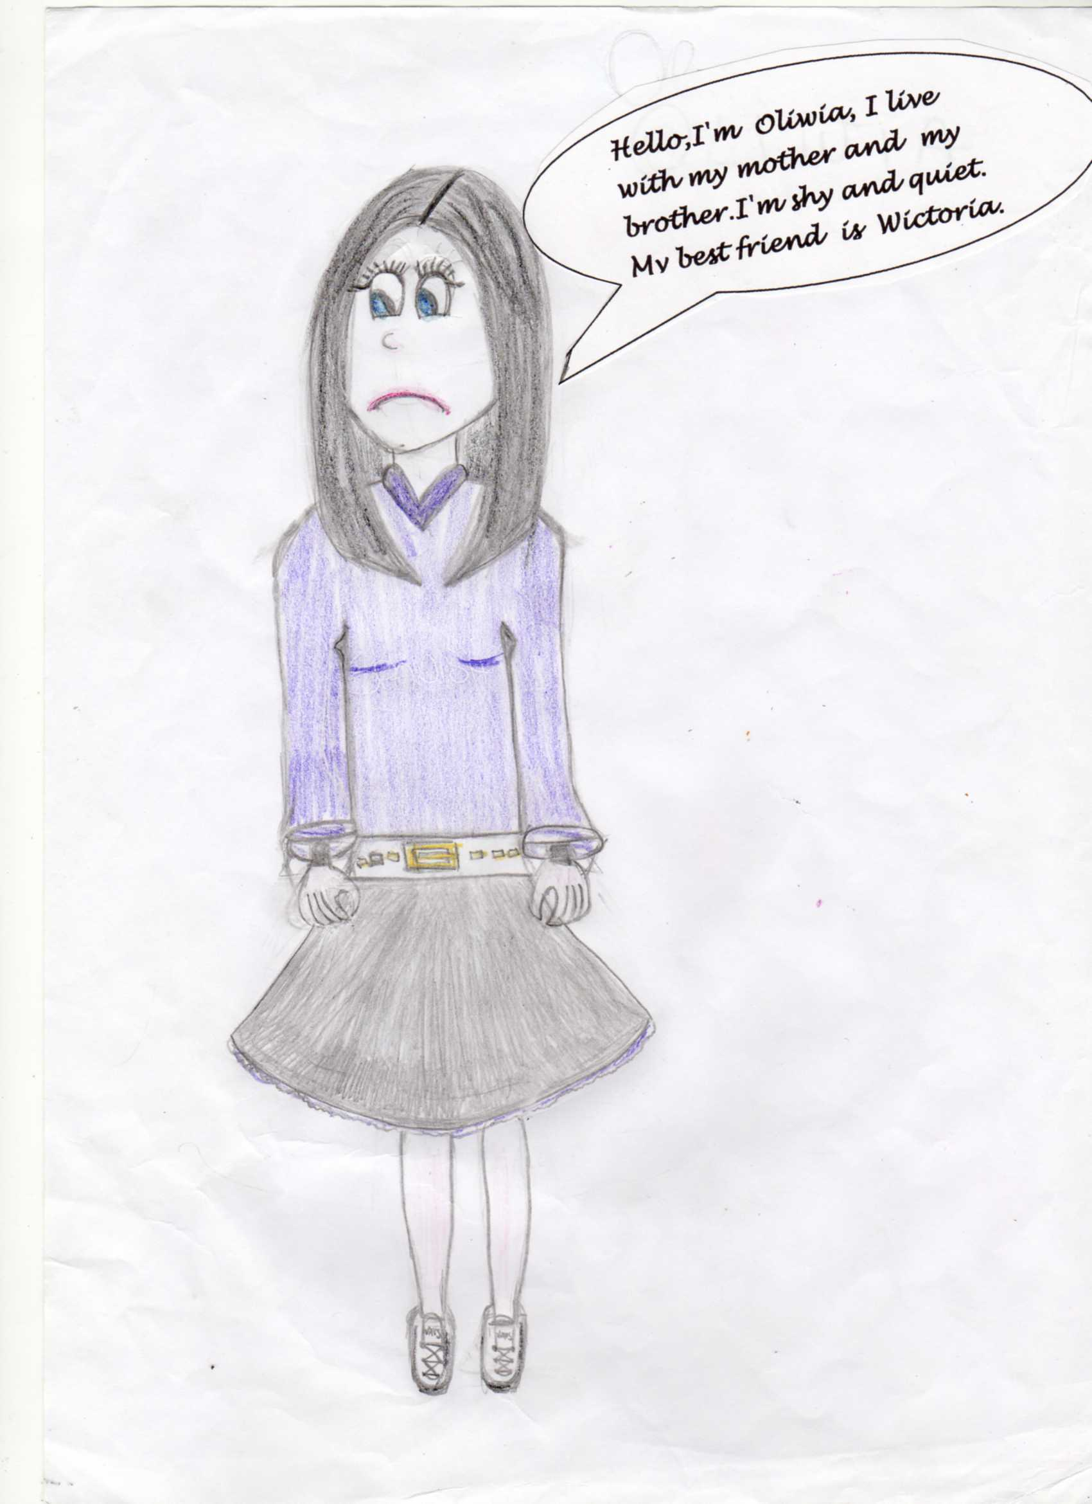

She has a kid so she has to look after her mother and brother, she has and old friend, her name is Wictoria (Wiki) she has to go to class, because they are going to get their marks. When she goes to class, she founds her friend Wictoria.
Wictoria is 14 years old, she is normal size and thin, like all the girls of her age. Her hair is brown and her eyes are green. She has dark skin, she isn`t shy, but she isn`t sociable either she`s patient, easy-going and little bit talkative. She has a normal family like her with a mother, father and two little twins.
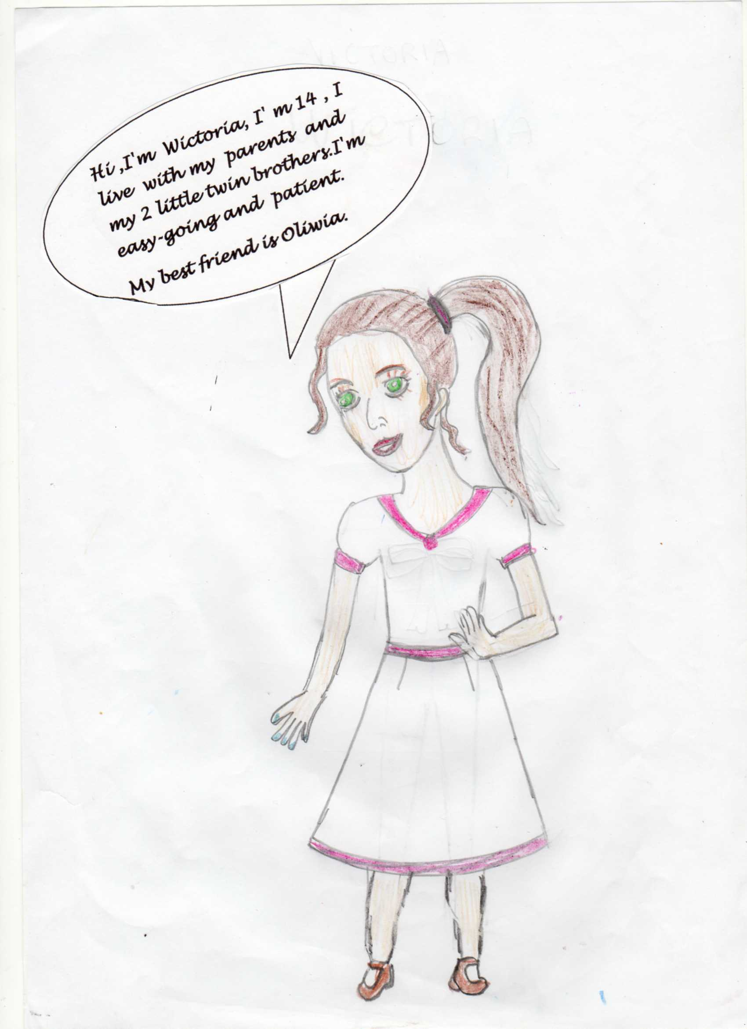
The high school has three floors where each floor is organized in a different way, the high school is very big and in the playground of secondary there is a football and basketball court.
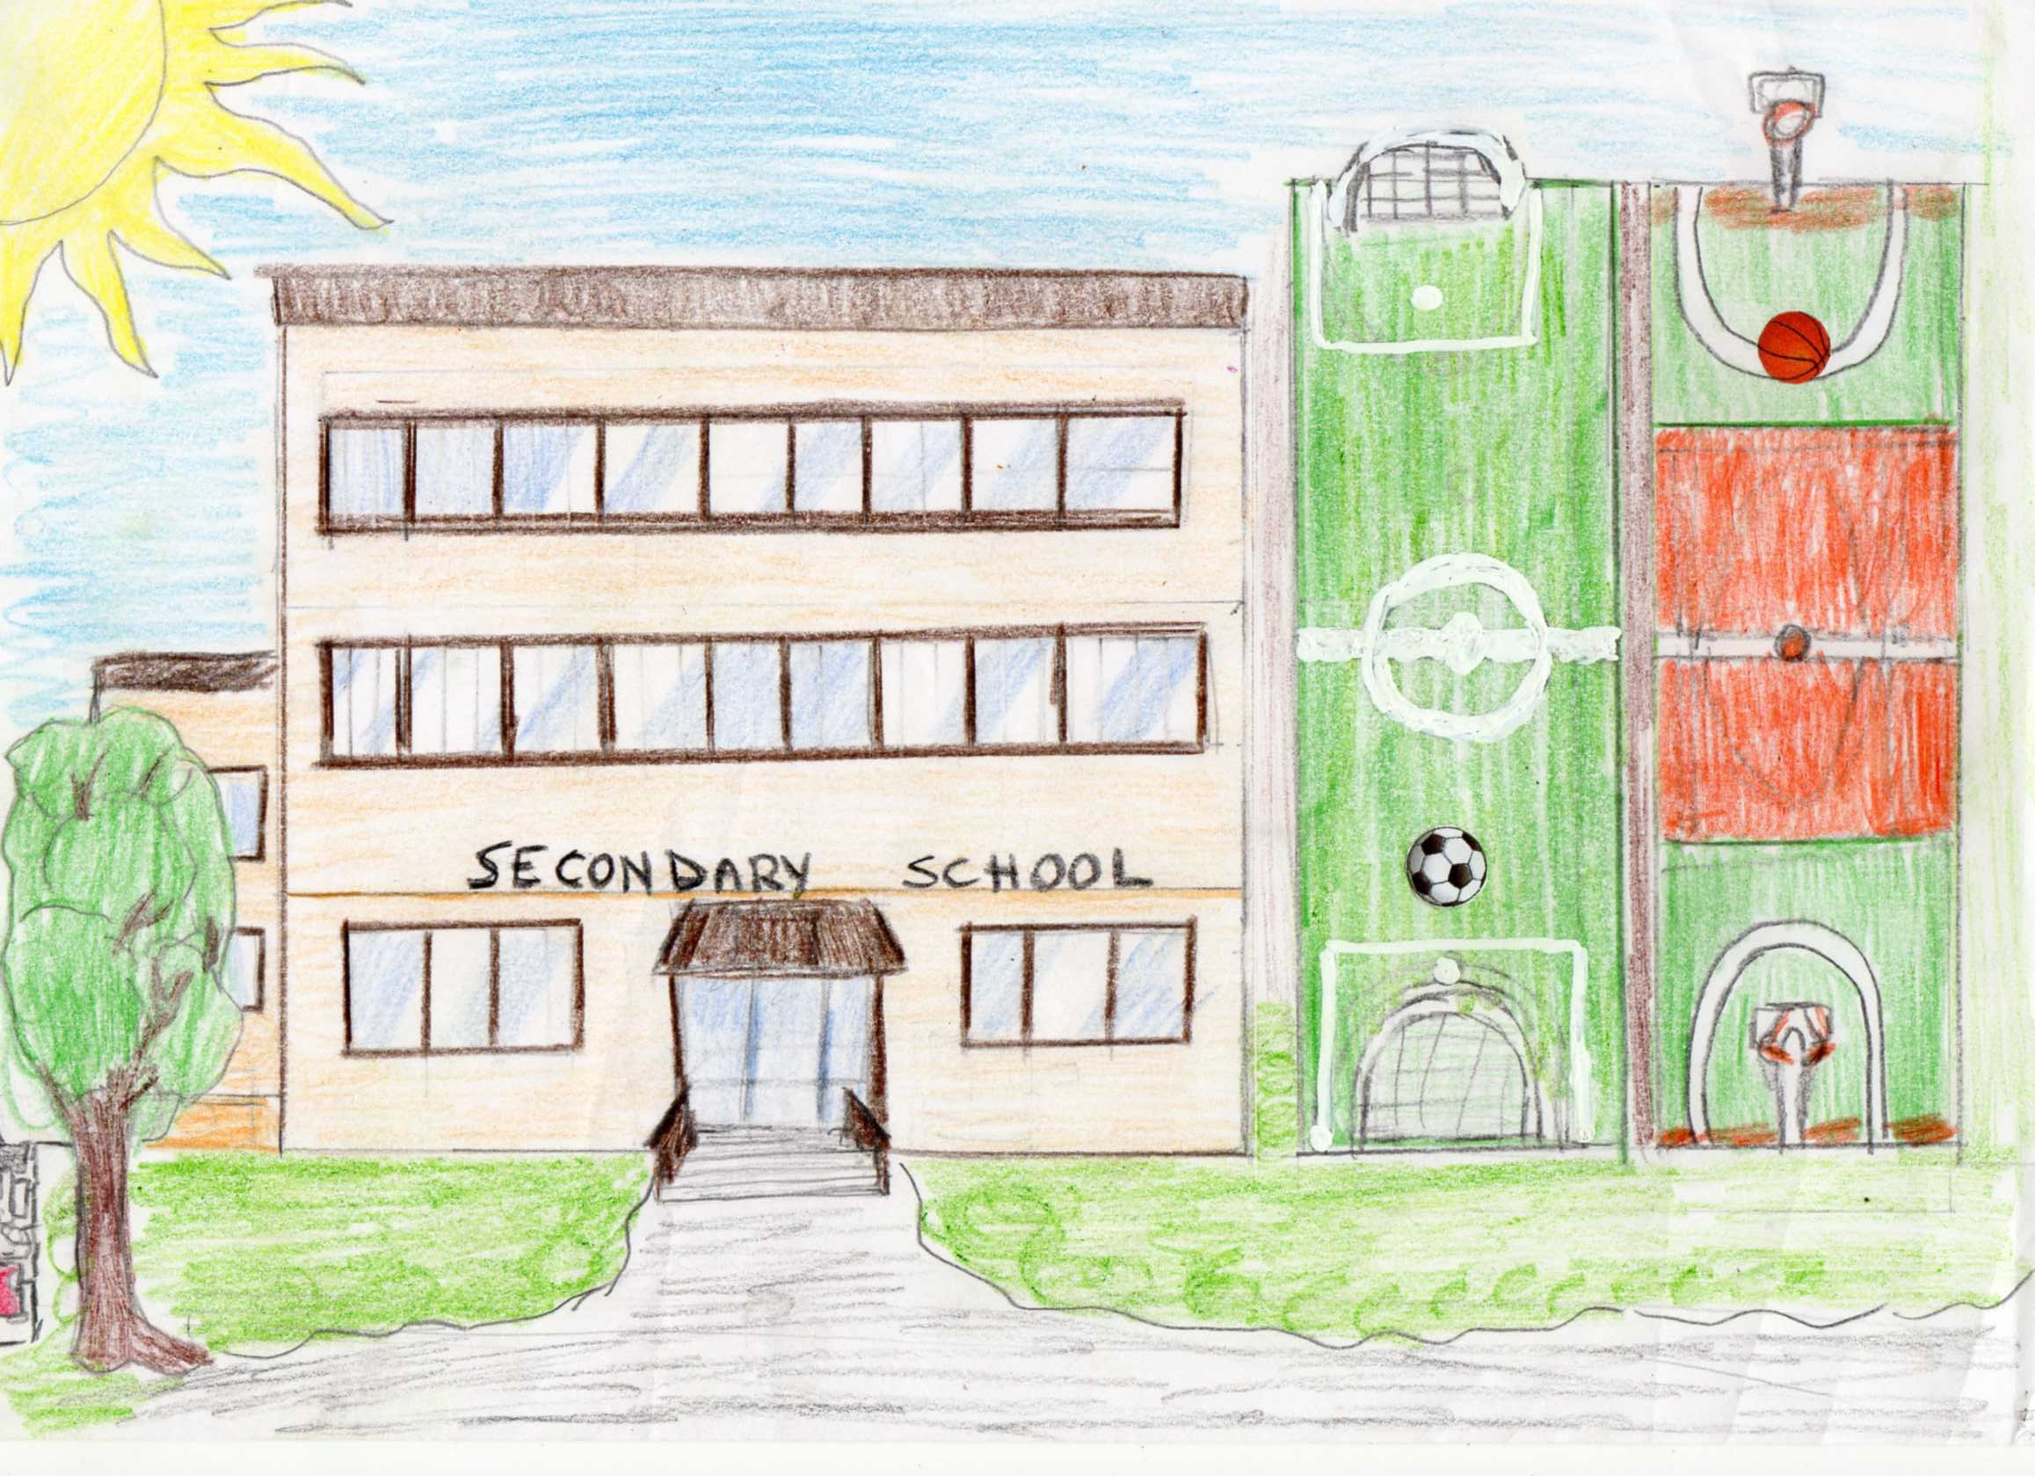
When Oliwia is going to go to get her marks, she falls down the stairs, she was injured and everyone start laughed.
Wiki goes very fast to help her. She had wounds on her body.
The students who are laughing are the next: Max Hofer, Stephanie and Rose.
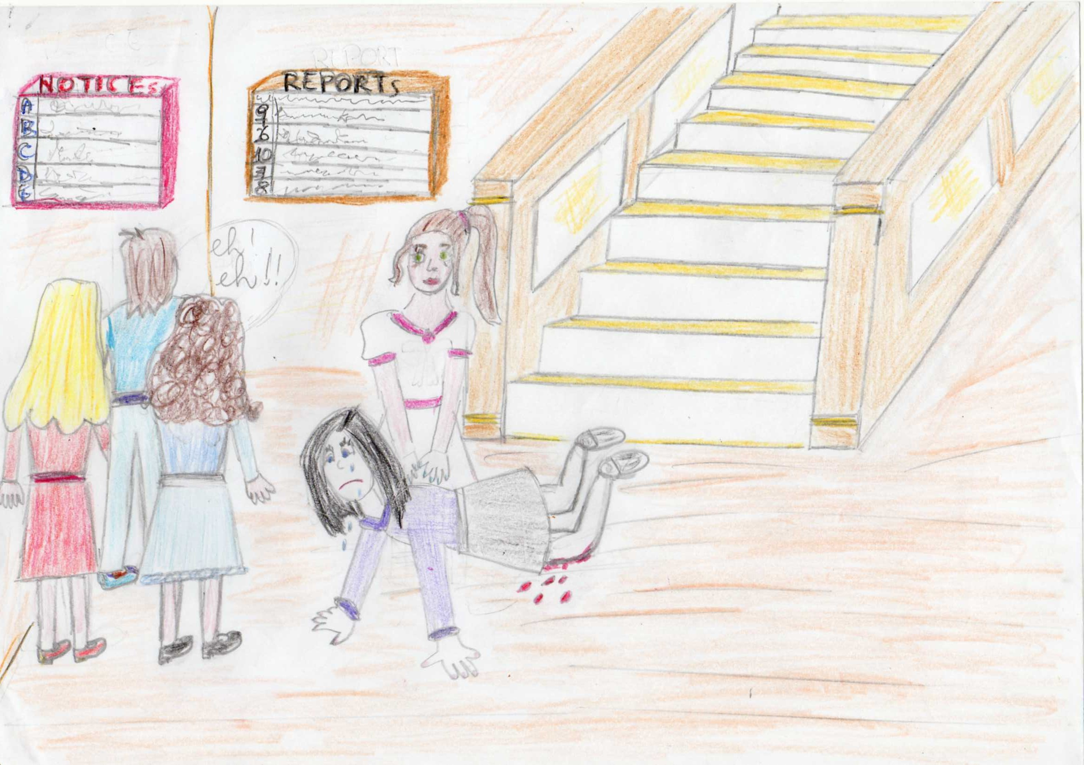
Max is 15 years old, he´s really tall, he has long hair and brown eyes, he´s the football team of High School, he has a top 10 body, because he´s a sportive boy. He has divorced parents; he´s an only child, so he lives only with his mum, his girlfriend is Stephanie, he doesn´t feel comfortable with her because she´s really jealous.
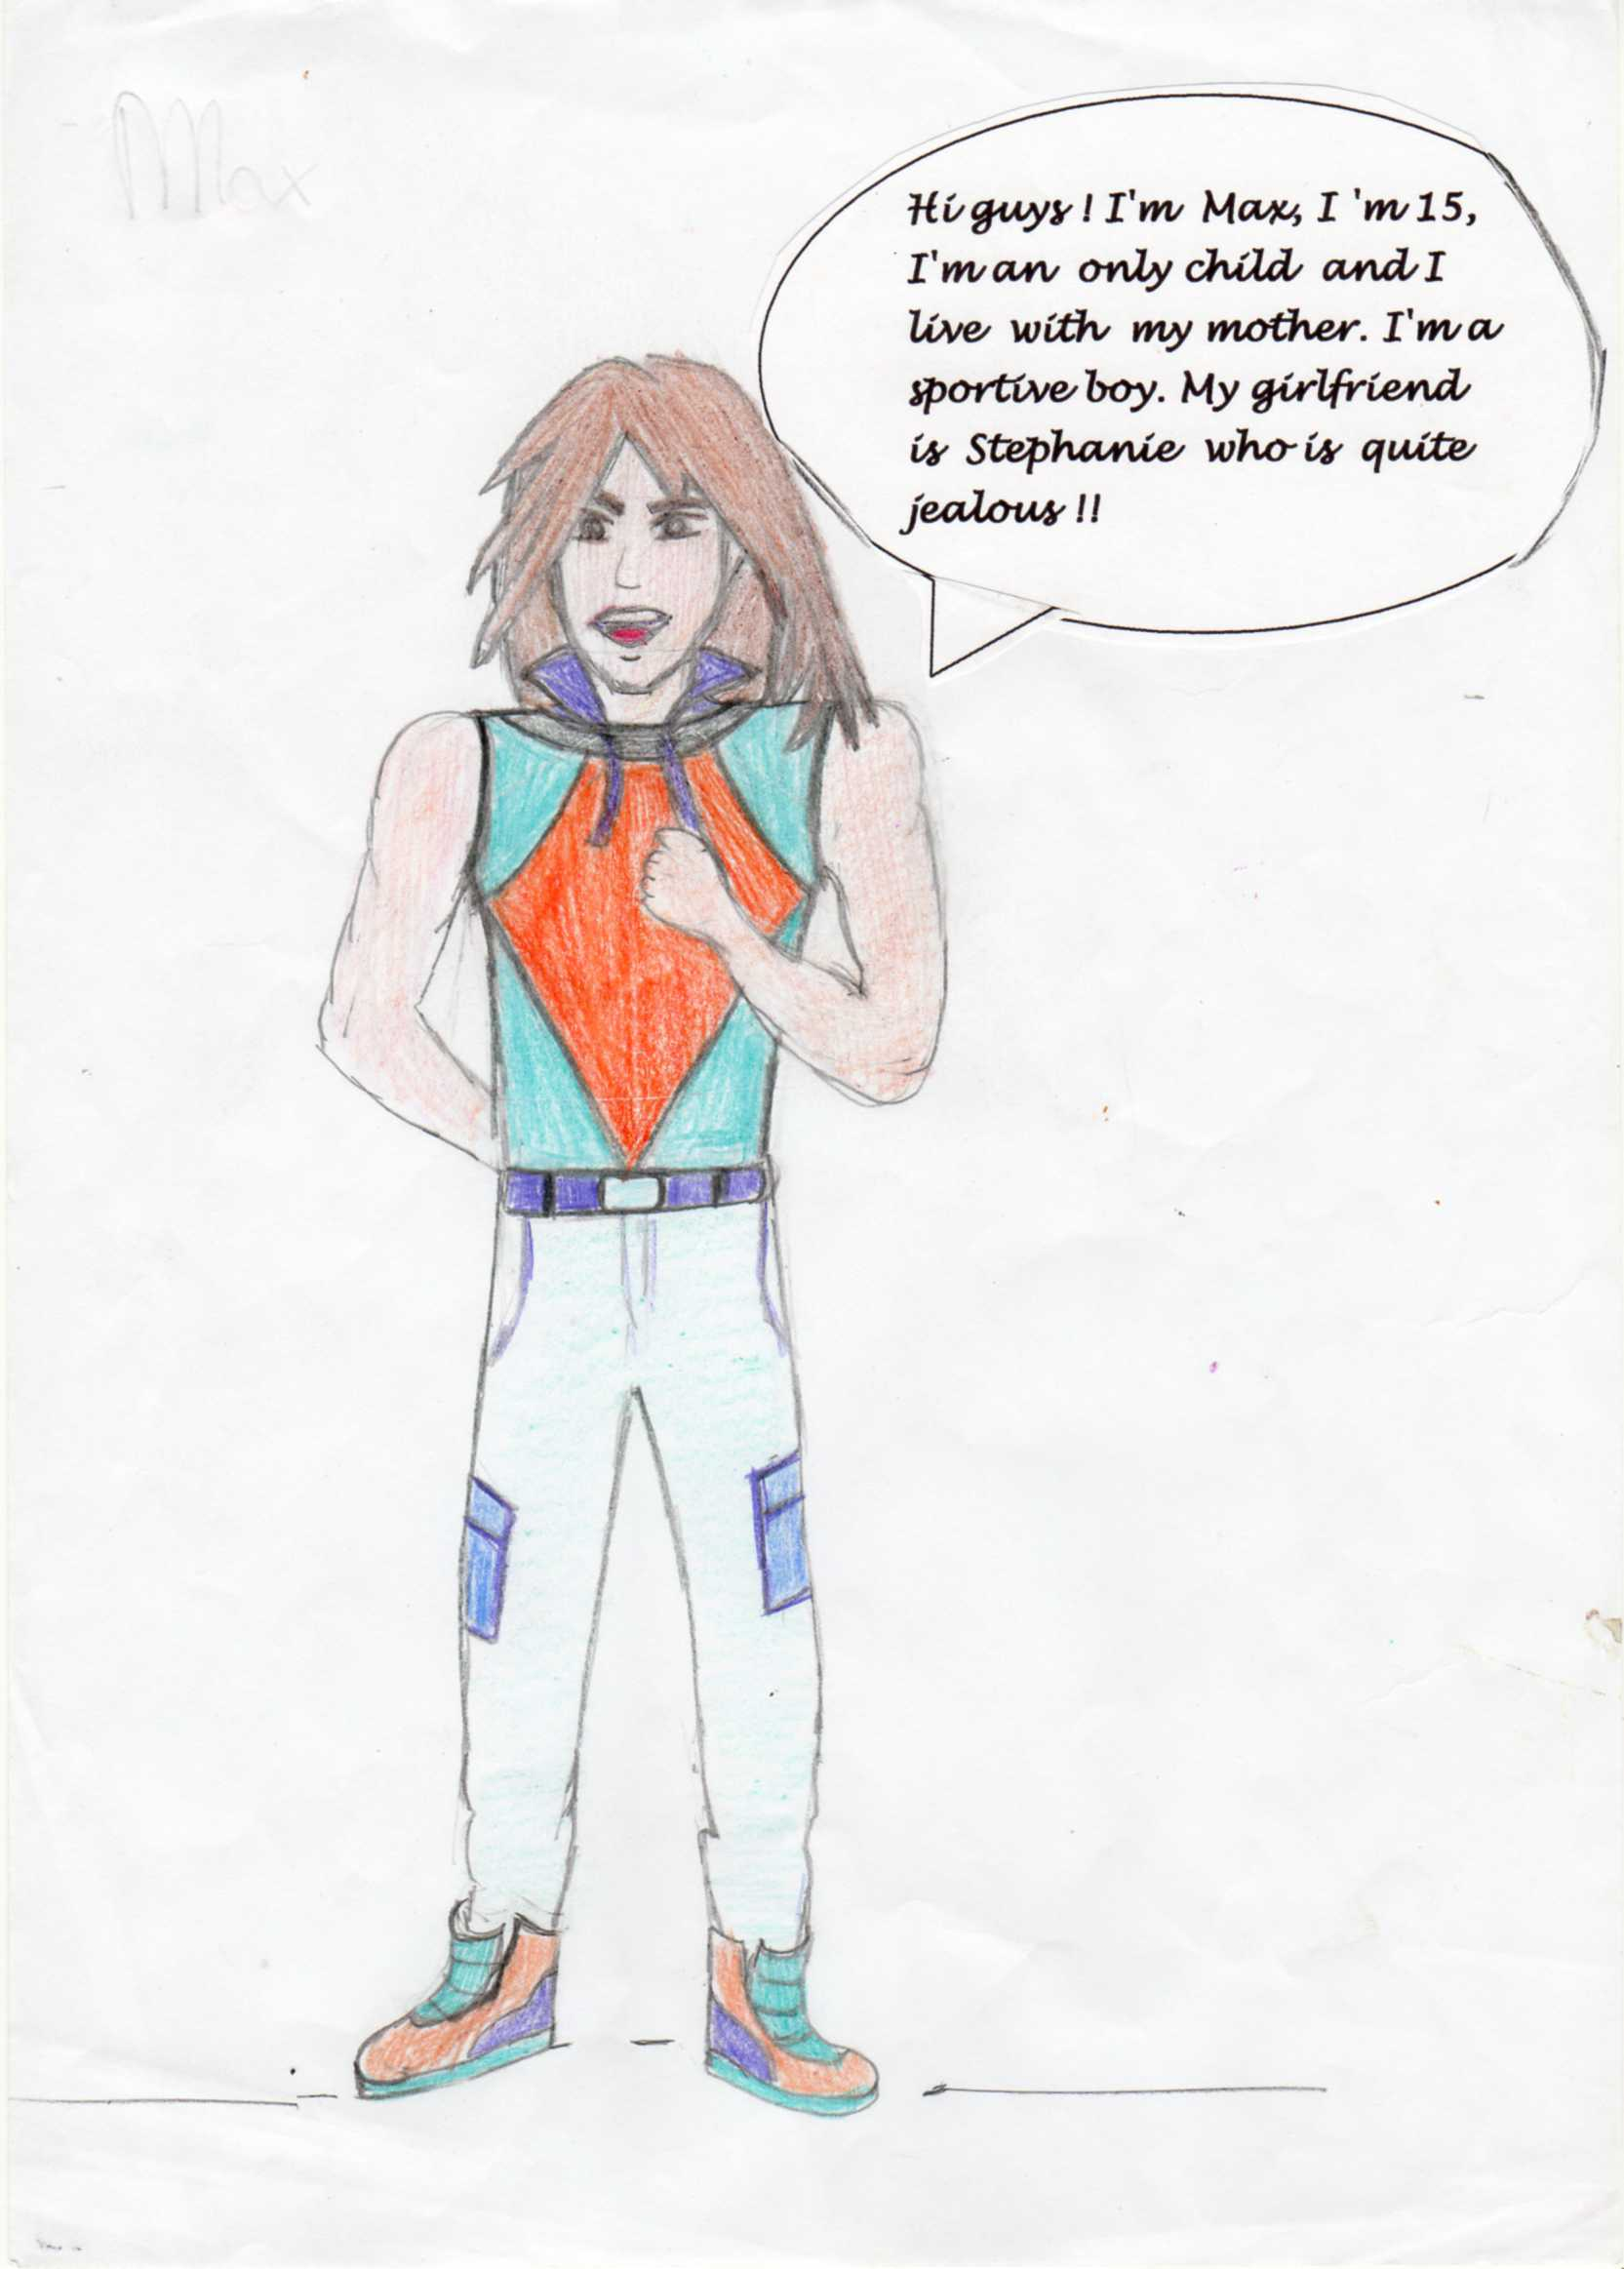
Stephanie is 15 years old, like Max, she looks like a model girl, she´s from Miami. Her eyes are green like the lawn, and brown like the Earth, and she´s blond. She doesn´t have brothers or sisters. She´s very jealous, impatient, mean and anxious. She likes bullying different girls, because she feels superior from others. Her boyfriend is Max Hofer, and her only friend is Rose.
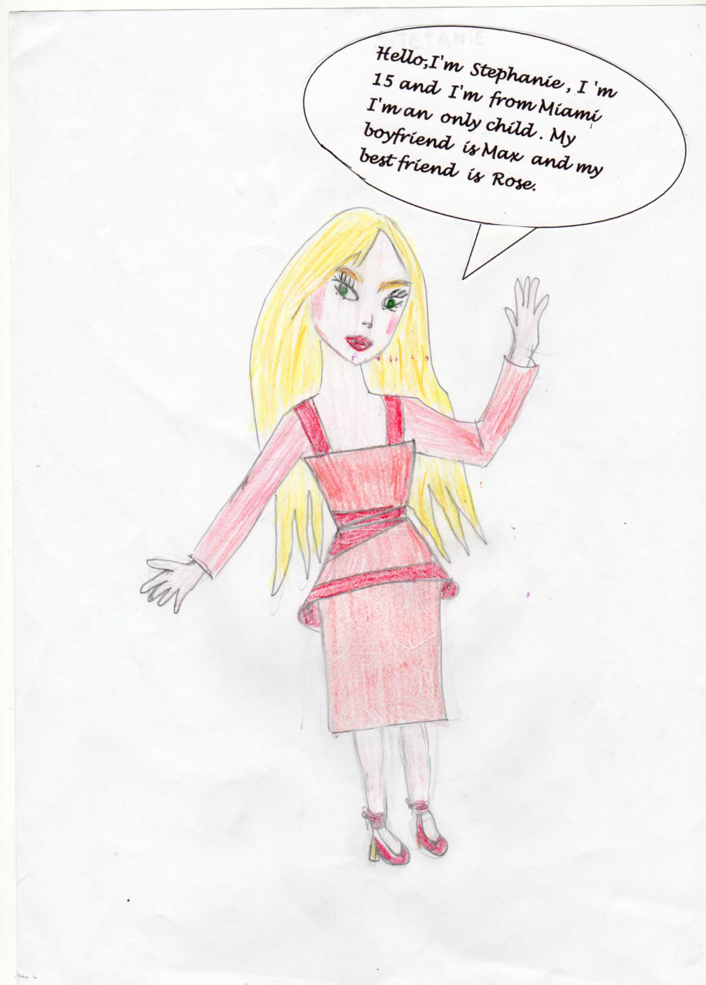

Rose is 14 years old, she´s the right hand of Stephanie. Her eyes are brown like her curly hair. She has one brother, the most awesome student of the High School. He´s impatient, she likes doing bulling to girls with her best friend Stephanie, but she´s friendly when she strives.
One month later, the best students go to the campsite. The campsite was located in a mountain in the south. Next to the river there are fifteen woods cabins dispersed in a great space and there is a lunchroom.
At night, next to a bonfire, Rose, Max and Stephanie were cooking marshmallows. Oliwia went to cook on their bonfire, because she didn’t know how to do it, and someone accidentally pushed her and she burned the end of her hair and everyone laughed about her…

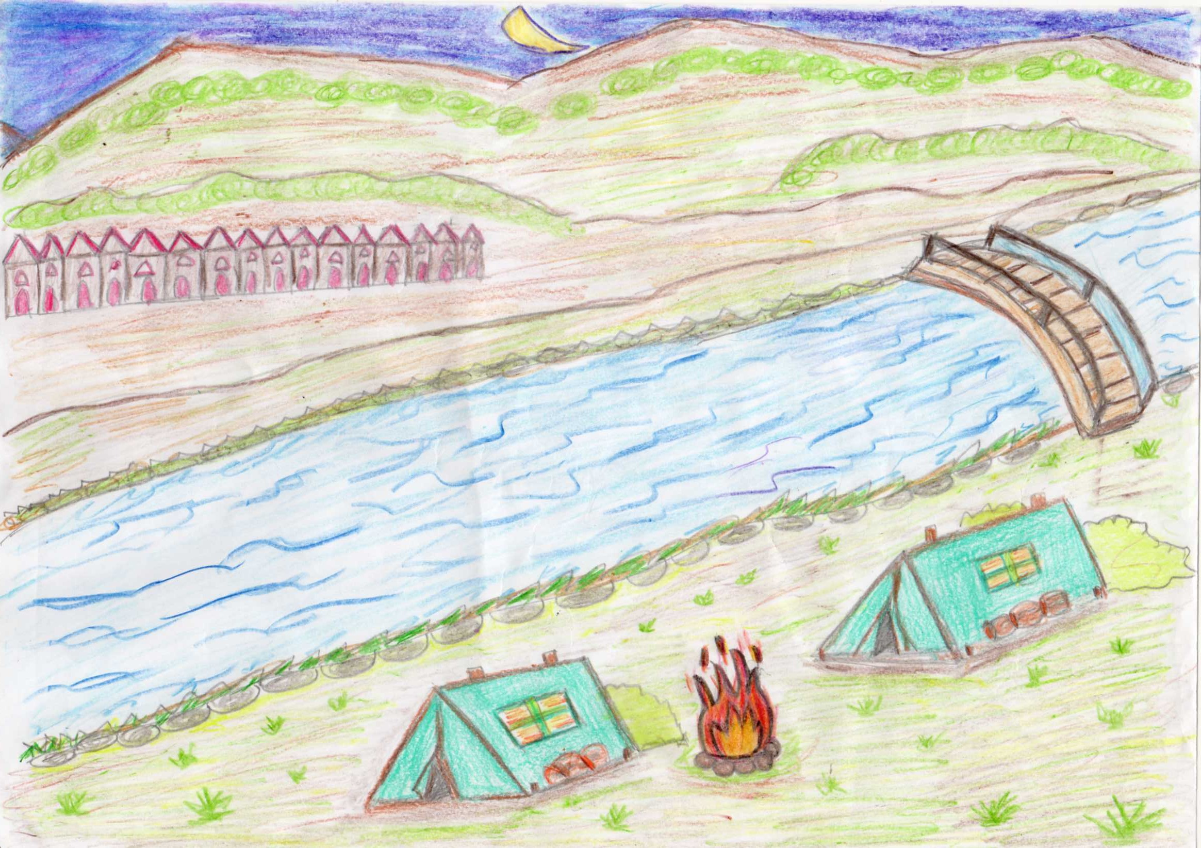

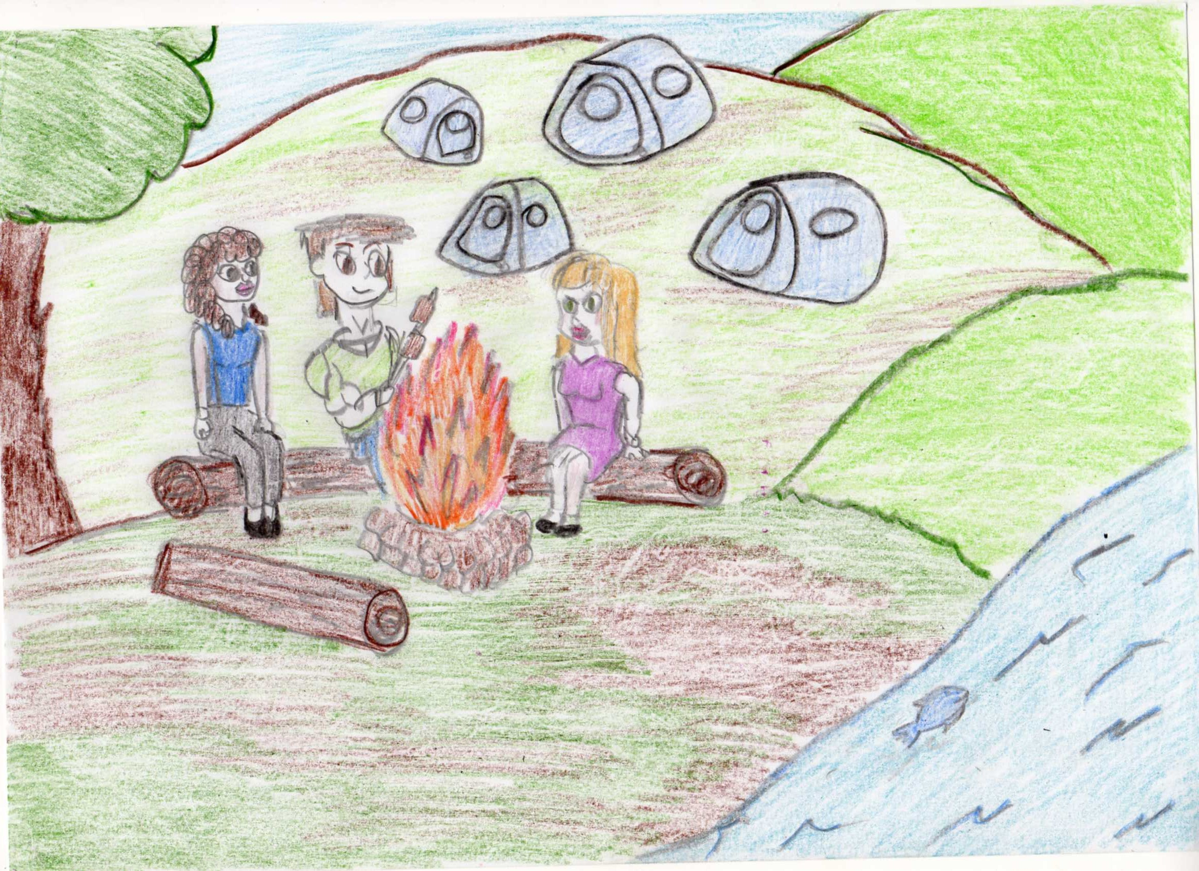
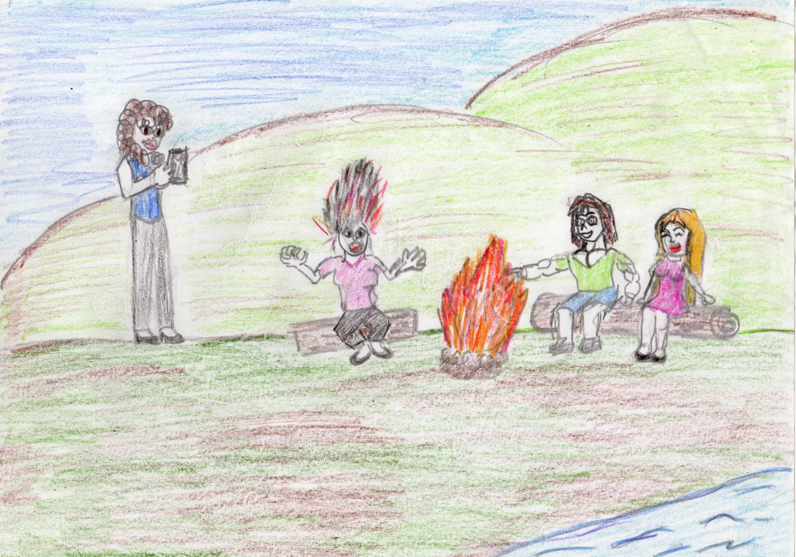
Olivia tried to stand up without caring of their laughing and her burned hair. Suddenly Mark got angry with the guys laughing to Olivia and helped her as he understood how dangerous the event was. He took Olivia to her tent and went back to the fire place. They talked there for a long time and went sleeping at night.
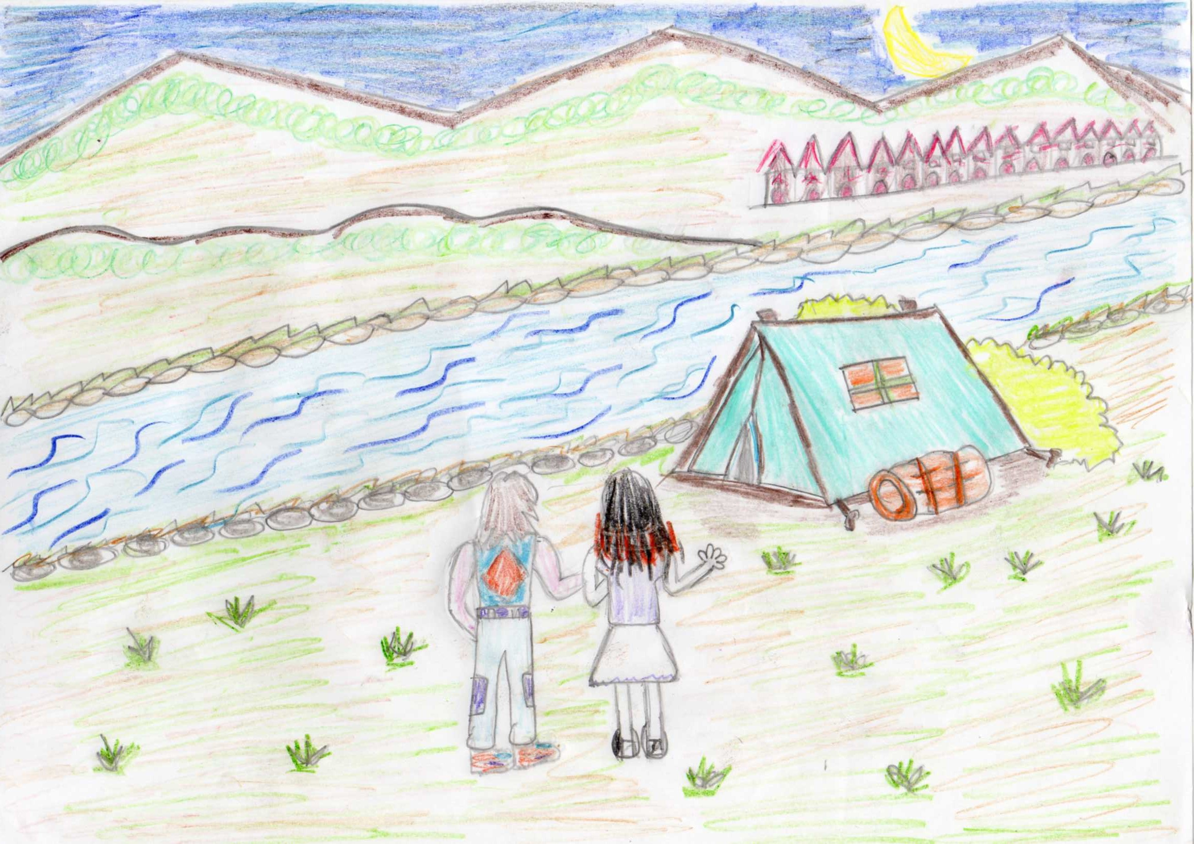
Olivia got permission from her teacher to leave the camp and packed her suitcase to go back home. Wictoria wanted to go back with Olivia ,but she convinced Wictoria to stay at the campsite.
Mark saw Olivia while she was packing her suitcase and asked her where she would go. Olivia told him that she would go back home. Mark didn’t want to leave her alone and got on the bus that went to town every morning from the campsite .
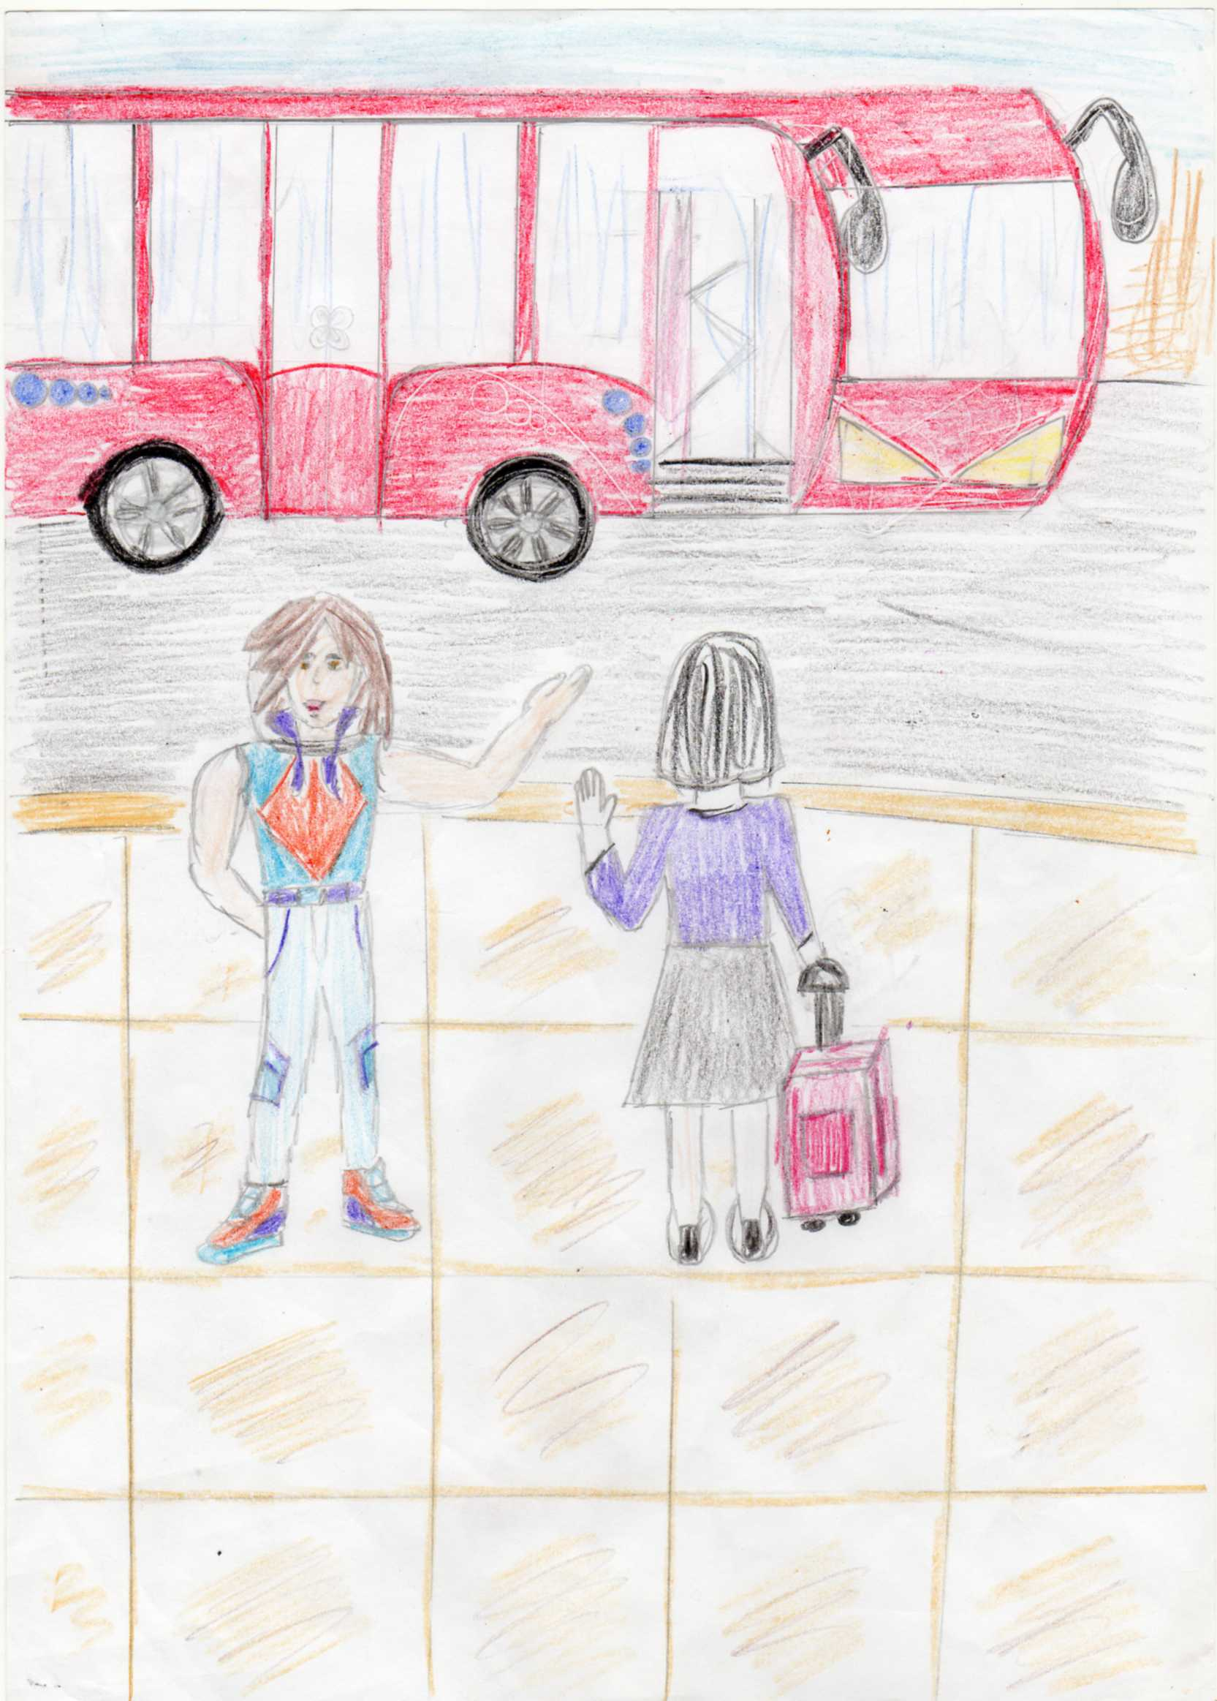
While going to the town, Mark apologised to Olivia for their bullying her. She forgave him. Then Mark suggested her to go to a hairdresser with him to have her hair cut and designed. Olivia thought it was a good idea and they went to the hairdresser in the town. The hairdresser cut her hair and designed. In fact her short hair suited her more than her long hair.

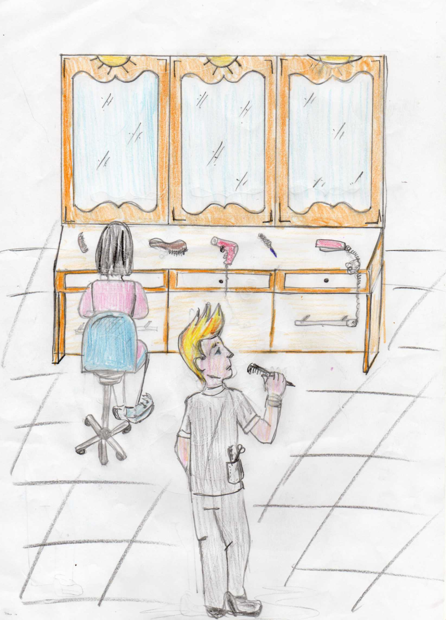
Mark ,Olivia and Victoria became close friends and hanged around together .Rose and Stephan understood how they hurt Olivia and they apologised to her.

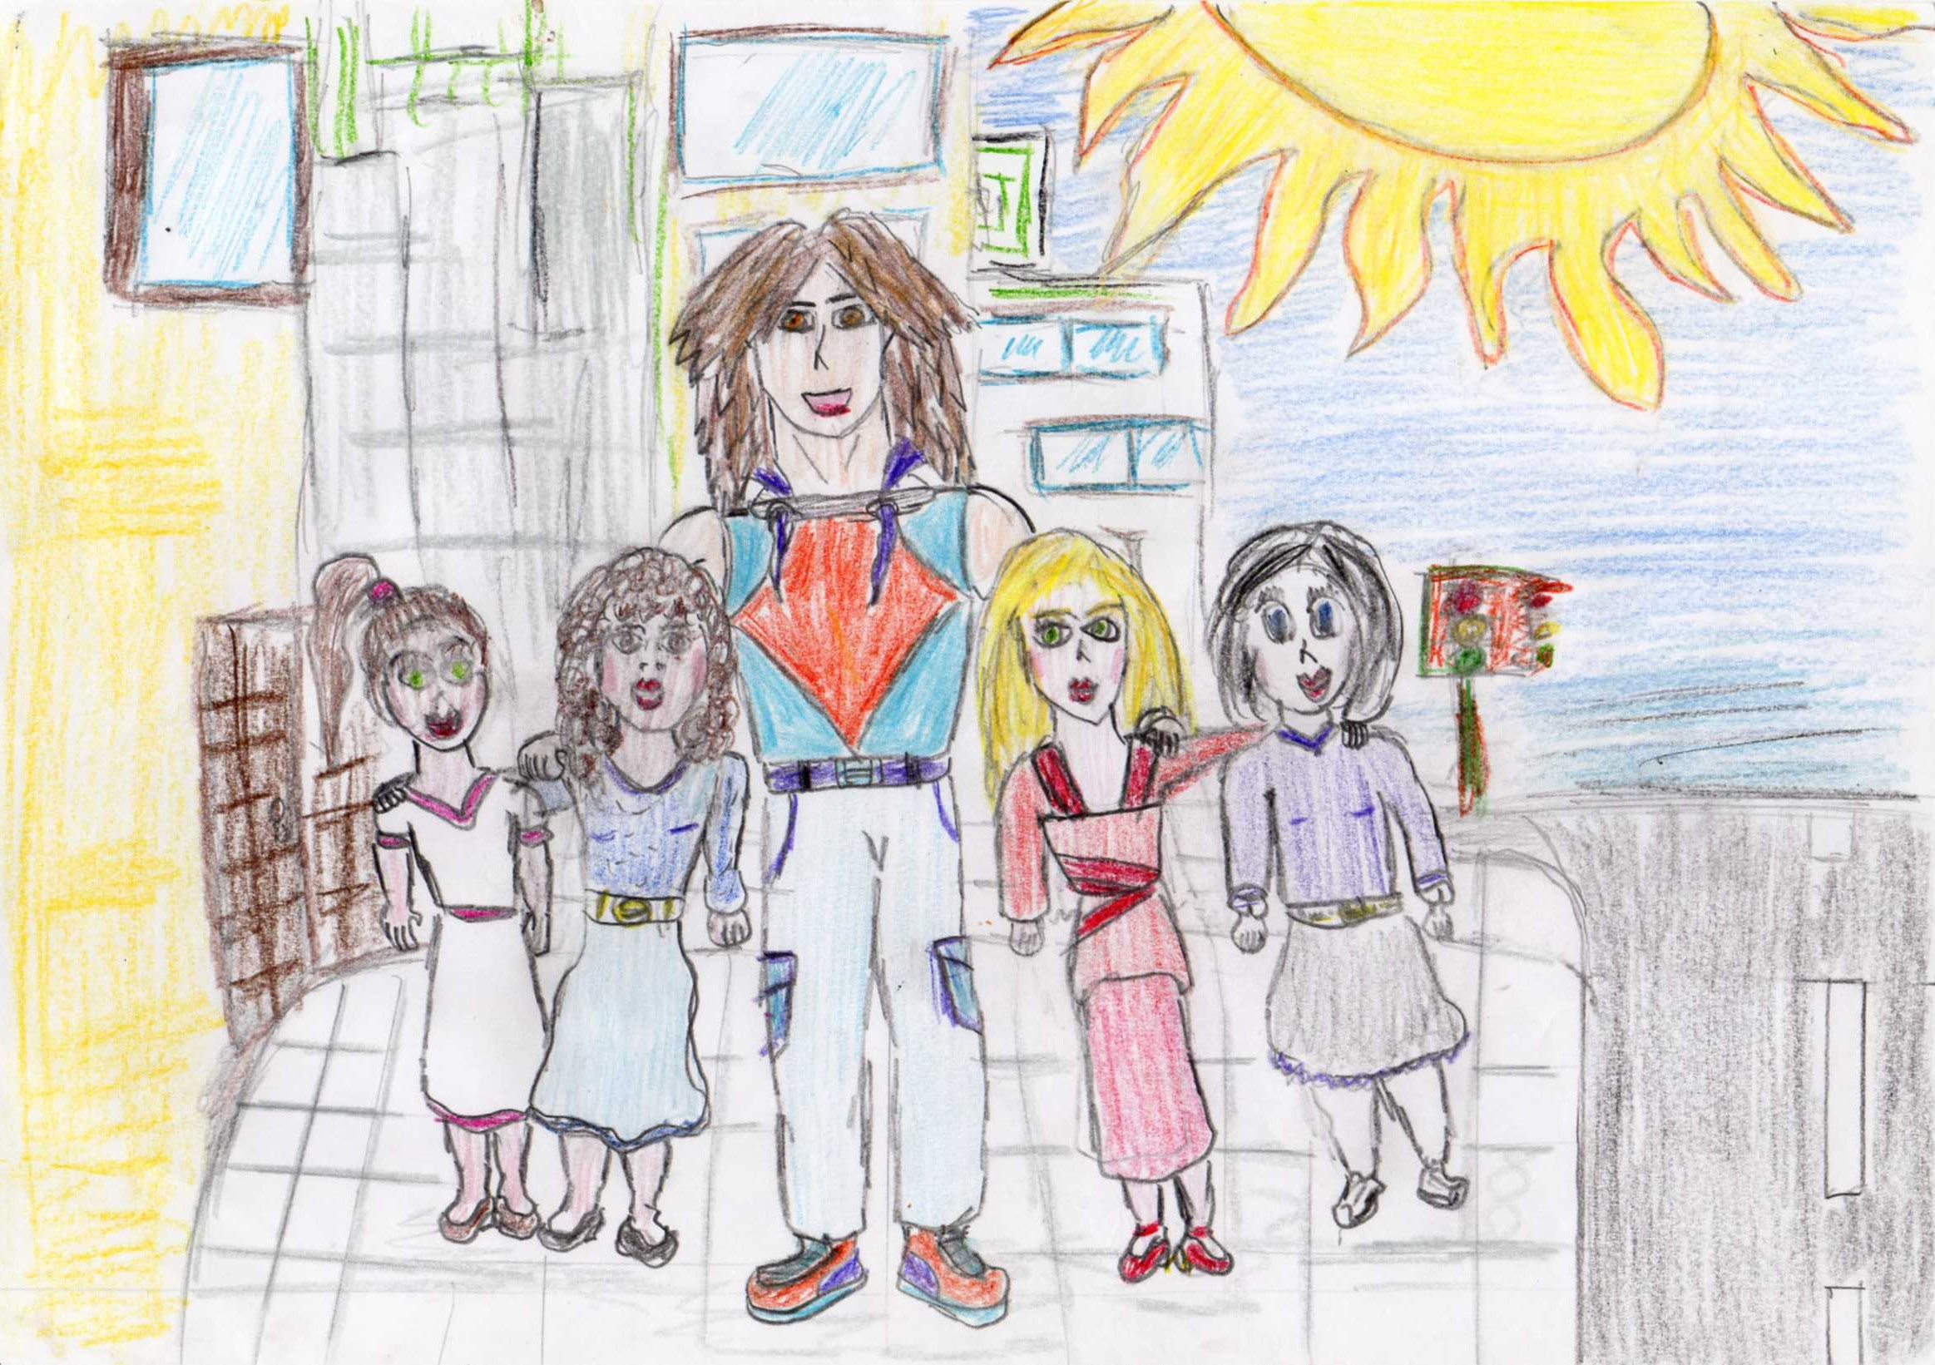
At last everyone understands that bullying does nobody any good and brings unhappiness to humanity. They have created an etwinning project with their teacher.

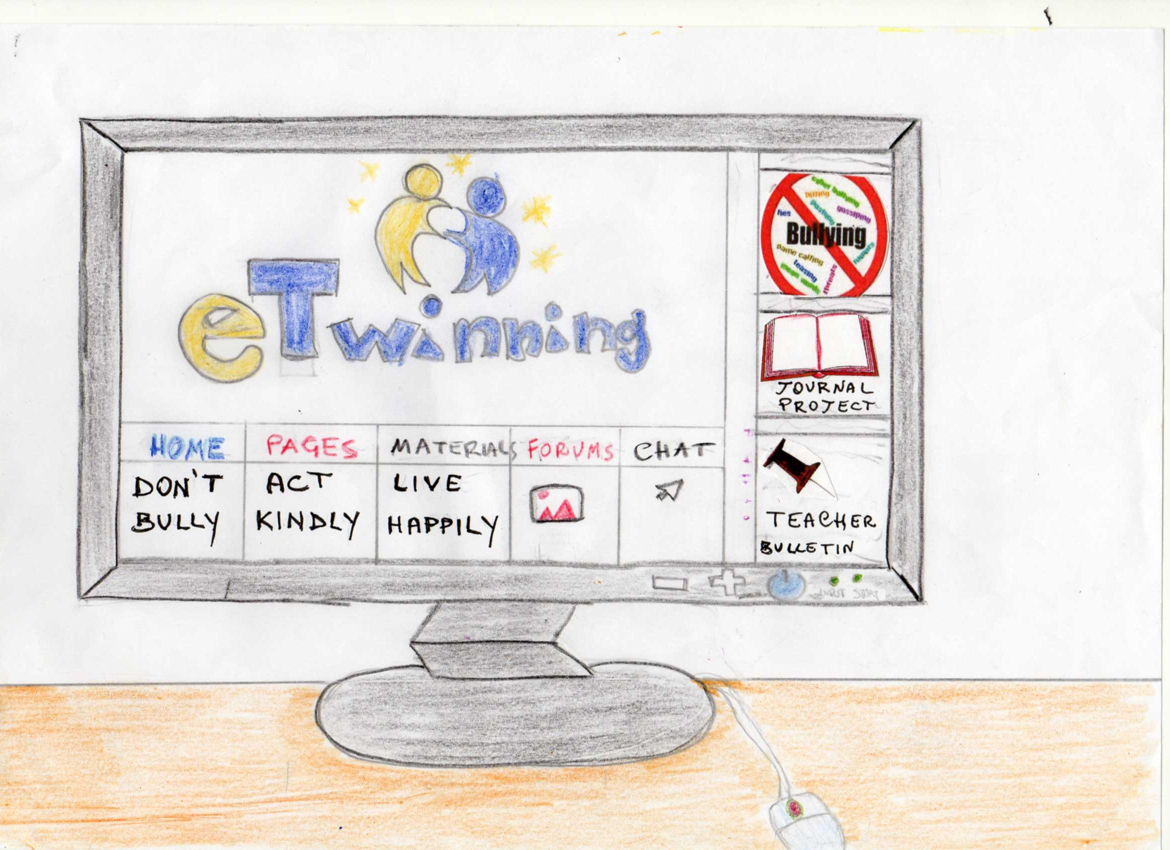
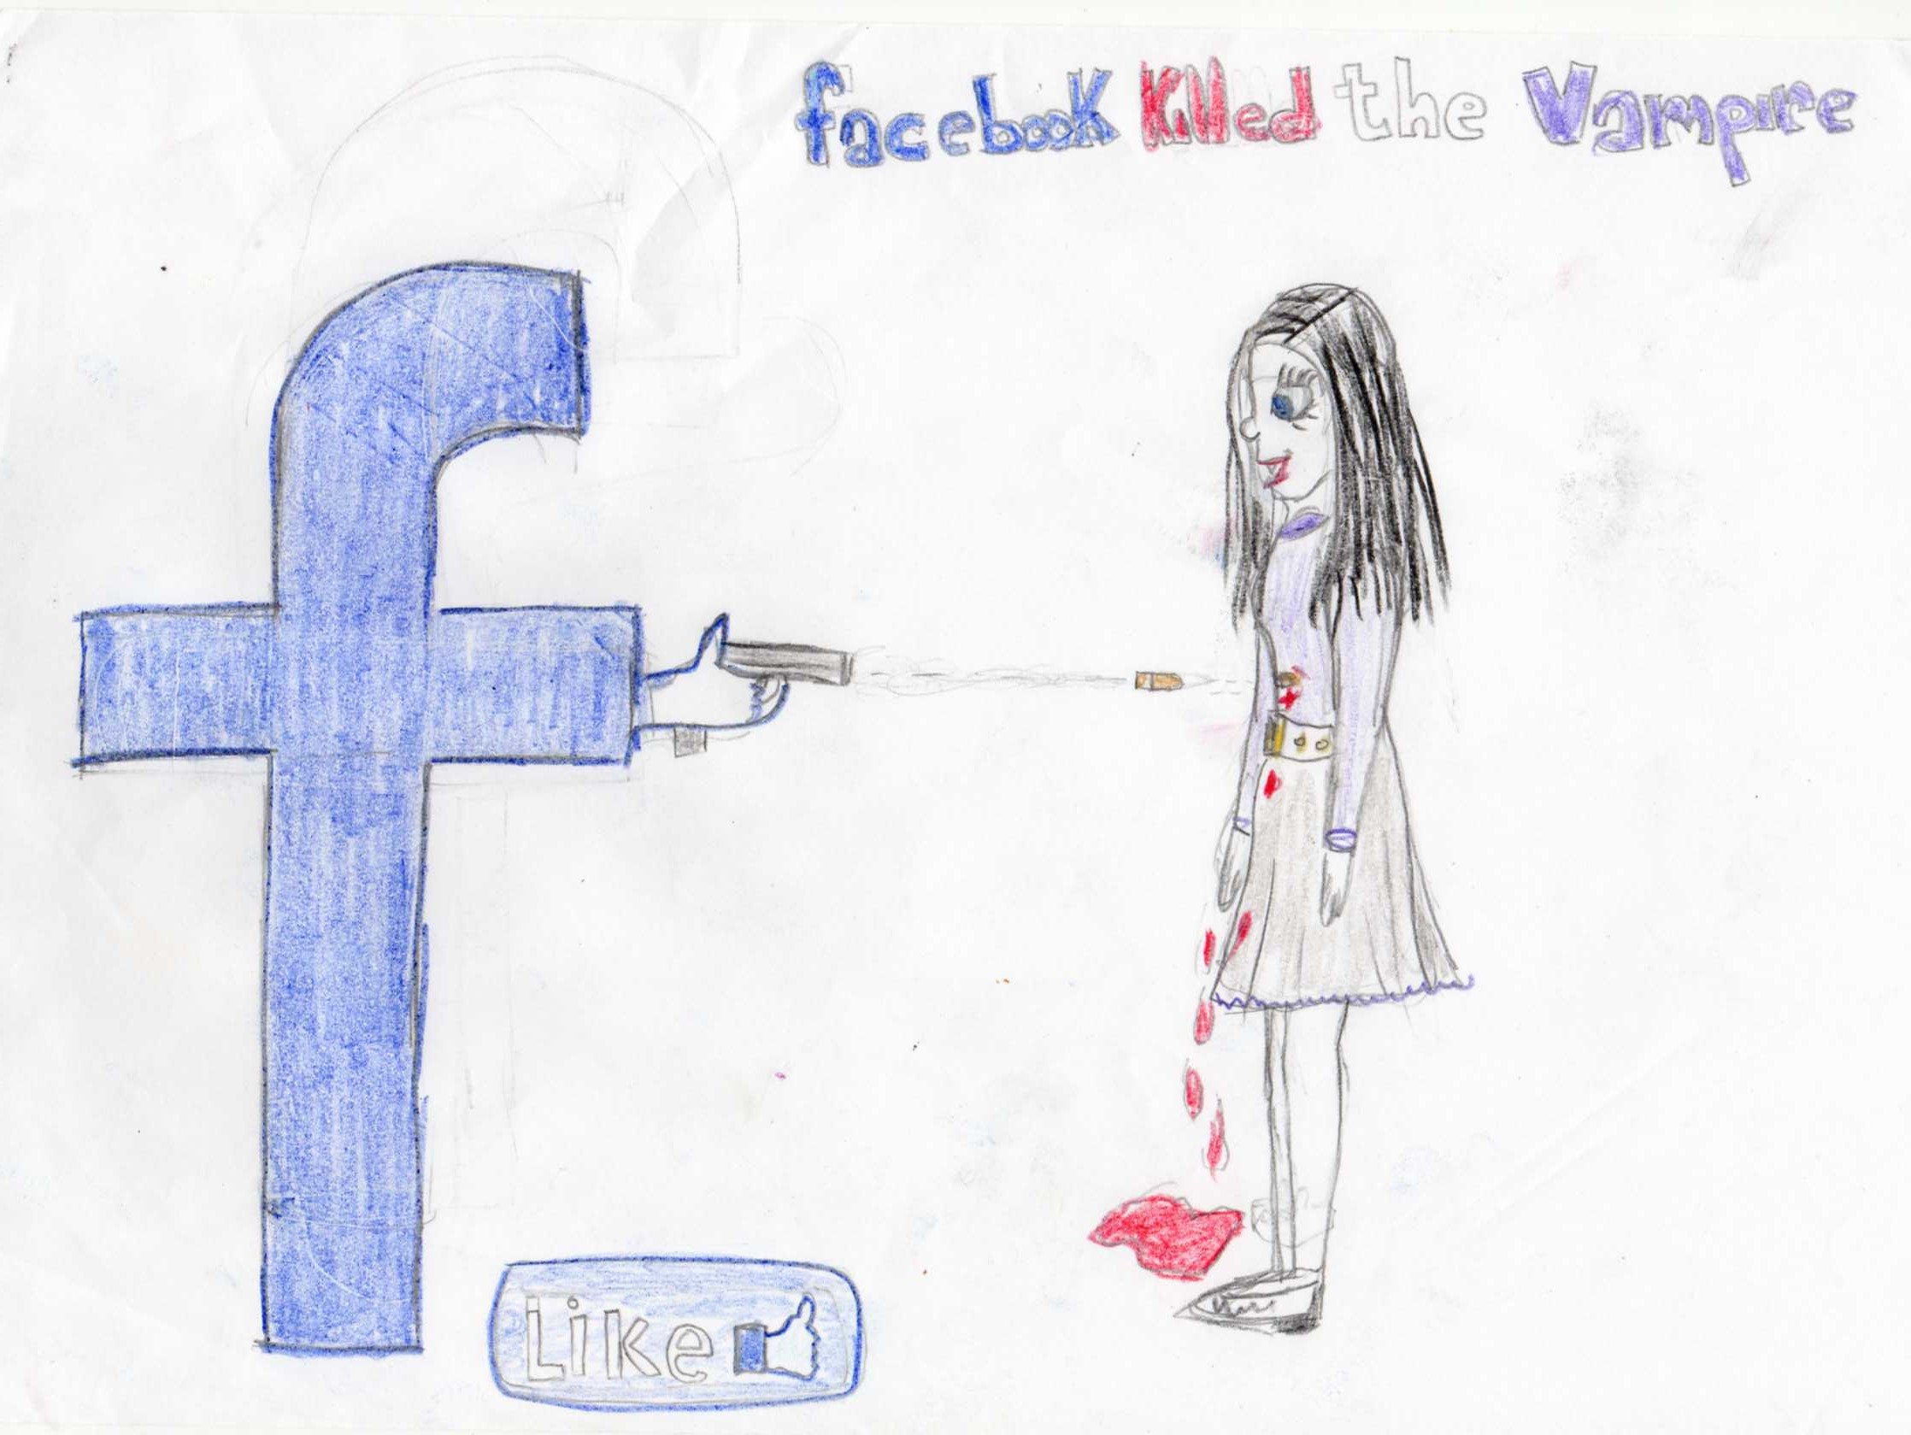
FACEBOOK KILLED VAMPIRE

It´s the last day of high school and Oliwia, a student, is very exicted because the head master, is going, to offer to the best students a trip to a campsite. Oliwia is a girl with black hair as coal, her eyes are round and blue as the sea. She has a sweet sight. Her skin is white, so she looks like a vampire. She is really quiet and unsociable, because she is shy. Her dad died when she was little since her dad died her mother started drinking.

She has a kid so she has to look after her mother and brother, she has and old friend, her name is Wictoria (Wiki) she has to go to class, because they are going to get their marks. When she goes to class, she founds her friend Wictoria.
Wictoria is 14 years old, she is normal size and thin, like all the girls of her age. Her hair is brown and her eyes are green. She has dark skin, she isn`t shy, but she isn`t sociable either she`s patient, easy-going and little bit talkative. She has a normal family like her with a mother, father and two little twins.

The high school has three floors where each floor is organized in a different way, the high school is very big and in the playground of secondary there is a football and basketball court.
When Oliwia is going to go to get her marks, she falls down the stairs, she was injured and everyone start laughed.
Wiki goes very fast to help her. She had wounds on her body.
The students who are laughing are the next: Max Hofer, Stephanie and Rose.
Max is 15 years old, he´s really tall, he has long hair and brown eyes, he´s the football team of High School, he has a top 10 body, because he´s a sportive boy. He has divorced parents; he´s an only child, so he lives only with his mum, his girlfriend is Stephanie, he doesn´t feel comfortable with her because she´s really jealous.
Stephanie is 15 years old, like Max, she looks like a model girl, she´s from Miami. Her eyes are green like the lawn, and brown like the Earth, and she´s blond. She doesn´t have brothers or sisters. She´s very jealous, impatient, mean and anxious. She likes bullying different girls, because she feels superior from others. Her boyfriend is Max Hofer, and her only friend is Rose.
Rose is 14 years old, she´s the right hand of Stephanie. Her eyes are brown like her curly hair. She has one brother, the most awesome student of the High School. He´s impatient, she likes doing bulling to girls with her best friend Stephanie, but she´s friendly when she strives.
One month later, the best students go to the campsite. The campsite was located in a mountain in the south. Next to the river there are fifteen woods cabins dispersed in a great space and there is a lunchroom.
At night, next to a bonfire, Rose, Max and Stephanie were cooking marshmallows. Oliwia went to cook on their bonfire, because she didn’t know how to do it, and someone accidentally pushed her and she burned the end of her hair and everyone laughed about her…

Her black hair was burnt. With her white skin and because she was dishevelled, she looked terrible! Rose, Max and Stephanie took a video of her with a cellphone and posted it on Facebook right away with the following comment : ‘Oliwia, a vampire at the campsite’.
Oliwia was scared. She didn’t know what to do. She tried to phone her friend, Wictoria but she didn’t answer. She saw the video on Facebook and 50 people had already clicked on ‘LIKE’ and 25 had already written comments such as ‘she’s so ugly with that new hair-cut’ or ‘She’s such a loser’ or ‘Where can I find this awful wig ?’ etc….
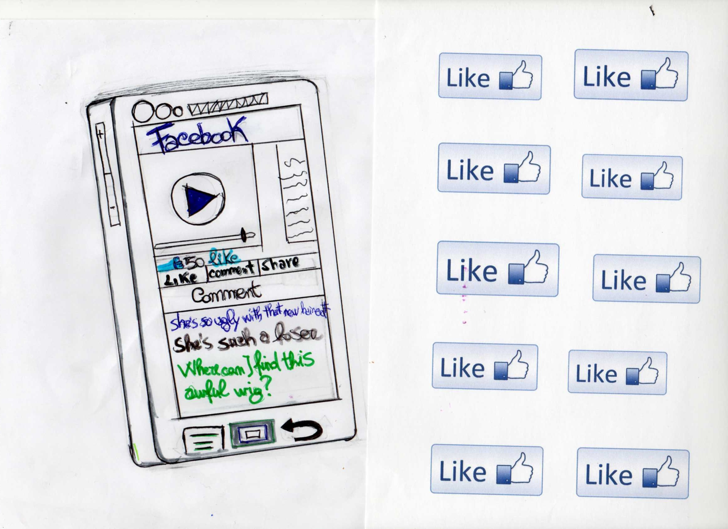
Oliwia was so sad that she decided to run away. She ran a long time. She couldn’t stop running. She was crying at the time. After a while, she couldn’t see anything because of the obscurity of the night and because of the tears in her eyes. But she was still running. She was very far from the campsite now.

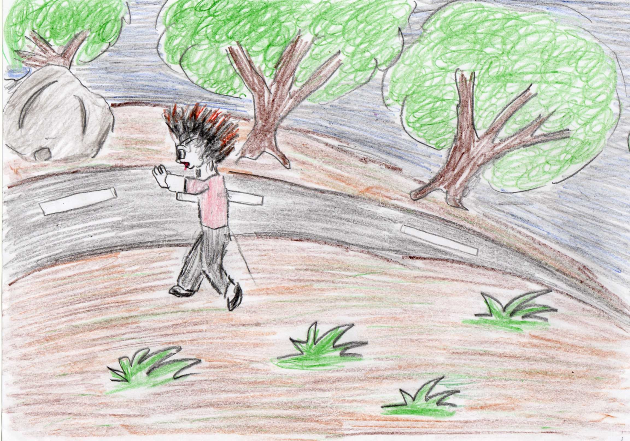
Wictoria, who had learnt about what happened on the bonfire, tried to phone Oliwia back but she got the answering machine. Oliwia was so far, in the mountain that her phone didn’t have any network.
While Oliwia was running, she stumbled and her head banged badly on the ground on a big rock.
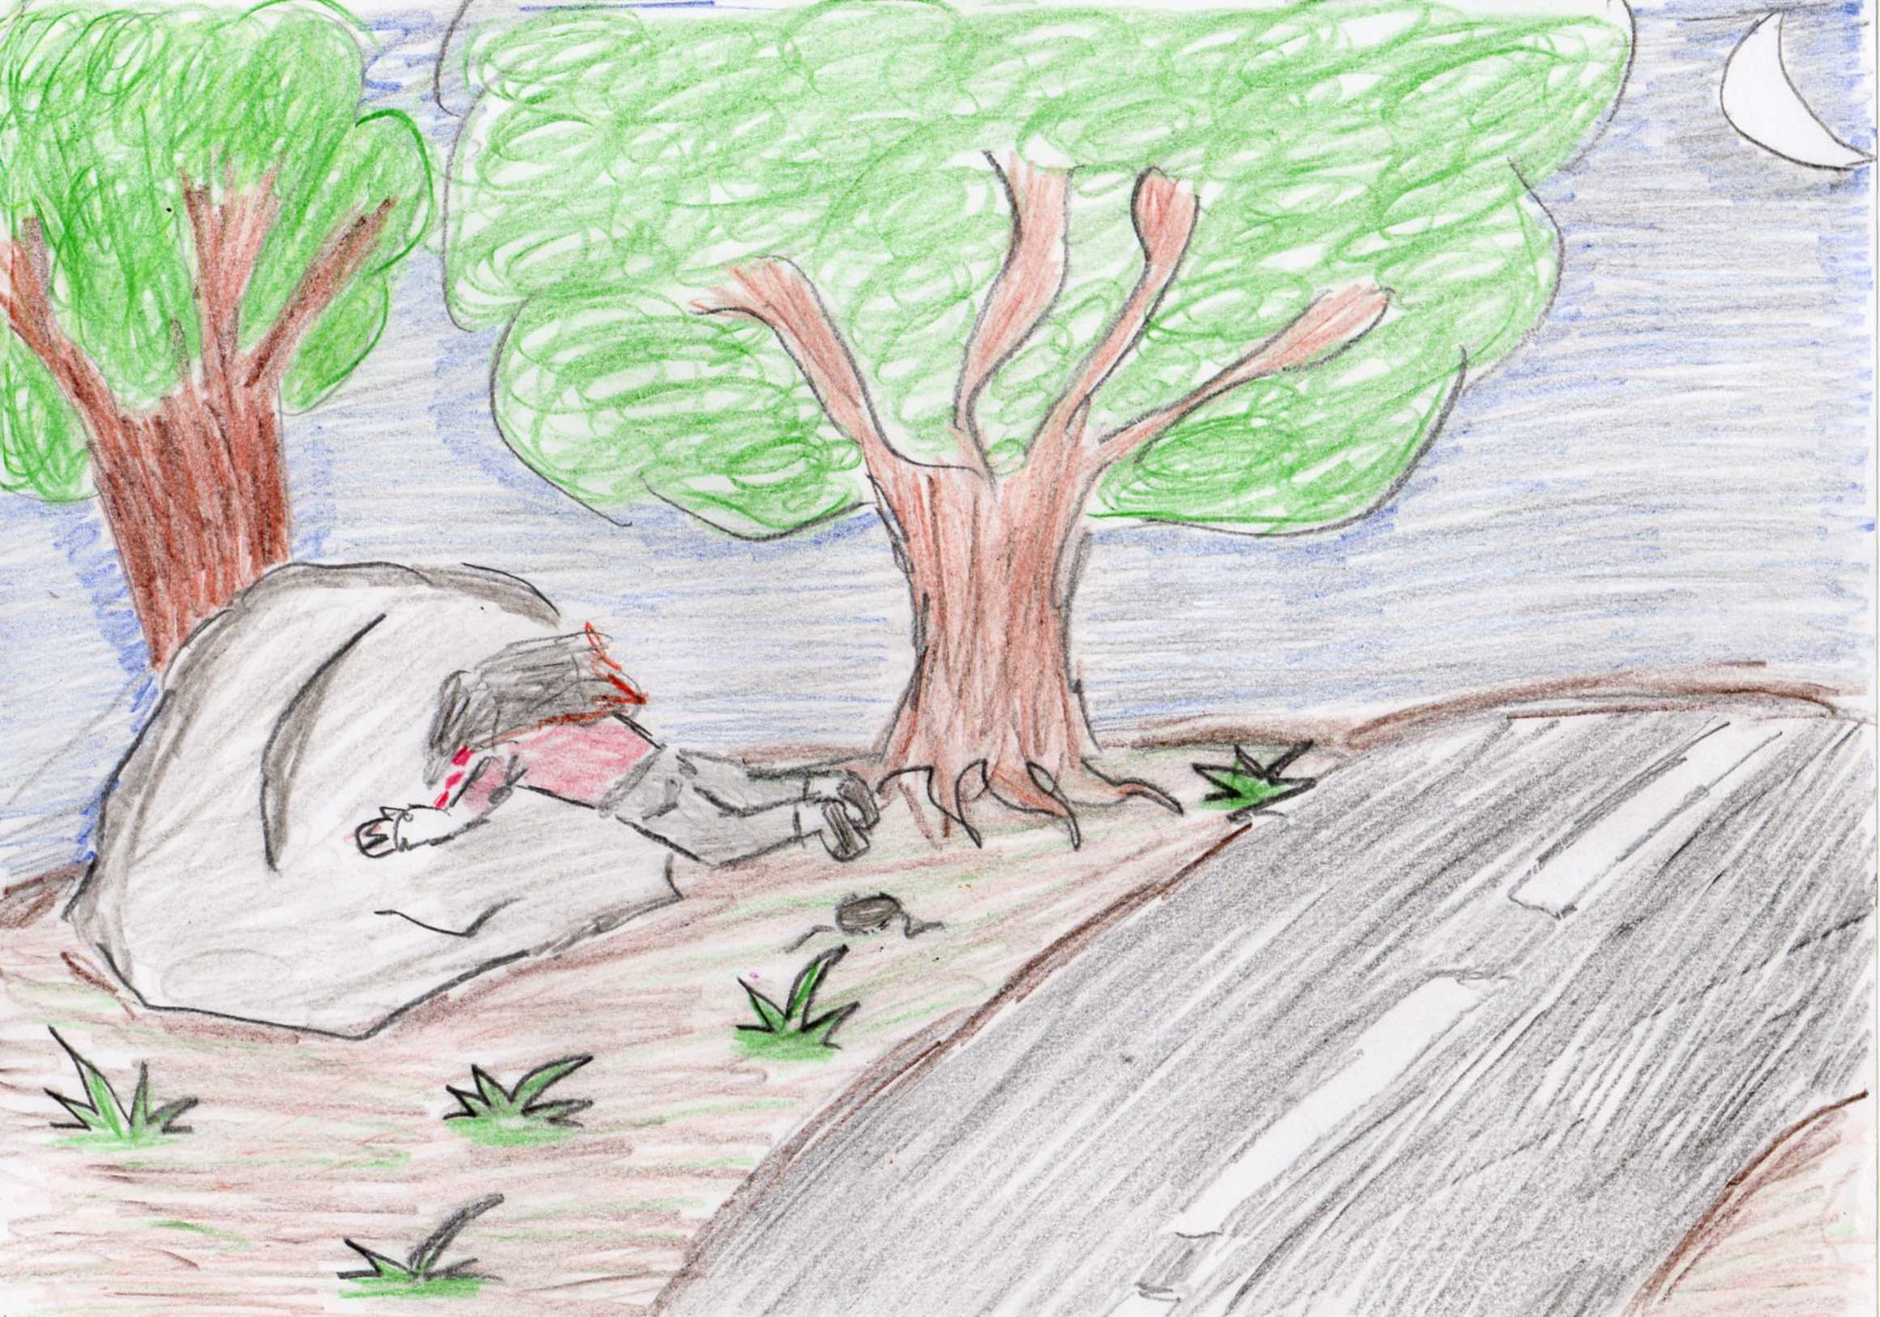
The next morning, the police found Oliwia’s dead body.
