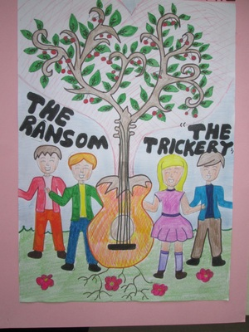

Some students are at Radice-Alighieri school in Catona,Italy.
It's 3.00 p.m. and Marco, Luca, Maria are at the music classroom for the music rehearsal. They are ready to start playing when a boy comes in and says : Good afternoon teacher. I'm Giuseppe Longo and I'm here to replace Luigi.
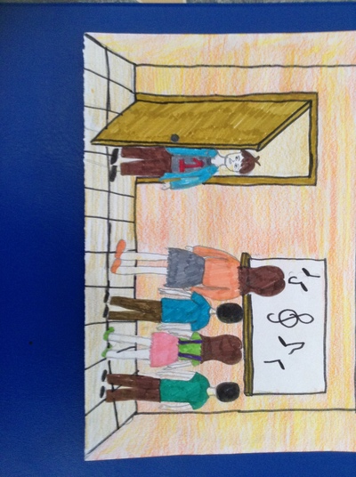

Mrs Rossi: Okay, hello Giuseppe. So you play the guitar,do you?
Giuseppe: Yes ,that's right and he starts playing.
Mrs Rossi: Okay, you know the songs we're rehearsing?
Giuseppe: yes I've got the list
Mrs Rossi: Ready? a one-two-three-four...
All the students are playing their instruments and Giuseppe too,but ...he is out of tune ; the teacher goes on making them to play twice,then she says: Stop! Are you sure you can play the guitar ,Giuseppe?
Giuseppe:Well you know! Mrs Rossi : I'm sorry ,you can't do it. You can go home and practise a lot!!
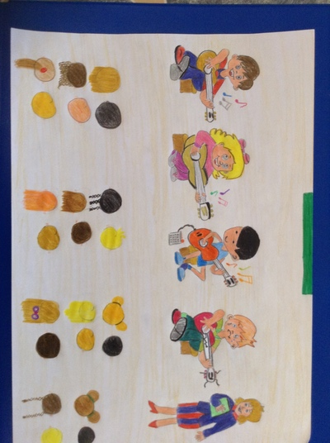

He goes out getting nervous and angry for having made a bad impression !
The next afternoon Marco and Luca are practising music, Luca tells Marco that his guitar is beautiful and Marco tells it is a Gibson SG ,worth a lot of money. Luca asks if he can try it and Marco gives it saying:
- Sure, but be careful!
While Luca is placing the guitar, Giuseppe arrives and taking it,starts to play. Marco, amazed, says: - Hey! What are you doing? Stop it !
Giuseppe says: - Why? Don't you like it?
-No, you can't play . Marco answers and Giuseppe smiling: Is it your guitar? Well, it's out of tune. I'll tune it.
So he tightens a guitar string until he breaks it and , tauntingly , he gives Marco his guitar saying : - Now it's tuned. You can play it and goes out.
Marco is dumbstruck ! Luca is speechless !
- What a bully !! says Marco
Luca, shyly says: Have you got a spare string?
Marco : Yes , I 've got one. I won't tell anything to my parents! I'll tell that I broke it accidentally. I hate that boy, I want only forget him!!
The following day Marco sees Giuseppe in the corridor who pretending to be distracted, thrusts Marco and goes on his way.
Two days after Marco,Luca and Maria go to the music classroom , Marco takes his guitar case ,opens it but it's empty, the guitar is missing! He turns pale. Maria looks at him and asks: Marco what's the matter?
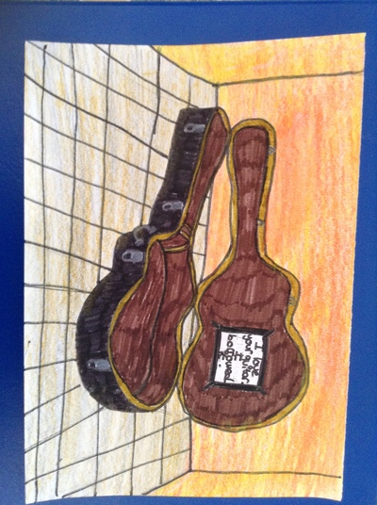

Marco: Someone took my guitar ! Look !
Maria has a look into the case and sees a paper note ; -What is this?
Marco opens it and reads: - "I love your guitar. I borrowed it. If you want it back leave 20 euros in your locker and put the key under the mat. Don't tell anyone or else...."
Maria: -Oh dear! Who wrote the message?
Luca: Who knows!
Marco: - But what can I do now? My beautiful guitar! My parents bought me to make me feel happy. Oh,no!!
Luca:- Let me think. Have you got the money,the 20 euros ?
Marco: - No, I only have 5 euro.I had my pocket money last day.
Luca: - I 've got 10 euro. My dad gave me to buy a phone charge .
Maria:- Don't worry, I've 5 euro ,my pocket money , Here take it Marco.
Marco : -Thanks a lot . If my parents knew.....But what's your plan ,Luca?
Luca:- Listen! And he starts telling what he has hatched out.....
When the school bell rings, all the students leave the school, but Luca,Marco and Maria don't. They go to the locker room and hide behind a row of chairs .They are waiting for the person to come and get the money . A boy comes in taking a guitar covered under a blanket .
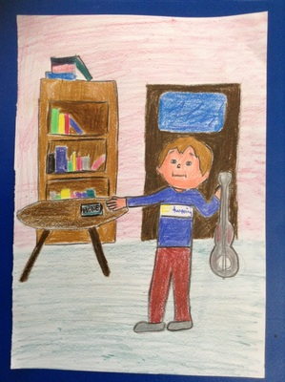

It’s Giuseppe! He puts the guitar down into the guitar case, gets Vic’s locker key under the rug, opens it and takes the money out, then he closes and locks the locker, replaces the key under the rug and goes out.
Luca and the other kids are amazed, Marco is embittered, they were suspicious of Giuseppe.... Marco picks up his guitar, they decide do not tell anything to the headmaster nor to the music teacher Mrs Rossi and go out of the room sadly and angrily.
In the afternoon they meet at Luca's and decide to play a trick on Giuseppe. That bully deserves a lesson !!!
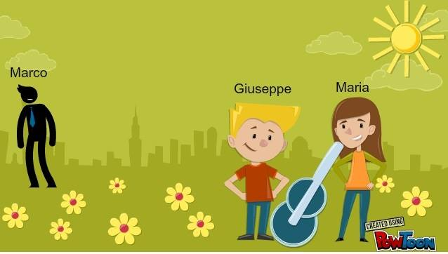
Two afternoons later....
Luca, Marco and Maria go to the school library because they know that Giuseppe must consult some books for a Science project .
Maria has finished to study and stands up, says goodbye to her mates,when she arrives near to Giuseppe she makes a note slide on his desk.
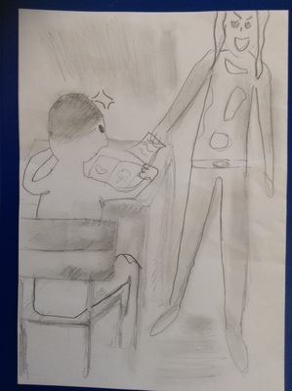

Giuseppe, a bit surprised, opens the note and reads: You're cute. I like you. Meet me tomorrow in the park, near the ice-cream kiosk at 5,30 p. m. Don't be late !
But what Giuseppe doesn´t know is that the friends pull his leg with the letter. At 5.15 pm Marco, Luca and Maria arrive at the ice-cream kiosk. The two boys hide behind a cherry tree. It is summer, it´s very hot every day, the sun shines, so on the tree hang a lots of big and red cherries. Marco and Luca pick some cherries to throw them later at Giuseppe. Maria counts her money… perfect! Enough for two scoops. She waits for 10 minutes.
Luca: Oh Maria look! Giuseppe is coming!
Luca is soon back, behind the tree.
Giuseppe: Hey Maria. How are you?
Maria: Hi, Giuseppe. Thank you, very fine! The weather is perfect for an ice-cream, isn´t it?
Giuseppe: Yes that´s right!
Maria and Giuseppe each buy two scoops of chocolate ice-cream.
Maria: Have you heard…? Marco´s guitar was stolen … The unknown person wanted 20 euros for the guitar!
Giuseppe: Really?! Has Marco got his guitar back?
Maria: Yes. But it’s broken. He wants to know who the blackmailer is. Have you got any idea who it could be?
Giuseppe: No, I´m sor…
The first cherry flies and lands directly in Giuseppe´s face.
Giuseppe: What was that?! It hurt.
Maria : Perhaps a bird that wants to pick a cherry off the tree and it has been dropped accidentally.
Giuseppe: Yes, maybe that’s possible..
Marco and Luca giggle.
Maria:… so I don´t think it isn´t too bad that Marco’s guitar was stolen. He brags with it too much, doesn’t he? The person who has stolen the guitar is very cool!
Marco is outraged. He whispers
Marco: What´s wrong with Maria? Why does she say that?
Luca: Oh… Marco, you are so stupid! She just says that to put him a trap.
Marco: Oh… I see; that is very clever.
The two boys listen again to Giuseppe and Maria.
Giuseppe: Do you really think so? Ehhh…. I stole Marco’s guitar.
Maria: Really?! I can´t believe that. Do you have a proof?
Giuseppe: Yes, here are the 20 euros from Marco. Do you believe me?
Marco and Luca come out of their hiding.
Luca: Giuseppe! Why did you do that? That was very nasty!
Giuseppe: Marco, Luca …. Ehhh what are you doing here?
Marco: Maria, Luca and I have set you a trap and we want you to recognize yourself what you did.
Giuseppe: Okay, you got me. I´m so sorry, Marco .I was so jealous. There are your 20 euros. Please, give me your guitar, I will have it repaired.
Marco: OK, Giuseppe, but don´t do that again!
Giuseppe: Yes, I promise! Come on, I will pay you an ice-cream.
Marco: Thank you, Giuseppe!
Two days later Giuseppe gives Marco his guitar. Marco teaches Giuseppe how to play the guitar, and the students become really good friends… and Giuseppe turns into a very friendly person.
