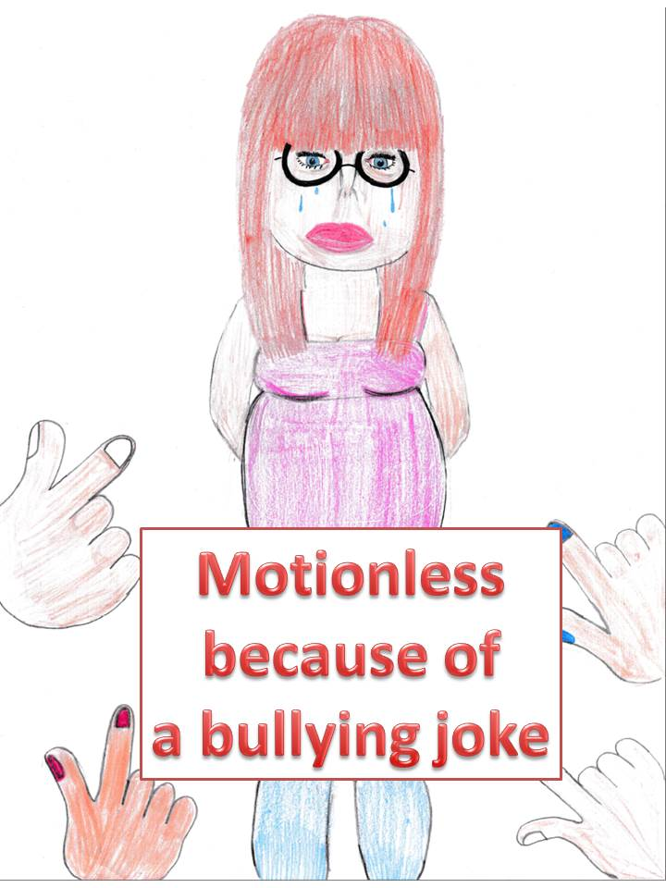
So, I’m going to tell you the story of Antonia, the girl who was bullied by a group of three boys.
Just to make some sense, the names of the boys were Yannick, Richard and Tristan.

It all started, Antonia was new at the school. She wasn’t skinny, like “normal” size. She was a bit bigger and wearing glasses. As the boys saw her, they immediately started to call her names. “God, why are there such fat pigs in this world?” said Yannick. “That’s a big glassed whale right there!” shouted Richard. Everybody else was laughing or just pretending not to see or hear anything. At this point Antonia already knew something: “This is already like all of the other schools. Bullying starts all over again. Hopefully I can handle it this time. I don’t want to change school again!”
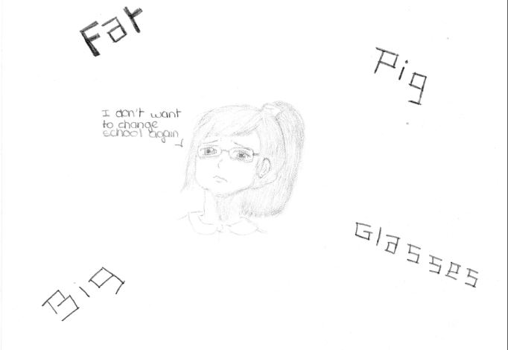

In her first lesson they threw paper at her with little insults on it. In the breaks between the lessons they pulled her hair and screamed, “Look! I caught a big glassed whale!” Every time she came home, with tears on her face, she immediately ran into her room threw herself on her bed and just cried. And every day at school it started all over again.
One evening she chatted online with one of her friends, Florentine, who she had met in a summer camp for talented musicians during the summer holidays. “They throw paper at me with insults on it. They call me names. They pull my hair. They draw ugly pictures of me on the board. And they gossip about me.

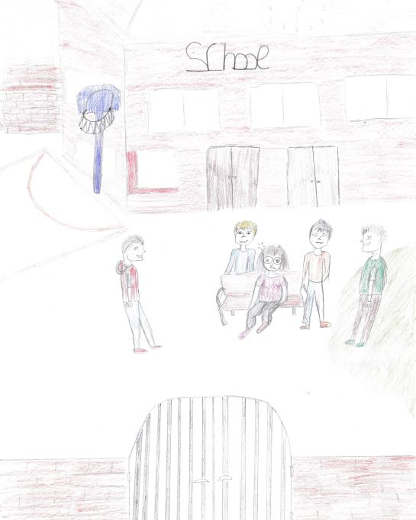
It’s not really nice, I can tell you.” Antonia was silently crying while telling her friend about her hard days at school.
Why didn’t anybody stop the bullies? Why didn’t anybody seem to notice anything? Why did the teachers seem to be blind?

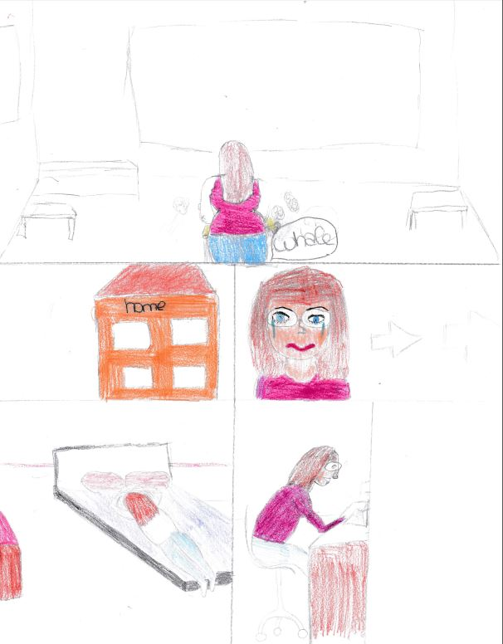
Florentine tried to cheer up Antonia. She said, “Come on. You are such a nice and talented girl. You are a great guitar player. I am your friend and will always be there for you. Just ignore those bullies; they don’t know anything about you. They are so superficial.”

“If I looked like you, they wouldn’t call me names,” Antonia replied with an upset voice, but somehow her friend had encouraged her.

That night she didn’t sleep well – like all the other nights – but something was different.

She did no longer want to be a victim: tomorrow she would stand up against those mean boys.

On her way to school the next morning she met some of the boys from school and they said, “Look at that whale girl with glasses!”

Antonia replied, “I prefer being myself to looking like you.”

One of the boys, “Aaaaahh ... a talking idiot whale! ...Brrrrr….Brrrrr….Brrrr…”

Antonia was angry, ” Enough’s enough !!! I hate you, pimply-faced, damned pig. How dare you talk to me like this?”

The boy said, “God damn you, bird brained “and pushed her.

Antonia fell down and hit her head to the curbside in the street.

The boys stood next to her and said, “Stand up, Big whale, stand up”, but she couldn’t……

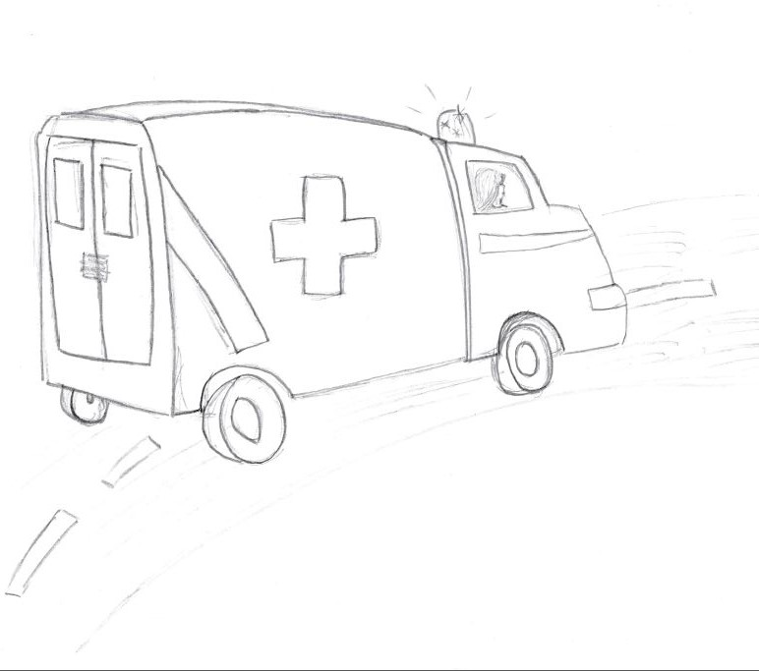

When she opened her eyes after ten days, she was in hospital. She had been operated by the surgeons, but the surgeons said she could neither walk nor stand up as she had a serious cerebral accident. She would become a bedridden from now on…… :(((

