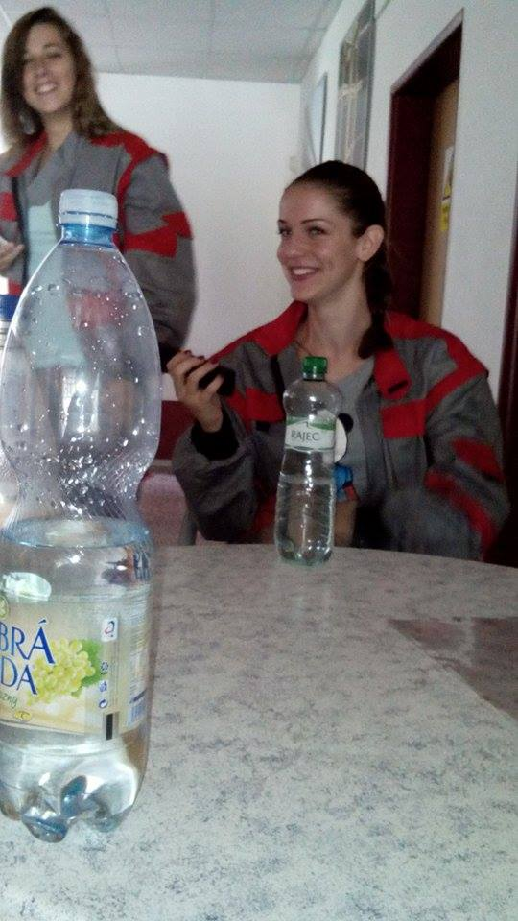
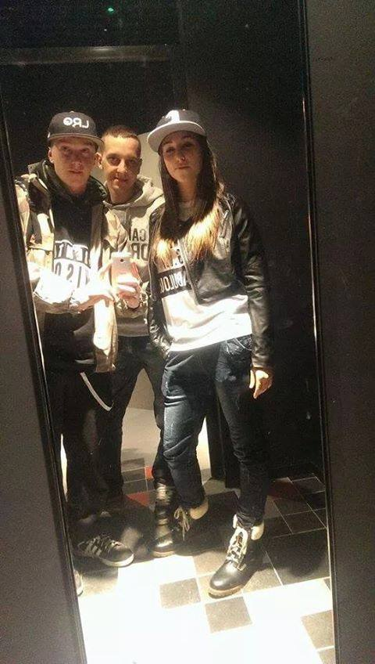
My name is Vladislava Hotová and I‘m 16 years old. I live in Želetava. I study at a secondary school in Třebíč. I like sports, music, books, movies, food and animals. I hate shopping and gossiping. My hobbies are dancing, swimming, running, singing and acting. My dream is finish school and find use.
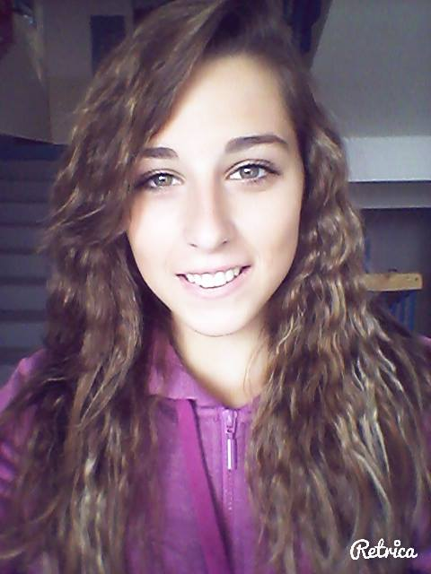
I in school. I and my best friends.
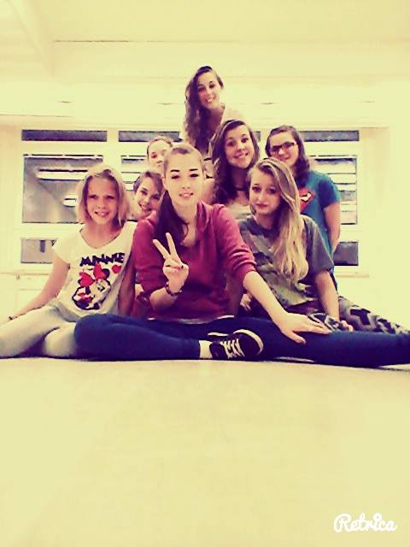
My dancing crew. I and my friend Denda.

